Who voted for whom? Vote choice in the 2017 Catalan election
By ERIC GUNTERMANN | Published: JANUARY 5, 2018

In this blog post, we present some further analyses of the data from the Making Electoral Democracy Work 2017 Catalan election study. Our focus is now on demographics.

To determine which characteristics help explain vote choice in the 2017 Catalan election, we ran bivariate multinomial logistic regressions of vote choice on each of the demographic variables (age, first language, education, income, sex, and urban/rural). Age, first language, and education had an impact on vote choice.

In our final model, we regressed vote choice on these three demographic variables and we successfully predicted vote choice for 33.5% of respondents. We then simulated vote choice probabilities at each possible value of each of the demographic variables, keeping other variables at their most typical value (mean age, Spanish as first language, non-university education).

The first demographic characteristic we consider is age. Age is an important determinant of vote choice for most parties. As we can see in Figure 1, the anti-independence party Citizens (Cs) did best among younger voters. On the other hand, the anti-independence Socialists’ Party of Catalonia (PSC) did best among older Catalans. Like Citizens, the pro-independence Catalan Republican Left (ERC) and the Popular Unity Candidacy (CUP) did best among younger Catalans. The more conservative pro-independence coalition Together for Catalonia (JxC), led by Carles Puigdemont, did best among older voters. What is clear from these results is that younger Catalans are more supportive of the parties with the most extreme positions with respect to independence (Cs, CUP, and ERC).
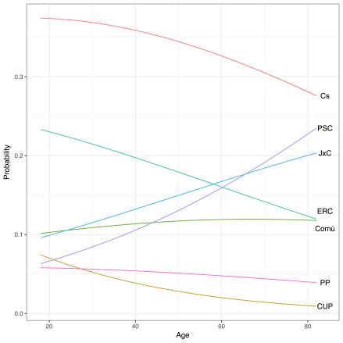
Figure 1: Age and Vote choice

The second variable we look at is education. We compare respondents who have finished university to those who have not. The most striking result is that Citizens did much better among Catalans who have not completed university. Together for Catalonia was also more successful among Catalans without a university degree, but the effect is small. All other parties did best among university graduates. In short, a lack of university education strongly distinguishes Citizens’ supporters from supporters of other parties

Figure 2: University Education and Vote Choice
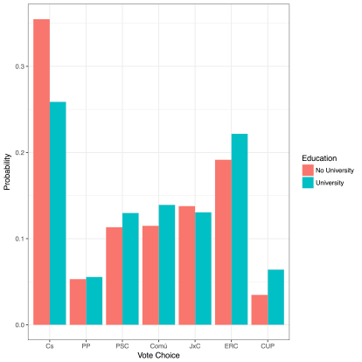
The most important demographic variable for explaining vote choice is a voter’s first language. We distinguish Catalans whose first language is Catalan from those whose first language is Spanish or who grew up in bilingual homes. The three pro-independence parties, CUP, ERC, and JxC, did much better among Catalan-speaking voters. Conversely, all other parties did better among Catalans who learned Spanish at home. The difference is greatest for Citizens, for which the probability of voting jumps from 0.11 among Catalan speakers to 0.35 among Spanish Speakers. It is also large for ERC and for JxC. The predicted probability of a Catalan speaker voting for ERC is 0.37; for a Spanish speaker, it is 0.19. For ERC, the probabilities are 0.32 and 0.14.
For all parties, language is the most important factor accounting for vote choice. Catalan speakers are much more likely to support pro-independence parties. Age is the second most important socio-demographic characteristic. Younger voters are more supportive of the parties with the most extreme positions with respect to independence (Cs, CUP, and ERC). The impact of education is more limited, except for the lower propensity of university graduates to vote for Cs.

Figure 3: First Language and Vote choice
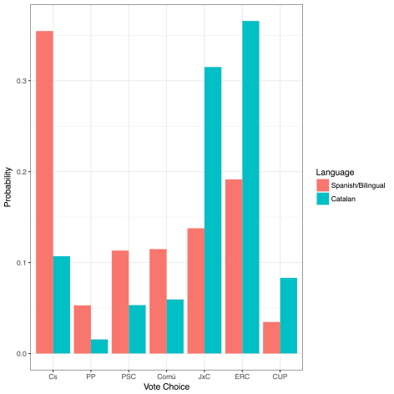
Based on these results, we can characterize the typical voter of each party. The typical Citizens voter is young, Spanish-speaking and has not been to university. In contrast, the Socialists did best among older, Spanish-speaking voters. The PP’s electorate was young and Spanish-speaking.
The typical CUP or ERC voter is young and Catalan speaking. Together for Catalonia did best among older, Catalan-speaking Catalans. The typical voter for Catalonia in Common-We Can is somewhat older and Spanish-speaking.

The socio-demographic profile of party supporters reveals the presence of two strong cleavages. The first and most important is the linguistic cleavage; Catalan speakers are much more likely to vote for pro-independence parties. The second is age; younger voters are much more prone to support the parties that are most extreme on the independence issue, that is, the Cs on the one hand and CUP or ERC on the other hand.

Eric Guntermann is a postdoctoral researcher in the department of political science at Université de Montréal. He is the research coordinator for Making Electoral Democracy Work.
André Blais is Professor in the department of political science and holds a Research Chair in Electoral Studies at the Université de Montréal. He is the principal investigator for Making Electoral Democracy Work.

The Structure of Party Ratings in Catalonia
By ERIC GUNTERMANN | Published: DECEMBER 22, 2017
The Making Electoral Democracy Work (MEDW) project conducted an online survey over the seven days preceding the regional election held on December 21 in Catalonia with a sample of 1500 respondents (obtained from Survey Sample International). Respondents were weighted so that our sample is representative in terms of age, gender, province, the decision to vote, and vote intention.
We asked respondents to rate each party on a scale from 0 to 10 where 0 means that the person strongly dislikes the party and 10 means that she strongly likes the party. In this short note, we present the responses to these questions.

Figure 1 shows the mean rating obtained by each party. Only one party has a mean score above 5, and that is Catalan Republican Left (ERC). Only one party has a score below 3, and that is the People’s Party (PP). The other major pro-independence party, Together for Catalonia (JxC), has a relatively good score, close to 5. What is most remarkable is that the Popular Unity Candidacy (CUP), which obtained only 4% of the vote, has the same mean score as Citizens (Cs), which managed to obtain 25% of the vote. We also note that the average rating of Catalonia in Common-We Can (Comú) is almost the same as that of the Party of Catalan Socialists (PSC), even though the former received much fewer votes. All in all, the pro-independence parties get much better scores, as those who support independence are prone to evaluate positively all pro-independence parties (see below).

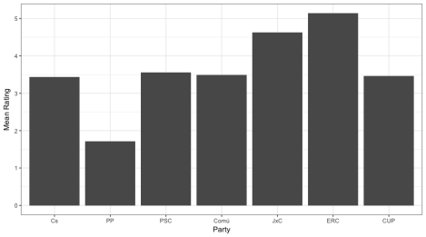
Figure 1: Mean Rating of Each Party in the Catalan Election
Table 1 shows the correlations given to pairs of parties. Positive correlations indicate that those who like (dislike) one party tend to also like (dislike) the other party, and negative correlations mean that the more one likes one party the more she tends to dislike the other party. We can see that the correlations between the pro-independence parties are very high (between .67 and .82), much higher than the correlations between the anti-independence parties. In the latter case, ratings of Cs and PP are strongly correlated while those with PSC are much weaker. It is also interesting to look at the ratings of Catalunya in Comú, the party that is not clearly pro or anti-independence. Its ratings are moderately positively correlated with those given to the three pro-independence parties and negatively correlated with those of Cs and PP. There is no correlation between the ratings of Comú and the PSC.

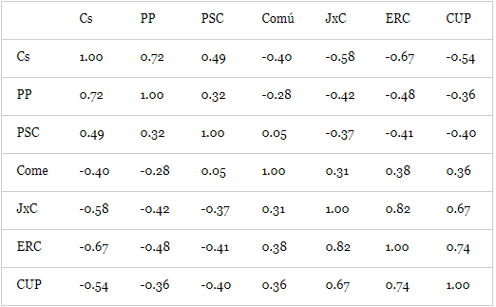
Table 1: Correlations between Evaluations of Each Party

Finally, Table 2 presents the mean score given to the other parties by the supporters of each party (that is, those who prefer a given party). We see again that supporters of each pro-independence party are positive (the means are clearly above 5) towards the other pro-independence parties, which is not the case on the anti-independence side. Most importantly, supporters of the PSC give extremely low scores to the PP, while supporters of the PP are also quite negative towards PSC. It is also worth noting that Cs supporters give slightly higher marks to the PSC than to the PP. As for Comú supporters, they give very negative ratings to Cs and the PP while being more neutral with respect to the other parties. Comú manages to get an overall mean of 5 on the 0 to 10 scale among supporters of ERC.

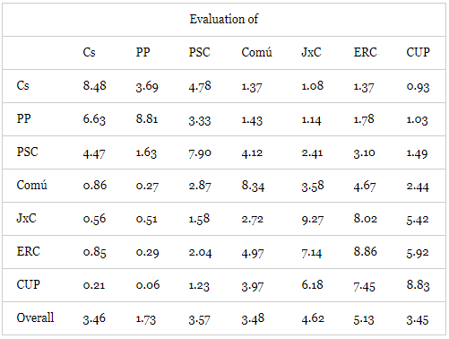
Table 2: Evaluations of each Party by Preferred Party
The main finding is that pro-independence party supporters are much more cohesive than their anti-independence counterparts. The former feel positive towards each of the other pro-independence parties, which is clearly not the case of anti-independence supporters. Finally, these data confirm the strong repudiation of the PP among the electorate. Not only did the party get only 4% of the vote, but even those opposed to independence are not willing to give the party a positive evaluation.

André Blais is Professor in the department of political science and holds a Research Chair in Electoral Studies at the Université de Montréal. He is the principal investigator for Making Electoral Democracy Work.

Eric Guntermann is a postdoctoral researcher in the department of political science at Université de Montréal. He is the research coordinator for Making Electoral Democracy Work.

The Recent Election in Catalonia: A Vote on Independence
By ERIC GUNTERMANN | Published: DECEMBER 22, 2017
On December 21st, Catalans voted in an election to their regional Parliament. Spanish Prime Minister Mariano Rajoy called the election hoping to lower the tension caused by the crisis over independence. However, as in the previous regional election held in 2015, pro-independence parties collectively won a majority of seats. At the same time, the party that most strongly opposes independence, Citizens, won a plurality of votes and seats.

Making Electoral Democracy Work (MEDW) conducted an online survey over the seven days preceding the election with a sample of 1500 respondents obtained from Survey Sampling International. Respondents were weighted so that our sample is representative in terms of age, gender, education, province, the decision to vote, and vote choice.

We found that voters overwhelmingly voted for a party on their side of the independence issue. We asked respondents how strongly they support or oppose independence on a scale from 0 to 10, with higher values indicating stronger support. We consider those who gave a score under 4 independence opponents (35.9% of the sample), those who gave a score over 6 independence supporters (47.6% of the Sample), and those who answered from 4 to 6 ambivalent (16.4% of the sample).

Figure 1 shows how respondents in each group voted. As we can see nearly all independence supporters voted for one of the pro-independence parties, Together for Catalonia (JxC), Catalan Republican Left (ERC), and the Popular Unity Candidacy (CUP). Most of those who oppose independence voted for one of the parties opposing independence, Citizens (Cs), the People’s Party (PP), and the Party of Catalan Socialists (PSC). The more ambivalent Catalonia in Common-We Can (Comú) did best among Catalans who neither clearly support nor oppose independence.

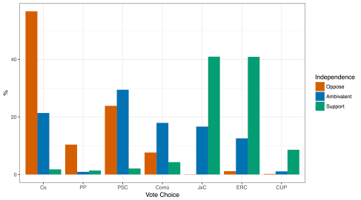
Figure 1: Vote Choice by Position on Independence

Based on the independence scale, supporters of independence, although a minority, appear to outnumber those opposing it. We also asked about independence two other ways.
First, we ran a question-wording experiment in which half the sample was asked whether they want Catalonia to become an independent state. The other half was asked whether they want Catalonia to separate from Spain. As Figure 2 shows, when asked whether Catalonia should become an independent state, the same percentage of Catalans says yes as no (45%). When asked whether Catalonia should separate from Spain, however, opponents outnumber supporters of separation (47% compared to 41%).

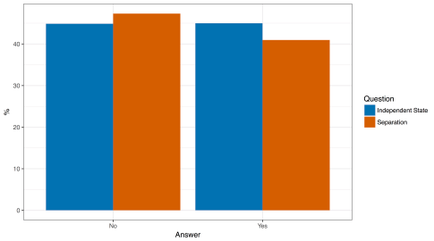
Figure 2: Support for an Independent State Compared to Separation from Spain
We also asked Catalans what their preferred relationship is between Catalonia and Spain using a question-wording experiment. One random half of the sample was asked whether Catalonia should be “an autonomous community with less autonomy than it currently has,” “an autonomous community with the same autonomy it currently has,” “an autonomous community with more autonomy,” or “an Independent state.” The second half of the sample was presented with the same set of categories except the option “autonomous community with more autonomy” was replaced with “state in a federal Spain.” This option – a “state in a federal Spain” – is the solution to the nationalist conflict Catalan and Spanish Socialists have been proposing for years.
Figure 3 presents support for these options in each of the groups. Once again, we find different levels of support depending on the question asked. In the “more autonomy” version, 39% support independence. In the federalization option, 30% do. Question wording clearly makes a difference.

Figure 3: referred Relationship Between Spain and Catalan, by Question Wording
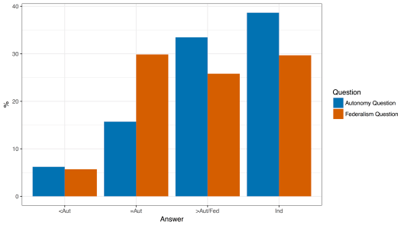

Finally, we asked people to evaluate four major decisions made by the Catalan and Spanish governments over the past three months: the Catalan government’s decision to organize an illegal referendum, the Spanish government’s decision to send the police to stop the referendum, the Catalan government’s decision to declare independence, and the Spanish government’s subsequent decision to suspend autonomy. As the table below shows, Catalans clearly opposed decisions made by both governments, except the Catalan government’s decision to hold an illegal referendum, which received slightly more support than opposition.

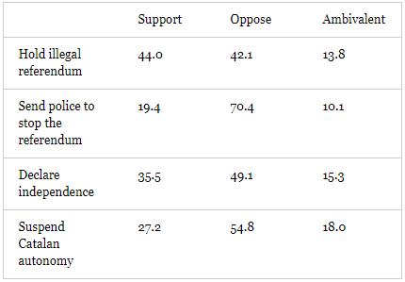
Table 1: Percentage who Support Government Actions
In short, on December 21st, Catalans voted overwhelmingly based on their attitudes towards independence. However, voters’ preferences for Catalonia’s future vary depending on the question wording. Finally, Catalans support neither the actions of the Catalan government nor those of the Spanish government in the recent crisis over independence.

Eric Guntermann is a postdoctoral researcher in the department of political science at Université de Montréal. He is the research coordinator for Making Electoral Democracy Work.

Catalan Election Survey
By ERIC GUNTERMANN | Published: DECEMBER 13, 2017
In the context of the historic election that will be held on December 21st in Catalonia, Making Electoral Democracy Work (MEDW) has decided to run a pre-electoral survey. The survey is being run by Eric Guntermann, André Blais (Université de Montréal), Ignacio Lago (Universitat Pompeu Fabra), and Marc Guinjoan (Universitat Autònoma de Barcelona). It will interview 1500 respondents online in the week preceding the election.
The survey will consist notably of questions on vote choice, on attitudes related to Catalan independence, and on evaluations of the actions taken by both the Catalan and Spanish governments.
The objective of the survey is to explain vote choice and attitudes related to independence. Consequently, MEDW researchers will not release any results prior to the close of polls on December 21st. Shortly after the election, a short report with the main findings will be posted on the project’s blog and sent to the media.
Questions about the survey should be addressed to the MEDW research coordinator at eric.guntermann@umontreal.ca

Party influence where predispositions are strong and party identification is weak: Assessing citizens’ reactions to party cues on regional nationalism in Spain
By ERIC GUNTERMANN | Published: NOVEMBER 29, 2017
By Eric Guntermann, Postdoctoral researcher at the Research Chair in Electoral Studies and research coordinator for Making Electoral Democracy Work

Do parties influence opinions on nationalism in Spain?
Numerous studies have shown that parties influence opinions, especially in the US (e.g. Cohen, 2003; Druckman et al., 2013; Kam, 2005). It is unclear, however, whether such influence occurs in other contexts where party identification is less common and where multi-party systems are the norm. Moreover, it is not clear what kinds of issue opinions parties can influence. The existing literature suggests that opinions that are rooted in predispositions are resistant to party influence (Tesler, 2015).
In this recent publication, I show that parties influence opinions on regional nationalism in Spain, even though most people lack a party identification there and even though nationalism is rooted in identity. I argue that, when confronted by conflict between a party they like and a party they dislike, citizens adopt the position of the side they prefer regardless of whether they identify with it. Moreover, parties can influence opinions on nationalism, because many people in nationalist contexts have ambivalent identities, both with the region and with the country.

Study 1: Laboratory experiment in Catalonia
In May 2016, I recruited 113 participants for a lab experiment in Barcelona. I presented each participant two positions their preferred party has that they do not share as well as the contrasting positions of a party they dislike. While participants in the control group simply read statements that were attributed to “some politicians”, those in the treatment group were clearly associated with the relevant parties. As the figure shows, I found that those in the treatment group became more than one point (on a scale from 0 to 10) more supportive of their party’s position than those in the control group. However, they did not change their ratings of either their preferred or disliked parties.

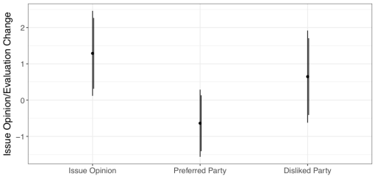
Figure: Changes in issue opinions and in evaluations of preferred and disliked parties

Study 2: Survey experiment in Galicia
A few weeks later, I recruited a representative sample of 600 respondents in Galicia. I showed them party positions on two issues: whether Galicia is a nation and whether Galicia has a right to self-determination. The order of these issues was randomized across respondents. On the first issue, participants read their preferred party’s position. On the second issue respondents read about, they saw that position along with the contrasting position of a party they dislike. As in Study 1, respondents in the control group read positions that were attributed to anonymous politicians, while those in the treatment group read statements that were clearly associated with parties.

I found that the treatment-group respondents reported opinions that were closer to their preferred party’s position on the second issue on which they read contrasting cues. Cues from a preferred party alone only influenced opinions among participants who identified with that party. Influence was strongest on the issue of whether Galicia is a nation and among participants who identify with both Galicia and Spain.
In short, party influence extends to opinions on an issue that is rooted in identities despite the weakness of party identification.
For more details, see Eric Guntermann. Party influence where predispositions are strong and party identification is weak: Assessing citizens’ reactions to party cues on regional nationalism in Spain. Party Politics. DOI: http://journals.sagepub.com/doi/pdf/10.1177/1354068817736756

When David and Goliath campaign online: the effects of digital media use during electoral campaigns on vote for small parties
By ERIC GUNTERMANN | Published: NOVEMBER 13, 2017
What is the story?
A growing literature examines the effects of digital media on the fortunes of challenger parties. Challengers might have an advantage online given that digital technologies are making small contenders more visible compared to big ones. Moreover, the plurality of new media will cater to niche audiences, undermining the appeal of mainstream parties. Most of this literature, however, focuses on party strategies (and is mostly American) and not on vote choice.
In this paper, we ask whether digital media contribute to electoral fragmentation by moving citizens’ vote from mainstream to third parties. We address the causal mechanisms connecting digital media and vote for challenger parties, namely the perceived electoral chances of small parties and, voters’ indecision caused by exposure to online political information. Also, we test the fragmentation potential of the Internet on vote choice using a cross-country study (Making Electoral Democracy Work, 21 elections held in 4 countries). Finally, we measure fragmentation at the individual level, comparing vote intention in pre-electoral surveys with vote reported in post-electoral surveys.
Figure 1: Causal schema. Direct and direct effects of digital media use during electoral campaigns on voting for “big” and “small” parties
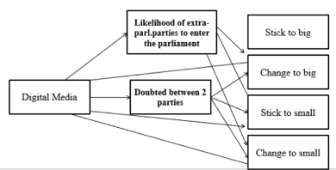
Figure 2. Distribution of the dependent variable, by country
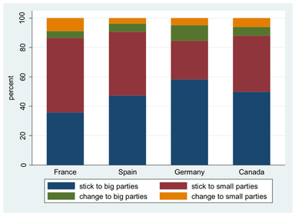
Results and Conclusions
Only 5% of voters change their initial vote intention from a large party to a small one. While traditional media use during the campaign has a concentration effect, benefitting large parties; online media has a positive effect on both the likelihood of sticking with small parties and, especially, the likelihood of switching to small parties.
We also contend that indecision about one’s vote choice and the perceived chances of small parties will increase with digital media use. This, in turn, positively affects the chances of voting for a small party. We tested a multiple mediation model by means of structural equations. We found that, the more an individual uses the Internet during an electoral campaign, the more uncertain they become about their vote choice, which, ultimately, increases their likelihood of voting for a small party. Nevertheless, the mediating role of the perceived chances of extra parliamentary parties is only marginal, and it works better for the chances to switch in favor of a large party.
Carol Galais and Ana Sofía Cardenal, A. S. (2017). When David and Goliath campaign online: the effects of digital media use during electoral campaigns on vote for small parties. Journal of Information Technology & Politics

What Do Political Scientists Know About Electoral Reform that Practitioners Do Not? A View from Europe and Canada
By ERIC GUNTERMANN | Published: NOVEMBER 1, 2017
Camille Bedock (University of Brussels), Damien Bol (King’s College London), Thomas Ehrhard (University of Paris II)

What is the story?
When politicians or public officials consider changing the electoral system, they often seek advice from political scientists. The APSA Task Force on Political Science, Electoral Rules and Democratic Governance conducted a survey on the topic. In their follow-up report, the authors note that more than 50 US-based political scientists have been involved in electoral reform processes since 2000.
In a symposium recently published in the Election Law Journal, we offer new insights on this topic by offering a view from outside of the US. We invited five political scientists from Europe and Canada who have been involved in electoral reform in their country, and who engaged with politicians, public officials, and the national media on the topic, to answer two related questions: (1) what do political scientists know about electoral reform that practitioners do not?; (2) do they make a difference?

Content
There are 5 contributions to the symposium:
-Bedock, Camille, Damien Bol, and Thomas Ehrhard (2017) Political Scientists and Electoral Reforms in Europe and Canada: What They Know, What They Do. Election Law Journal 16(3): 335–340.

In this introduction, we give a brief overview of the literature on the role of political scientists in electoral reform and summarize the main conclusions of the contributions to the symposium. We identify the differences and similarities between countries, and give new comparative insights to the debate regarding the involvement of political scientists in electoral reform.
-Renwick, Alan (2017). Electoral Reform: What Do Political Scientists Know That Practitioners Do Not? Lessons from the UK Referendum of 2011. Election Law Journal16(3): 341-348.

Alan Renwick reports on his experience as one of the main government and media experts in the (unsuccessful) 2011 electoral reform referendum in the United Kingdom. He explains why the common wisdom that practitioners know less about electoral systems than political scientists is largely unfounded. Practitioners have a clear idea about the consequences of electoral laws. Therefore, political scientists should focus on educating the public rather than politicians, and accept to learn from practitioners, as they sometimes know more about electoral systems than they do.
-Milner, Henry (2017). Electoral System Reform, the Canadian Experience. Election Law Journal. 16(3): 349-356.

Henry Milner builds upon years of involvement in various electoral reform processes in Canada. He notes that despite the clear preference built over the years by some political scientists in Canada for moving to a mixed-member proportional system, they have not been able to change the system. According to him, political scientists should engage in the strategic dimension of electoral reform, for example, by anticipating the arguments of proponents of the status quo.
Freire, André (2017). Electoral Reform in Portugal: The Role of Political Scientists. Election Law Journal 16(3): 357-366.

André Freire answers the questions of the symposium based on his involvement as the main government expert in an important electoral reform in Portugal in 2009. He argues that the major difference between political scientists and practitioners is not so much their knowledge but the specific partisan interests of the latter. Also, he notes that the involvement of political scientists in electoral reform processes makes them more open and transparent.
Riera Pedro, and José Roman Montero (2017) Attempts to Reform the Electoral System in Spain: The Role of Experts. Election Law Journal 16(3): 367-376.

Pedro Riera and José Ramón Montero report on their involvement in the (failed) electoral reform processes that took place in Spain in 2008 and 2015. They admit, quite honestly, that despite their formal involvement in the process their influence was almost nil. They argue that, in situations where there is a divergence of interests among parties, there is little that political scientists can do to affect the outcome of electoral reform.

Does Democratic Consolidation Lead to a Decline in Voter Turnout? Global Evidence Since 1939
By ERIC GUNTERMANN | Published: SEPTEMBER 27, 2017
By Filip Kostelka, Institutions and Political Economy Research Group (IPERG), University of Barcelona & Centre d’études européennes, Sciences Po, Paris

Voting rates in new democracies often decline dramatically. For instance, in less than twenty years after democratization, voter turnout fell by 17.5 percentage points (pp) in Portugal (which has held democratic elections since 1975), 29 pp in El Salvador (1982), 30 pp South Korea (1988), and 47 pp in Romania (1990). Both researchers and journalists usually ascribe these declines to citizens’ disillusionment with the functioning of the new democratic regime and raising apathy in the face of reduced electoral stakes. Democratic consolidation, the process through which democracy becomes established, is believed to depress turnout.
However, this conventional interpretation is problematic. First, it does not explain the striking variation that exists among new democracies. My review of 91 democratic consolidations that took place between 1939 and 2015 shows that, in half of new democracies, turnout declined little or not at all (see Figure 1). For instance, in Spain, which, like neighbouring Portugal, experienced a military dictatorship that lasted several decades before democratizing in the mid-1970s, turnout decreased by only 2.6 pp. This is 7 times less than in Portugal. Second, a number of recent studies, including those employing a pre-/post-election panel design, have found no causal relationship between democratic dissatisfaction and voter turnout.
Figure 1: Voter Turnout Change in the First Six Democratic Elections
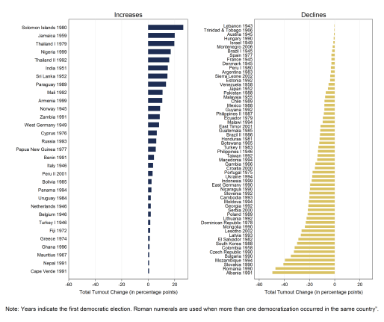
In a new study, I offer an alternative explanation of the deep participation declines that sometimes occur in new democracies. I argue that these declines originate in exceptionally high levels of participation at the beginning of the democratic transition, which are provoked by the democratization context. If regime change is a revolution or if citizens are used to voting from the authoritarian era, the democratization context is strongly mobilizing and conducive to electoral participation. In such cases, the voting rate in the founding democratic elections exceeds the “standard” level that would be expected in an established democracy with the same characteristics as the new democracy at hand. Later on, however, as the democratization context loses salience, voter turnout returns to the “standard” level, which is determined by the same factors as in established democracies. Only on face value, it seems that participation is depressed by the democratic consolidation context but, in reality, the dynamic is driven by what happened before the process of consolidation has even started.
To test both the conventional and my alternative accounts, I compiled an original dataset that covers most legislative elections held in new and established democracies between 1939 and 2015. I run two regression analyses. In the first, I test whether, in the first democratic elections, voter turnout reaches higher levels that those that would be expected in established democracies. I find that it is the case and that, as hypothesized, participation is particularly high after bottom-up democratizations, and when the preceding authoritarian regime held elections and forced its citizens to vote in them.
In the second analysis, I model voter turnout dynamics in new democracies. The results reveal that the initial participation surplus, which I call as the democratization bonus, translates into declines. This makes sense of the stark contrast between Portugal and Spain. In Portugal, the democratization process was mainly driven by the democratic opposition, which rendered the Portuguese founding election particularly mobilizing. In Spain, the democratization mover was the authoritarian regime, which limited the euphoria and stakes in the Spanish founding election.
Once this democratization bonus is controlled for, democratic consolidation seems to depress voter turnout only in post-communist democracies. Additionally, like in established democracies, voting rates in new democracies have tended to decrease since the 1970s regardless of the democratization and democratic consolidation contexts.
Altogether, the results untangle the complexity of voter turnout dynamics in new democracies. They show that a single occurrence of a voter turnout decline in new democracies may stem from one to three sources. In combination, the three sources can contribute to particularly sharp drops in electoral participation, such as that observed in Romania. They also explain why we have seen so many dramatic declines since the beginning of the third wave of democratization in 1974: prior to the third wave, opposition-driven democratizations from electorally mobilized dictatorships were rare, no consolidating democracy had to cope with Communist legacies, and the global environment was pushing turnout up in all democracies.
For more details, read Kostelka, Filip. 2017. “Does Democratic Consolidation Lead to a Decline in Voter Turnout? Global Evidence Since 1939.” American Political Science Review. Doi: https://doi.org/10.1017/S0003055417000259.

What’s Happening in Catalonia? The Crackdown May Increase Support for an Unpopular Plan
By ERIC GUNTERMANN | Published: SEPTEMBER 22, 2017
By Eric Guntermann, Université de Montréal

People all over the world this week read about Spanish police arresting Catalan government officials and confiscating ballots for an independence referendum. Rather than harming the Catalan government, however, I argue that the crackdown may help it raise support for its unpopular roadmap towards independence.

In the last regional election, held in 2015, secessionist parties argued that a majority of votes would give them a mandate to make Catalonia an independent state. However, they did less well than expected and needed the radical secessionist Popular Unity Candidacy (CUP) to govern. Together they received a majority of seats (53.3%) but not of votes (47.9%).

Nevertheless, they saw the result as a mandate to move unilaterally towards independence. They eventually announced a referendum on independence for October 1, 2017, even though the Spanish government insisted doing so was unconstitutional.

However, the Catalan population has been reluctant to support the regional government’s plan. In a survey Making Electoral Democracy Work (MEDW) ran prior to the Spanish national election held in 2016, only 43.3 % of respondents supported the government’s unilateral independence plan. In fact, more Catalans strongly opposed it (28.0%) than strongly supported it (24.2%). Catalan government surveys also showed that support for independence fell below 40% in 2015.
Parties and Ambivalent Citizens
In a paper that was recently accepted for publication at Party politics, I show that conflict between opposing party positions leads people who prefer one side to the other to adopt that party’s positions as their own. Thus, conflict between regional nationalist parties and the national government led by the People’s Party (PP), which is extremely unpopular in Catalonia, should increase support for the nationalists’ plan.

In Catalonia, many citizens are ambivalent. In separate questions, the MEDW survey asked Catalans how attached they are to Catalonia and Spain on a scale from 0 to 10. I created a score representing how much more (or less) a respondent identifies with Catalonia than with Spain by subtracting identification with Spain from identification with Catalonia.

I plot the proportions with each value in Figure 1. We can see that overall Catalans identify more with Catalonia than with Spain. The mean value is 1.3. However, many Catalans have ambivalent identities and may be influenced by the PP’s opposition to the Catalan government’s actions.

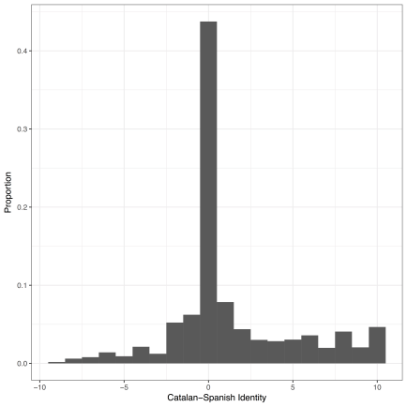
Figure 1: Relative Identification with Catalonia and Spain
Survey Experiment: Does Opposition from the PP Increase Support for the Catalan Government’s Plans?
An experiment was added to the MEDW survey to see how Catalans respond to PP opposition to the Catalan government’s actions. Half of the 543 respondents were randomly assigned to a control group that read a statement that the “Catalan Government has decided to take steps towards the independence of Catalonia without an agreement with the Spanish Government”. The other half were assigned to a treatment group that read the same statement followed by “the Partido Popular (PP) opposes this decision”.

Respondents in both groups were asked whether they support or oppose the Catalan government’s actions. I focus on the half of Catalans with the most ambivalent identities, who, as argued above, are the most susceptible to being influenced by the PP’s opposition.

Figure 2 shows the responses among these participants. In the control group, 60.0% oppose the plan, while 27.09% support it. In the treatment group, opposition drops to 53.8% and support rises to 33.8%.

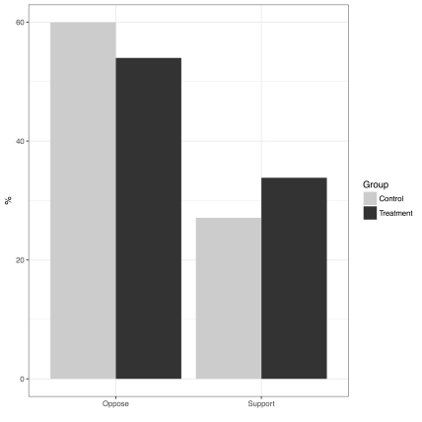
Figure 2: Effect of PP Opposition on Support for Unilateral Steps Towards Independence (Ambivalent Identifiers)
To test for significance, I created a numeric version of the support variable (coded from 1 to 4, where higher numbers indicate greater support for unilateral independence). The difference between the two groups is 0.32 (p<0.05). Thus, ambivalent respondents who read about the PP’s opposition to unilateral independence were significantly more supportive of the Catalan government’s plan than those who did not read about that opposition.
Given that a simple statement that the PP opposes the secessionists’ plan influences support for it, it is likely that the powerful assertion of the PP’s opposition we saw this week will have a much stronger effect.
For the article referenced above, see
Guntermann, Eric (2017). “Party influence where predispositions are strong and party identification is weak: Assessing citizens’ reactions to party cues on regional nationalism in Spain ” Party Politics, http://ericguntermann.com/docs/partycues.pdf
Was my decision to vote (or abstain) the right one?
By ERIC GUNTERMANN | Published: SEPTEMBER 8, 2017
By André Blais, Fernando Feitosa and Semra Sevi, Université de Montréal

How do individuals, after the election, evaluate their decision to vote or abstain? This is the question our study examines in our recent publication in Party Politics.

Respondents were asked, right after the election, how satisfied they are with their decision to vote (or not to vote)” We hypothesize that satisfaction (or lack of it) is driven primarily by voters’ motivation to vote. The study includes interest in politics, a sense of civic duty, and party attachment as motivating factors for voting, and it also examines how the cost of voting and socio-demographic factors affect voters’ satisfaction with their decision to vote or to abstain. Finally, the study examines whether priming voters about the result of the election affects their satisfaction with their decision.

We use an original dataset that is part of the Making Electoral Democracy Work Project, led by André Blais. We analyze a total of 22 surveys conducted in 5 different countries (Canada, France, Germany, Spain and Switzerland) in national, supra-national and sub-national elections held between 2011 and 2015. The surveys ask respondents, after the election, to indicate whether they think that their decision to vote (or abstain) was a very good decision, a fairly good decision, a fairly bad decision, or a very bad decision. Half of the respondents are primed to consider the results of the election (“Given the outcome…”) before indicating their level of satisfaction.
Our study tests the four following hypotheses:

- The stronger the motivation to vote, the more satisfied (dissatisfied) one is with her decision to vote (abstain).
- The higher the cost of voting, the less (more) satisfied one is with her decision to vote (abstain).
- Men, older and better educated citizens are more satisfied with their decision to vote or abstain.
- Priming ‘given the outcome’ decreases (increases) satisfaction among voters (abstainers).

We find that an overwhelming majority of those who voted in an election feel, ex post, that they made the right decision, while non-voters are less certain about the correctness of their choice to abstain. Table 1 shows the total distribution of responses to our satisfaction questions. Of those who voted, 71 per cent indicated that they made a very good decision and another 26 per cent said that it was a fairly good decision. An overwhelming majority of voters thus felt very positive about their decision to vote. Things were different among abstainers. Only 26 per cent of abstainers qualified their choice as a very good one, while as many as 40 per cent acknowledged that it was a very or fairly bad decision not to vote. Abstainers are thus much more critical of their choice than voters.

Table 1: Distribution of responses (in %) to satisfaction with decision to vote/abstain
 | Decision  to vote  (%) | Decision  to abstain  (%)
Very bad decision | 1 | 15
Fairly bad decision | 2 | 25
Fairly good decision | 26 | 34
Very good decision | 71 | 26
N | 17,561 | 1,891
We also show that each motivating factor (interest in politics, sense of duty, party attachment) has an impact on voter (non-voter) satisfaction with their decision to vote (abstain), confirming H1. The findings present only partial support for H2, and suggest that motivational factors trump cost considerations in voters’ judgments. The data agree fully with the predictions of H3 for age, but only partially for gender and education. Finally, the prime has a substantial marginal impact, decreasing the likelihood of saying that the decision to vote was a very good decision by 10 percentage points. Interestingly, the prime does not have any impact among those who had abstained.

Our study shows that citizens’ views about the correctness of their decision to vote or abstain depend first and foremost on the strength of their motivation to vote. Those who are highly interested in politics, who believe that they have a moral obligation to vote, and who feel close to a party have no doubt that their decision to vote was the right one while the verdict is much less positive when they failed to vote.

For more details, see Blais, A., Feitosa, F., and Sevi, S. (2017). “Was my decision to vote (or abstain) the right one?” Party Politics, http://journals.sagepub.com/doi/pdf/10.1177/1354068817722058

MEDW-APSA Mini-Conference on Political Behavior This Friday (September 1st) in San Francisco!
By FILIP KOSTELKA | Published: AUGUST 30, 2017
By André Blais (University of Montreal) and Filip Kostelka (University of Montreal; Sciences Po, Paris)

Political scientists from all over the world will present their research this Friday at a mini-conference on political behavior organized by the Making Electoral Democracy Work project in San Francisco. The mini-conference is incorporated in the American Political Science Association (APSA) meeting and takes place at the Westin St. Francis Hotel (California East room) from 8 AM to 5:30 PM. All participants in the APSA meeting are warmly encouraged to attend the mini-conference. The programme is as follows:
8:00am-9:30am Panel 1: Participation and Partisanship,

Panel Chair: André Blais (University of Montreal)
Panel Discussant: Indridi H. Indridason (UC Riverside)
Papers:
- Elections Activate Partisanship Across Countries
Shane P. Singh (University of Georgia), Judd Thornton (Georgia State University)
- Does Too Much Democracy Kills Participation? Election Frequency and Voter Turnout in Canada and Germany
Filip Kostelka (University of Montreal and Sciences Po, Paris), Alexander Wüttke (University of Manheim)
- The Correlates of Duty: Universal or Context Specific?
Laura Stephenson (University of Western Ontario)
- Looking in a Carnival Mirror: Ideology and Protest Participation in Old and New Democracies
Filip Kostelka (University of Montreal and Sciences Po, Paris), Jan Rovny (Sciences Po, Paris and University of Gothenburg)

09:30am-09:45am Break

09:45am-11:15am Panel 2: French Elections
Panel Chair: Martial Foucault (Sciences Po, Paris)
Panel Discussant: Sylvain Brouard (Sciences Po, Paris)

Papers:
- Aging, habit and turnout. New evidence from 12 voting rounds in France
Jean-Yves Dormagen (Université de Montpellier)
- From votes to seats. The 2017 French legislative elections
Annie Laurent (Université de Lille), Bernard Dolez (Université Paris 1)
- Performance voting and the selection of alternatives.
Nicolas Sauger (Sciences Po, Paris)
- The Wealth Effect on the 2017 French Presidential Outcomes
Martial Foucault (Sciences Po, Paris)

11:15am-11:30am Break
11:30am-1:00pm Panel 3: Public Opinion and Satisfaction with Democracy
Panel Chair: Laura Stephenson (University of Western Ontario)
Panel Discussant: Damien Bol (King’s College London)

Papers:
- Does Ideological Congruence Matter? Assessing Its Impact on Satisfaction with Democracy
Eric Guntermann (University of Gothenburg)
- Revisiting the notion of electoral winner
Jean-François Daoust (University of Montreal)
- Conventional wisdom or paradigm shift? Getting at the root causes of temporal variability in public opinion towards immigration
Steven Vanhauwaert (Centro de Investigación y Docencia Económicas), Patrick English (University of Manchester)

1:00pm-2:15pm Lunch Break

14:15pm-3:45pm Panel 4: How do voters decide?

Panel Chair: Filip Kostelka (University of Montreal and Sciences Po, Paris)
Panel Discussant: Ruth Dassonneville (University of Montreal)

Papers:
- How government alternation shapes voter incentives to engage in compensational voting
Carolina Plescia (University of Vienna) and Francesco Zucchini (University of Milan)
- What Are the Causes of Voters’ Indecision? A Study of Late Deciders in Western Democraties
Simon Willocq (Université Libre de Bruxelles)
- Electoral Accountability in France
Martial Foucault (Sciences Po, Paris), Romain Lachat (Sciences Po, Paris), Guy Whitten (Texas A&M University)

3:45pm-4:00pm Break

4:00pm-5:30pm Panel 5: Study of Elections, Parties and Electoral Rules

Panel Chair: Jan Rovny (Sciences Po, Paris and University of Gothenburg)
Panel Discussant: Shane P. Singh (University of Georgia)

Papers:
- Voting and satisfaction with democracy under proportional representation: Does ballot structure matter?
Damien Bol (King’s College London), André Blais (Université of Motnreal), Lidia Nunez (Université libre de Bruxelles), Jean-Benoit Pilet (Université libre de Bruxelles)
- Negative Campaigning in Multi-Party Contests
Charles Crabtree (Pennsylvania State University), Matt Golder (Pennsylvania State University), Thomas Gschwend (University of Manheim) & Indridi H. Indridason (UC Riverside).
3. The Effects of Survey Mode and Sampling in Belgian Election Studies: A Comparison of a National Probability Face-to-Face Survey and a Non-Probability Internet Survey
Ruth Dassonneville (Université de Montréal), Kris Deschouwer (Vrije Universiteit Brussel) and Marc Hooghe (University of Leuven).

If you have questions about the mini-conference, do not hesitate to contact Filip Kostelka (filip.kostelka@umontreal).

MEDW Survey Data Now Available in Open Access!
By FILIP KOSTELKA | Published: AUGUST 28, 2017
By André Blais (University of Montreal), Laura B. Stephenson (University of Western Ontario), Damien Bol (King’s College London), and Filip Kostelka (University of Montreal) on behalf of the MEDW Team
The MEDW team is proud to announce that all survey data from the Making Electoral Democracy Work project are now available in open access in the Harvard Dataverse. In total, this represents 32 studies from national, subnational and supranational elections, which were conducted in seven established democracies between 2010 and 2016 (see the list below). The core data module is an aggregated dataset that combines information from 27 surveys fielded in 11 regions from five countries (Canada, France, Germany, Spain, and Switzerland) and that spans over 40 000 respondents. The project dataverse also includes 5 “special datasets” (additional studies conducted in Belgium, France, Germany, Spain and Sweden) that are not incorporated in the aggregated dataset but contain a large number of questions asked in the regular MEDW surveys.

The data are characterized by several unique features that may be of interest to political scientists and students of political behavior, mass political attitudes, and multi-level governance. They notably provide the same kind of information for different levels of government, which allows for cross-level comparison and the study of cross-level interactions. The topics covered by the surveys include satisfaction with democratic and government performance, political efficacy, election importance, perceptions of the voting act, attachment to different levels of government, perceived corruption, value orientations on economic and social issues, closeness to political parties, exposure to campaign information and mobilization efforts, electoral and non-electoral political participation, pre-election voting intentions, and reported vote choice (see the aggregated dataset codebook). Almost all of the studies are two-wave panels, in which a pre-election questionnaire was administered approximately one week before the election and a post-election questionnaire was launched in the period immediately after the election. While most attitudes were measured in the first wave, electoral participation, vote choice and non-electoral political participation were measured in the second wave. This allows for greater confidence in the direction of causality (i.e., from attitudes to behavior). Last but not least, the questionnaires feature several experimental questions where half of the respondents were asked a different wording of the same question or the same questions in a different order.

The MEDW project dataverse contains the Aggregated Dataset folder and 6 (sub) dataverses with election-specific datasets: “MEDW Canada”, “MEDW France”, “MEDW Germany”, “MEDW Spain”, “MEDW Switzerland” and “MEDW Special Datasets”. All datasets are in Stata (13) format and are supplemented with codebooks, questionnaires (in the original language and / or in English), and technical reports.
For more information, access the project dataverse and do not hesitate to contact André Blais (andre.blais@umontreal.ca).

We thank all members of the MEDW team who contributed to the project and to the production of the data. They include Christopher H. Achen, John Aldrich, Christopher Anderson, Vincent Arel-Bundock, David Austen-Smith, Laurie Beaudonnet, Stefanie Beyens, Marian Bohl, Maxime Coulombe, Charles Crabtree, William Cross, Fred Cutler, Jean-François Daoust, Ruth Dassonneville, Kris Deschouwer, Delia Dumitrescu, Jim Engle-Warnick, David Farrell, Fernando Feitosa, Benjamin Ferland, Martial Foucault, Carol Galais, François Gélineau, Elisabeth Gidengil, Matt Golder, Sona Golder, Thomas Gschwend, Marc Guinjoan, Eric Guntermann, Phillip Harfst, Maxime Héroux-Legault, Rafael Hortala-Vallve, Indridi Indridason, Ekrem Karakoc, Anja Kilibarda, Hanspeter Kriesi, Simon Labbé St-Vincent Simon, Romain Lachat, Ignacio Lago Peñas, Jean-François Laslier, Jean-Michel Lavoie, Andrea Lawlor, Louis Massicotte, Mike Medeiros, Claude Montmarquette, Alexander Morin-Chassé, Ben Nyblade, Scott Pruysers, Paul Quirk, Victoria Savalei, Semra Sevi, Shane Singh, Karine van der Straeten, Katherine Sullivan, Charles Tessier, Tom Verthé, and Steffen Zittlau.

The 32 MEDW studies were transformed into 23 datasets that are archived in the project dataverse.

This is their exhaustive list:

“Making Electoral Democracy Work” [aggregated dataset]
In the (sub)dataverse “MEDW Canada”:
“MEDW 2011 Ontario Provincial Election Study”
“MEDW 2012 Quebec Provincial Election Study”
“MEDW 2015 Canadian Federal Election Study”

In the (sub)dataverse “MEDW France”:
“MEDW 2012 French Legislative Election Study”
“MEDW 2014 French Municipal Election Study”
“MEDW 2014 French European Election Study”

In the (sub)dataverse “MEDW Germany”:
“MEDW 2013 Lower Saxony State Election Study”
“MEDW 2013 Lower Saxony Federal Election Study”
“MEDW 2014 Lower Saxony European Election Study”
“MEDW 2013-2014 Bavaria Panel Study”

In the (sub)dataverse “MEDW Spain”:
“MEDW 2011 Spanish National Election Study”
“MEDW 2012 Catalan Regional Election Study”a
“MEDW 2014 Spanish European Election Study”
“MEDW 2015 Madrid Regional Election Study”

In the (sub)dataverse “MEDW Switzerland”:
“MEDW 2011 Zurich Cantonal Election Study”
“MEDW 2011 Swiss Federal Election Study”
“MEDW 2011 Lucerne Cantonal Election Study”

In the (sub)dataverse “MEDW Special Datasets”:
“MEDW 2010 North Rhine-Westphalia State Election Study”
“MEDW 2010 Swedish National Election Study”
“MEDW 2012 French Presidential Election Study”
“MEDW 2014 Belgian National Election Study”
“MEDW 2016 Spanish National Election Study”

Duty to vote and political support in Asia
By FILIP KOSTELKA | Published: AUGUST 1, 2017
By Carol Galais, Universitat Oberta de Catalunya & André Blais, Université de Montréal
What is the story
Although sense of civic duty is a well-known predictor of voting behavior, we do not know much about its foundations. Hence the question: what are the psychological orientations that predispose citizens to believe that they do (or do not) have a duty to vote?
The moral and communitarian nature of the duty to vote have led several authors to establish links between this belief and attitudes towards democracy and one’s country. We posit that the belief that voting is a duty will be stronger among supporters of democracy and/or of their political community. We also posit that two contextual factors, degree of democracy and ethnic fractionalization, moderate the effect of political support on duty.
We test these expectations by means of two Asian Barometer Surveys conducted in 2004 and 2005, gathering 21 Asian countries, which provide a sufficiently diverse sample in terms of both democracy and heterogeneity.
Results
Figure 1 shows the mean value of duty in each of the 21 countries. These values range from .99 (Bangladesh) to .67 (Turkmenistan). South Asian countries score higher, while East Asian countries (Japan, Korea and Mongolia) come second in line. Southeast and Central (former Soviet Socialist Republics) Asian countries tend to score lower.
Figure 1: Average duty to vote per country.
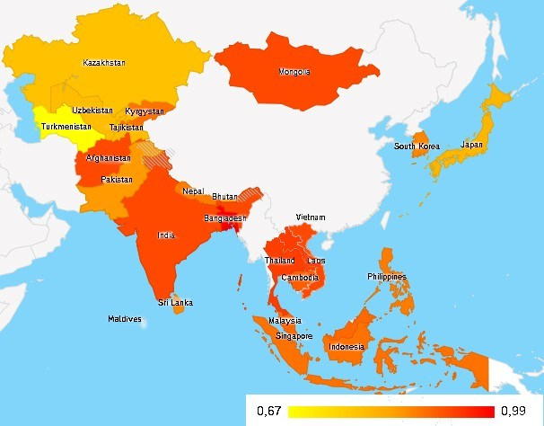
The estimations presented in Table 1 confirm the relationship between both aspects of political support and the duty to vote; support for one’s political community matters more than support for democracy. Finally, cross-level interactions are significant: the impact of support for democracy on duty is stronger in more democratic countries, and the effect of support for political community is more pronounced in ethnically fractionalized countries.
Table 1: Multilevel estimations of the duty to vote.
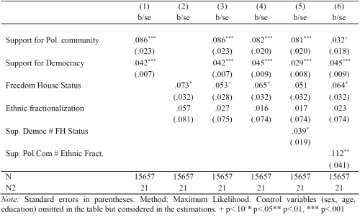
Conclusion
The belief that one has a moral obligation to vote stems more from attachment to one’s country than from the belief that democracy is a good thing.
The interaction between support for democracy and duty suggests that, under dictatorship, democracy supporters are more focused on basic rights than on their own duties. It is also possible that citizens develop beliefs about their duties as citizens only once the political system guarantees them political rights.
As for the interaction between fractionalization and duty, this suggests that societies that have overcome their divides can turn diversity into strength, building more encompassing national identities which bolster the civic duty to vote. Those who are proud of their diverse country adhere to the symbols, rules and institutions that keep the country together.
For more details, see: Galais, C., & Blais, A. (2016). “Duty to Vote and Political Support in Asia. International.” Journal of Public Opinion Research, doi.org/10.1093/ijpor/edw019.

What do voters do when they like a local candidate from another party?
By FILIP KOSTELKA | Published: JULY 26, 2017
By André Blais, University of Montreal & Jean-François Daoust, University of Montreal
What is the story?
In politics, what happens at the district level is still understudied compared to the national level. Paying attention to MPs and constituency politics seems to be in conflict with the traditional understanding of political representation. We focus on the local level and we address two questions:

- How many voters particularly like a candidate from another party?
- Do these voters vote for their preferred party or their preferred candidate?

We use the Making Electoral Democracy Work data from the 2015 Canadian federal election.
Results
Forty-eight per cent of the respondents expressed a preference for a local candidate. As could be expected, most of them (81%) mentioned the candidate associated with their preferred party. We thus have about 52 per cent with no preference for a local candidate, 39 per cent with a preference for the candidate of their preferred party, and 9 per cent who particularly like a candidate from a non-preferred party. Table 1 displays the descriptive statistics, where we first indicate the proportion of voters with no local candidate preference, then those with a local candidate preference which is congruent with the preferred party and finally those with a local candidate preference which is not congruent with the preferred party. This latter category is the one of interest.
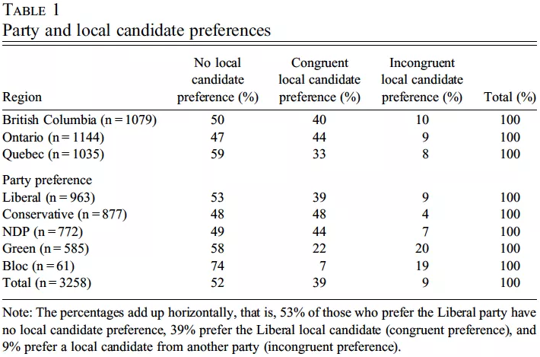
Table 1 Party and Local Candidate Perference
We focus on the group that interests us the most, that is, those who like a candidate from a non-preferred party. Our (very simple) question is: Do they vote for their preferred party or their preferred candidate?
We find that 60 per cent of those with conflicting preferences voted for the preferred party and 40 per cent for the preferred candidate. Table 2 displays the results.

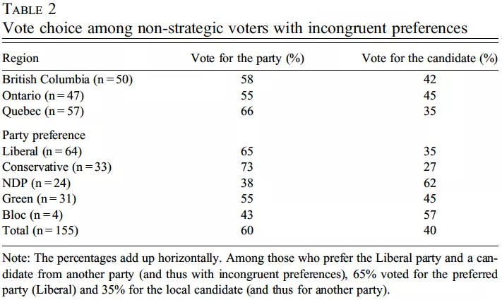
Table 2 Vote choice among Non-Strategic Voters with Incongruent Preferences

In general, those who prefer stronger parties (the Liberals and the Conservatives) tend to vote to a greater extent for their preferred party and those who prefer weaker parties tend to vote for their preferred local candidate. Quebeckers are somewhat more likely to stick with their preferred party. In short, in the three provinces, around one voter out of ten particularly liked a candidate from a party other than the one he or she preferred in the 2015 Canadian election. For two out of five of such voters, the preference for the local candidate trumped the party preference. Sticking with the local candidate is more frequent among those who prefer smaller parties, like the Bloc and the NDP.

For more details, see Blais, André and Jean-François Daoust. What do voters do when they like a local candidate from another party? Canadian Journal of Political Science. DOI: https://doi.org/10.1017/S0008423917000609

Les législatives françaises de 2017 : Pourquoi la participation était-elle si faible et comment peut-on y remédier?
By FILIP KOSTELKA | Published: JUNE 15, 2017
Par Filip Kostelka (cordinateur du projet Making Electoral Democracy Work)

Note: Version en anglais se trouve ici. / English version is here.

Ce texte est une tribune publiée sur le site du journal Le Monde.

Le fort taux d’abstention constitue le résultat le plus frappant du premier tour des élections législatives de dimanche dernier. La participation de 48,7 %, en déclin de 8,8 points par rapport à 2012, est la plus faible dans l’histoire des scrutins législatifs depuis 1945. L’une des causes principales est sans doute la mutation du système partisan: l’effondrement des partis du centre gauche et du centre droit, la décrédibilisation du l’extrême droite lors du dernier débat présidentiel, ainsi que le profil centriste et peu mobilisateur du vainqueur présumé de LREM.

Néanmoins, un autre facteur explicatif important est la fréquence record des élections. Le vote du dimanche a été le troisième en 2017 après les deux tours des élections présidentielles. Plus généralement, pendant les trois dernières années, certains des électeurs français ont pu voter – en fonction de la compétition partisane dans leurs circonscriptions – à 9 occasions : aux élections municipales de 2014 (deux tours), aux élections européennes de 2014 (un tour), aux élections départementales de 2015 (deux tours), aux élections régionales de 2015 (deux tours), et aux élections présidentielles de 2017 (deux tours). De surcroît, les Français ont également pu participer aux deux tours de chacune des élections primaires tenues avant les présidentielles par les Républicains, EELV et le Parti socialiste, entre novembre 2016 et janvier 2017.

Cette multiplication des scrutins est sans précédent dans l’histoire électorale française. Encore dans les années 1970, les citoyens étaient incomparablement moins sollicités. A titre d’exemple, pendant les trois années qui ont précédé l’élection législative de 1978, les Français sont allés voter au maximum quatre fois. Une moitié des électeurs a pu participer aux élections cantonales de 1976 (deux tours) et l’ensemble de l’électorat a été invité à renouveler les conseils municipaux en 1977 (deux tours).

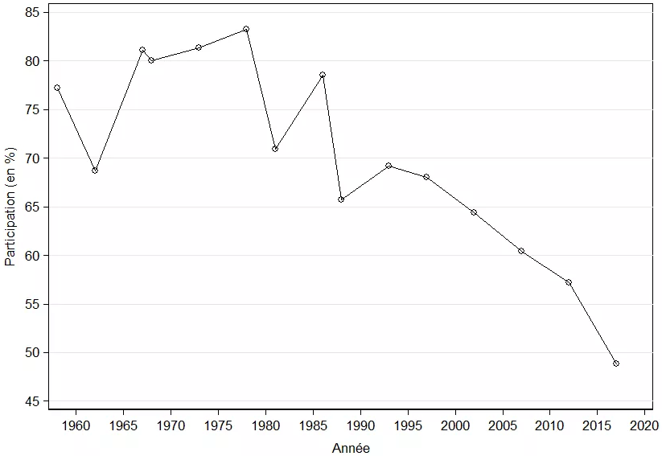
Graphique 1 : Les taux de participation au premier tour des élections législatives depuis 1958
En effet, la fréquence des élections s’est considérablement accrue depuis les années 1970. Cet accroissement provient d’une série de réformes institutionnelles : l’adoption des élections directes au Parlement européen (1979), la décentralisation et l’introduction des élections régionales (1986), et l’instauration du quinquennat présidentiel (2002). De plus, les réformes territoriales de 2010 et 2013 ont temporairement réduit la durée du mandat des élus régionaux et cantonaux de 6 à 5 et 4 ans respectivement. Enfin, il y a les primaires organisées de façon ouverte par le PS et l’EELV depuis 2012 et par les Républicains depuis 2017. Cette forte hausse de la fréquence électorale s’est accompagnée d’un déclin progressif de la participation électorale aux scrutins législatifs. Ayant commencé au début des années 1980, ce déclin a atteint un record dimanche (voir le Graphique 1).
Les études en science politique suggèrent qu’une fréquence élevée des élections réduit la participation en affectant à la fois les attitudes des citoyens et les capacités de mobilisation des partis politiques. Dans mes recherches, j’ai confirmé cet effet négatif de la fréquence des élections sur la participation électorale dans deux contextes différents : les démocraties postcommunistes en Europe centrale et orientale et deux démocraties fédérales en Europe occidentale (le Canada et l’Allemagne). Plus d’élections équivaut à moins de participation dans chacune de ces élections, et, en particulier, dans les élections de moindre importance.
Pour réduire l’abstention électorale, la France devrait s’inspirer de pays qui connaissent des taux de participation plus élevés. Le meilleur exemple en est la Suède, qui est l’une des rares des démocraties occidentales où la participation électorale n’a pas diminué pendant au cours des derniers vingt années. Les suédois ne votent habituellement que deux fois tous les quatre ans car toutes les élections, sauf celles au Parlement européen, se tiennent simultanément. Il est vrai que la tenue simultanée des élections de différents types comporte le risque d’une « contamination ».
Par ce terme, les politistes désignent l’impact des enjeux politiques dans une arène électorale (par ex. législative) sur les résultats électoraux dans une autre arène (par ex. régionale). Cependant, la participation électorale en dessous des 50 % aux élections législatives est vraisemblablement bien pire que tout risque potentiel de contamination.
En combinant différents types d’élections, il est possible d’obtenir un nombre optimal d’échéances électorales qui maximise la participation sans exacerber les risques de contamination. Dans le contexte français, il serait logique de tenir simultanément les présidentielles et législatives d’un côté, et les différents scrutins locaux (élections régionales, départementales, et municipales) de l’autre. Cela ne ferait pas augmenter la participation seulement grâce à une fréquence des élections plus raisonnable mais aussi parce que les scrutins jugés moins importants (par ex. les législatives) bénéficieraient du caractère mobilisateur des scrutins jugés plus importants (par ex. les présidentielles).

Filip Kostelka a soutenu à Sciences Po, Paris une thèse intitulée «Mobiliser et démobiliser: le déclin énigmatique de la participation électorale dans les démocraties postcommunistes». Il est actuellement chercheur postdoctoral à la Chaire de recherche en études électorale de l’Université de Montréal et chercheur associé au Centre d’études européennes, Sciences Po, Paris.

The 2017 French Legislative Election: Why Was Voter Turnout So Low and What Can Be Done About It?
By FILIP KOSTELKA | Published: JUNE 12, 2017
by Filip Kostelka, University of Montreal and Sciences Po, Paris

Note: French version is here. / Version en français se trouve ici. /

This text was published in French as an op-ed in the journal Le Monde.

The most striking outcome of the first round of the 2017 election to the French National Assembly is that less than half of the registered voters came to the polls. The participation rate of 48.7 %, down by 8.5 percentage points from the last election in 2012, is the lowest in the history of the French legislative contests since 1945. Two factors are likely to have contributed to this particularly weak participation rate. The first and obvious factor is the recent transformation of the French party system: the collapse of the traditional parties on the centre left and centre right; the far right’s loss of credibility in the preceding presidential election; and the centrist profile of the anticipated winner, unlikely to generate strong positive or negative mobilization in the electorate.
Yet, there is another important culprit: high election frequency. Sunday’s election was the third round of voting in 2017 after two rounds of presidential elections. More generally, in the last three years, a French citizen could vote – depending on party competition in his or her electoral district – in up to 9 contests: municipal elections (2014, 2 rounds), European Parliament elections (2014), departmental elections (2015, 2 rounds), regional elections (2015, 2 rounds), and presidential elections (2017, 2 rounds). On top of that, French voters could also participate in two rounds of open presidential primaries organized in the run-up to the 2017 presidential elections by the main centre-right and centre-left parties as well as the Greens. This proliferation of elections is unprecedented in the French electoral history. Just a few decades ago, the number of participatory demands on French citizens was substantially lower. For instance, in the three years preceding the legislative election of 1978, there were at maximum 4 opportunities to vote: departmental elections (1976, 2 rounds but only half of the electorate was eligible to vote) and municipal elections (1977, 2 rounds).
Figure 1: Voter Turnout in the First Round of the French Legislative Elections since 1958
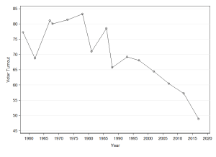
As a matter of fact, election frequency in France has strongly increased since the late 1970s. This is due to a host of institutional reforms: the introduction of direct elections to the European Parliament (1979), decentralization and the introduction of regional elections (1986), and the reduction of the presidential mandate from 7 to 5 years (2002). In addition, before last Sunday’s election, new territorial reforms (of 2010 and 2013) resulted in a temporary reduction of the term of the regional and some departmental representatives from 6 to 5 and 4 years respectively. Finally, mainstream French political parties have newly held open primaries before presidential elections: the centre left since 2012 and the centre right since 2017. This steep rise in election frequency coincides with the decline in voter turnout in the French legislative elections, which started in the early 1980s and reached its peak on Sunday (see Figure 1).
Political science literature shows that high election frequency depresses voter turnout through several channels, affecting both citizens’ attitudes and political parties’ mobilization capacities. In my research, I found support for the negative effect of election frequency on voter turnout in two very different contexts. First, in my PhD dissertationdefended at Sciences Po, Paris in 2015, I demonstrate that election frequency substantively contributes to the strong decline in voter turnout that has been observed in post-communist democracies since the 1990s. Second, in a paper presented at the 2017 Canadian Political Science Association meeting, my co-author Alexander Wüttke (University of Manheim) and I observe a robust relationship between election frequency and voter turnout in Canada and Germany. The more frequent elections are the lower voter turnout in every single election, particularly in less important elections.
As low voter tumour is normatively undesirable, French policy-makers should take lessons from other countries that record (much) higher voting rates. The best example is Sweden, one of the rare Western democracies in which voter turnout even increased since the early 1990s. Swedes typically vote twice every four years as all elections but those to the European parliament are held simultaneously. Of course, the simultaneity of different election types entails the risk of contamination (i.e. the political developments in one electoral arena may affect the results in another arena). Nonetheless, an abstention rate of more than 50 % is perhaps worse than any realistic degree of contamination.
Combining various types of electoral contests could achieve a Pareto-optimum number of elections in terms of high turnout and low contamination effects across different electoral arenas. In the French context, it seems logical to combine presidential and legislative elections on the one hand; and municipal, departmental, and regional elections on the other. This would boost voter turnout not only because of lower election frequency but also because the less important election type (e.g. legislative elections) would benefit from the mobilization effect of the more important type (e.g. presidential elections). Such a measure would probably not solve the issue of the decline in voter turnout altogether but it could largely offset the negative trend.

What is more important: winning or winning in a fair election?
By FILIP KOSTELKA | Published: JUNE 5, 2017
By Jessica Fortin-Rittberger, Philipp Harfst, and Sarah C. Dingler (University of Salzburg)
What is the story?
Perceptions of electoral fairness have an impact on voters’ attitudes and behaviour. Consequently, we believe that electoral malpractice will negatively affect citizens’ satisfaction with democracy. In a recently published article in the Journal of Elections, Public Opinion and Parties we argue that election tinkering shapes citizens’ feelings about democracy.

Hypotheses
The first hypothesis we examine draws on the direct link between electoral fraud and voters’ attitudes towards democracy. We expect that a high amount of fraud reported in elections should be related to low levels of satisfaction with the way democracy works.

Winning an election could change the nature of this relationship and positively affect voters’ attitudes irrespective of the degree of electoral misconduct. Thus, we also hypothesise that voters’ status as winners or losers will mediate the effect of electoral fraud on satisfaction with democracy.
Results
Using survey data from CSES, we explore 48 elections in 29 countries in the timespan between 1998 and 2006. Rather unsurprisingly, we can show that high levels of electoral fraud correspond to a lower degree of satisfaction with democracy (see Figure 1).

Figure 1: Overall magnitude of problems in elections in relation to average satisfaction with democracy.
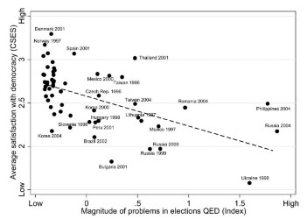
Notes: Data taken from CSES and QED. Figure contains 57 elections. Pearson’s r = −0.55.

However, this relationship is not straightforward. We find that citizens’ attitudes also depend on the outcomes of the election. While citizens who have voted for the winning party are more satisfied, this relationship only holds when elections are free and fair. As soon as elections are fraught with manipulation and malpractice, winning and losing no longer exert different effects on voters’ evaluation of the way democracy works. Election fraud thus affects the perceptions of citizens in the same way, no matter if they are on the winning or losing side.
Conclusions
Our findings have a far-reaching impact: If satisfaction with democracy is anchored on citizens’ evaluation of the performance of governments, the cost of electoral malpractice is high. Fraudulent practices are likely to negatively affect citizens’ evaluations of government and, ultimately, could undermine regime stability, especially in emerging or fragile democracies. We know that broad support for democratic values is an underlying condition for democratic consolidation. Widespread electoral fraud could therefore result in particularly inauspicious climates for the survival of new democracies. Yet our findings offer a glimmer of hope: citizens’ levels of satisfaction in third wave democracies remains higher than in older established democracies in spite of electoral malpractice.
For more details, see Jessica Fortin-Rittberger, Philipp Harfst & Sarah C. Dingler. 2017. “The costs of electoral fraud: establishing the link between electoral integrity, winning an election, and satisfaction with democracy”. Journal of Elections, Public Opinion and Parties, DOI: 10.1080/17457289.2017.1310111.

Voter Turnout and Social Fractionalization
By FILIP KOSTELKA | Published: MAY 8, 2017
By Ignacio Lago (Universitat Pompeu Fabra), Sandra Bermúdez (Universitat Pompeu Fabra), Marc Guinjoan (Universitat Autònoma de Barcelona), and Pablo Simón(Universidad Carlos III de Madrid).
Research question
Social fractionalisation has been omitted in most influential cross-sectional studies on turnout, and when it has been included, evidence is, at best, mixed, The purpose of this article is to revisit the relationship between social fractionalisation and turnout and also to delve into the mechanisms that may explain this link.
Arguments
Previous literature stems from the under-specification of the mechanisms that link social fractionalisation with electoral participation. In particular, to date, the literature has not considered the potential direct and indirect effects of social diversity on turnout, which may eventually explain the lack of consensus both from the theoretical and the empirical point of view. Our argument is that the causal mechanism linking social fractionalisation and turnout may be explained directly by the lesser attachment of the minority group to the community and/or indirectly via the lesser provision of civic duty among the minority
Data
We test our arguments empirically by using Franklin’s models, which account for the level of turnout in lower chamber elections in 22 countries from 1945 to 1999, but we add ethnic, linguistic and religious fragmentation to the specifications. The results indicate that turnout is negatively correlated with ethnic and linguistic fragmentation, but not with religious diversity. Second, as this aggregate association in not enough to pin down the origin of this finding, we then use individual data from electios in Catalonia (Spain) and Quebec (Canada), two multilingual territories, to examine to what extent social fractionalisation affects voting and the sense of duty to vote. By changing the majority ethnic group across regional and national elections, we show that those individuals who are relatively more averse to mixing with others different to themselves have a lower propensity to vote and are less likely to construe voting as a civic duty when they belong to the minority group.
Findings
We found that ethnic and, above all, linguistic heterogeneity are negatively correlated with turnout (see Figure 1). These results open the door for us to delve into the mechanisms that may explain this relationship at the aggregate level. For that purpose, we have conducted an individual analysis to test how civic duty, one of the main motivations that bring individuals to participate in elections, may affect turnout. Relying on individual data from Catalonia and Quebec, we have shown that people are more prone to think that voting is a moral obligation when the preferences of the majority are similar to their own. Thus, in national elections – in contrast to regional ones – individuals who feel only or more Catalan/Quebecer than Spanish/Canadian have a lower propensity to consider the vote as a civic duty than their counterparts (dual-identity individuals and the ones who feel only Spanish/Canadian or more Spanish/Canadian than Catalan/Quebecer). Additionally, while the impact of heterogeneity on voter turnout in Quebec is mainly direct, in Catalonia it is indirect through civic duty (see Figure 2). These mixed results concerning the direct and indirect effect of heterogeneity on turnout suggest that further research should take into account the role played by the specific context in which elections are held.
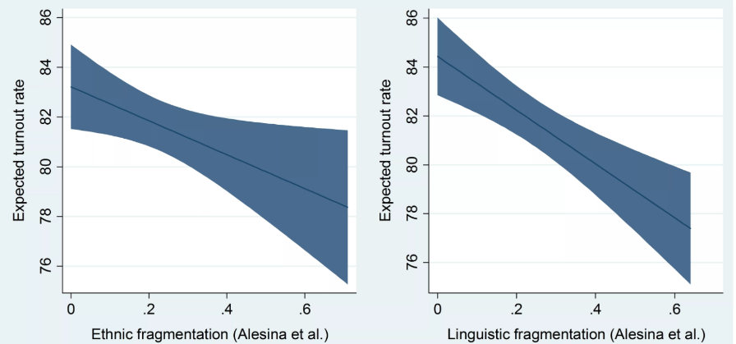
Figure 1: The impact of ethnic and linguistic fractionalisation on turnout
*The upper and lower lines show the 95% interval of confidence

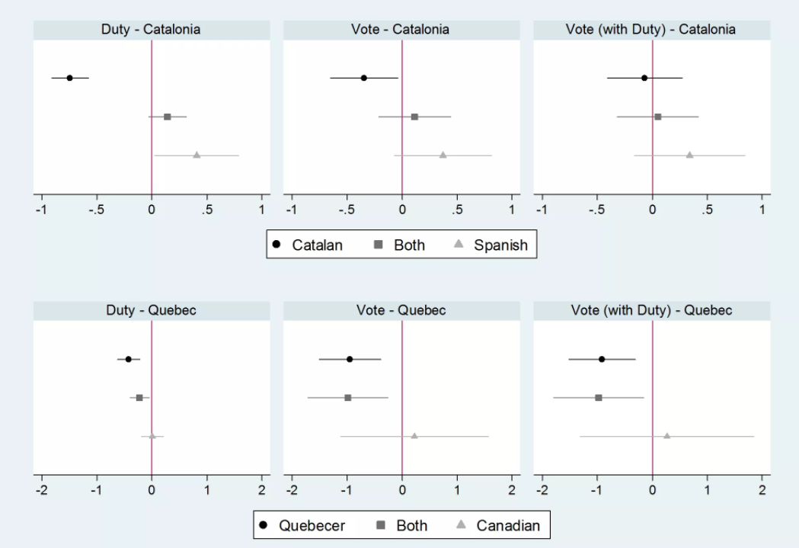
Figure 2: Expected civic duty and voter turnout in Catalonia and Quebec

Implications
The composition of societies makes a difference for civic and turnout. We show that those relatively more averse to mixing with others who are different to themselves have a lower propensity to vote and are less likely to construe voting as a civic duty when they belong to the minority group.
For more information, see Lago, Ignacio, Sandra Bermúdez, Marc Guinjoan, and Pablo Simón. “Turnout and Social Fractionalisation.” Politics, DOI: 10.1177/0263395716686598.

Voting for two different parties in mixed-member systems
By FILIP KOSTELKA | Published: APRIL 24, 2017
By Pedro Riera (University Carlos III, Madrid), and Damien Bol (King’s College London).

What is the story?
In some countries, voters have two votes: (1) a ‘candidate vote’ usually in a single-member district like in the UK, and (2) a ‘party-list vote’ in a multi-member district like in Spain. These are called mixed-member systems.
A remarkable increasing number of democracies around the world have adopted a mixed-member system in the last twenty-five years. They represent a good compromise between majoritarian and proportional representation systems. Emblematic examples include Germany, New Zealand, and Japan.
A substantial portion of voters use these two votes to support different parties. This is typically referred to as a split-ticket. In a recently published paper, we look at this intuitively-odd behavior, and show that even a very subtle difference in the electoral system can have important consequences for vote choice.

Hypothesis
There are two types of mixed-member system. In the first type, called MMP for mixed-member proportional, there is a linkage between the allocation of seats across tiers. The system works in two steps. First, the single-member votes are counted and transformed into seats. Then, some extra seats are allocated to parties, so that the final seat share of each party corresponds to its proportional representation vote share. In other words, proportional representation votes are used to compensate single-member district votes.
In the second type, called MMM for mixed-member majoritarian, there is no linkage between the tiers. Everything works just as if there were two elections organized in parallel: one in single-member districts, and the other under proportional representation.
Our argument is that the type of mixed-system should influence the propensity to cast a split-ticket. In MMP, voters should not care about which party is elected in single-member districts. Regardless of which party is elected, the proportional representation votes will compensate. In other words, single-member district votes have no effect on the final seat share of the parties.
Voters should thus feel to vote for another party than their favorite one in the single-member districts of MMP systems. This vote will not influence the overall success of their favorite party. But this is not the case in MMM systems where both votes count. Thus, split-tickets votes should be more likely in MMP than in MMM.

Results
To test this hypothesis, we gathered survey data across the four available waves of the Comparative Study of Electoral System Project. We also added all the survey data we could find for countries using mixed-member systems. In total, our data is covering 18 mixed-member elections in 7 countries/regions.
In each of these surveys, respondents were asked about their two votes for the latest election.
We consider that they are split-ticket voters if the single-member district vote is different from the proportional representation vote. Table 1 shows the proportion of split-ticket votes in our data. We observe that there are many more split-ticket votes in MMP elections than in MMM elections. The difference is about 15 percentage points.
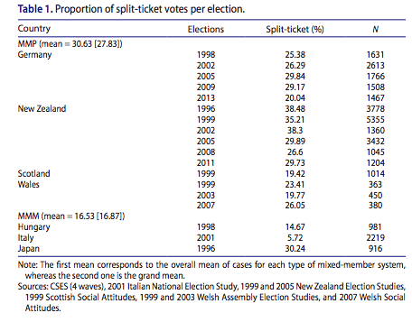
In the paper, we estimate a series of regressions in which we show that this difference is robust to the inclusion of many controls variables (socio-demographics, incentives to cast a strategic vote, democratic background of the country…) and many specifications (including the exclusion of some countries from the dataset).

Conclusion
With our paper, we would like to argue that it is important to study the intricacies of electoral systems to examine their impact on voting behavior and elections. More importantly, it is crucial to consider even the smallest detail of electoral systems. A difference that many might see as anecdotal, such as the existence of seat-linkage in mixed-member systems, can have important consequences for vote choice
For more details, see Pedro Riera and Damien Bol. 2017. >Ticket-splitting in Mixed-member Systems: On the Importance of Seat Linkage Between Electoral Tiers. West European Politics 40(3): 584-597.

Party Mobilization and Electoral Systems
By FILIP KOSTELKA | Published: FEBRUARY 6, 2017
By Ignacio Lago (Universitat Pompeu Fabra) & al.
Research question
Electoral systems scholarship has extensively researched how electoral systems affect voting and parties’ entry decisions. However, we have almost no insight into how electoral systems shape the strategies adopted by political parties in election campaigns. The goal of our study is to explore how district magnitude and the number of districts shape campaign strategies.
Arguments
When there is a single nationwide district, the payoff in seats of any given increment of votes as a consequence of mobilisation efforts is the same everywhere. Accordingly, both large and small parties will invest more heavily in the most populated areas/provinces given that they can win more votes there. When using a districted electoral system, party mobilisation will be driven less by (district-level) population (i.e., district magnitude) as the rate at which a mobilising party gains seats when it gains more votes differs across districts. But this logic only applies to large parties which face incentives to mobilise everywhere. Given that small parties only have good chances of winning a seat in those districts allocating a high number of seats, they will continue investing their resources in the most populated areas.
Second, as parties exert mobilizational effort the higher the probability of that effort being decisive, small national parties will target densely populated areas regardless of the electoral system. On the contrary, large parties’ mobilizational effort will be more driven by population when using a single national district than in a districted electoral system.
Data
The hypotheses are examined through a quantitative analysis of party mobilisation in the 2009 European election and the 2011 Lower House election in Spain. The 50 Spanish European MPs are elected in a single nationwide district, while the 350 members of the Lower House are elected in 52 districts in which magnitude ranges from 1 to 36. The analysis is focused on three national parties, the two largest, the Socialist Party (PSOE), the Popular Party (PP), and a small one, Union, Progress and Democracy (UPyD). The dependent variable is the number of visits to each district made by the candidate that topped the list in the 2009 European election and the candidate that topped the list put out by the district of Madrid in the 2011 Lower House election. We also use qualitative data collected through a series of semi-structured face to face interviews with members of the campaign teams of the three parties.
Findings
We found that varying district magnitudes create different incentives for campaigning. This effect on parties is not universal: smaller parties always target population size or districts with the highest number of seats to be awarded, where their chances of winning are much greater. We find that larger parties alter their strategies depending on the number of districts, mainly by targeting populous provinces in an electoral system with a single national district. When there are multiple districts, large parties will visit more provinces than when there is only one district.

Figure 1. Frequency of visits to each province in the 2009 European election
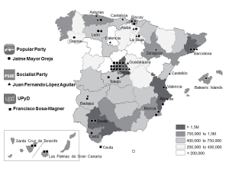
Figure 2. Frequency of visits to each province in the 2011 Lower House election
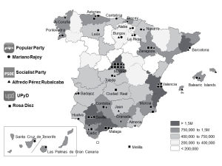
Implications
We show that there is not always a change in party mobilisation strategies when there is a change in the payoff of votes to seats. The effect of district magnitude and the number of districts on party mobilisation strategies depends on the size of the political party.
For more information, see:
Lago, Ignacio, Sandra Bermúdez, Marc Guinjoan, Kelly Rowe, and Pablo Simón. “Party Mobilization and Electoral Systems.” Government and Opposition, January 2017, 1–24. doi:10.1017/gov.2016.46.

Anti-Elite and Anti-Corruption Appeals of European Political Parties
By FILIP KOSTELKA | Published: JANUARY 24, 2017
By The CHES Team
What is the story?
While democratic institutions are currently being subverted by populists both in Hungary and Poland, the 5 Star Movement and the National Front are leading the polls in France and Italy respectively, and the Brits opted for a “hard Brexit” after a clearly anti-elite referendum campaign. These are just a few examples of how anti-establishment sentiments, typically depicting the existing political system as broken, and politicians as corrupt, are gaining prominence across the European continent.
In a recent article published in Research and Politics, we tackle this issue, and study the variation of anti-elite and anti-corruption salience in party positioning in European democracies. We show that whereas the salience of anti-elite appeals varies mostly as a function of party ideology, the salience of political corruption depends mostly on the country’s quality of government. Simultaneously, we introduce the most recent 2014 round of the Chapel Hill Expert Survey (CHES), which is the longest-running expert survey on party positioning in European democracies.
Hypotheses
Although some may intuitively assume that anti-elite and anti-corruption political messages are conceptually closely related, we expect that they function according to divergent logics.
Populist anti-elite stances are likely to be associated with ideological extremism. We differentiate two classical ideological axes: economic left-right, and placement on the socio-cultural (GAL-TAN) dimension, which spans from social liberalism to social conservatism. Left-wing extremists tend to stress economic issues, whereas right-wing extremists tend to emphasize their authoritarian and nationalist appeals. Both extremes, the economic left and the cultural right, should be more inclined to criticize the political establishment (in much the same way as they have opposed European integration).
Hypothesis 1: Parties of either the economic left or the socio-cultural right are more likely to emphasize anti-elite, anti-establishment rhetoric.
As regards anti-corruption appeals, they are less likely to be related to ideology. While populists often denounce the alleged corruption of career politicians, a call to reduce political corruption alone does not make a party populist. Instead, anti-corruption appeals are likely to be driven by the prevalence of corrupt practices. The more they are seen as widespread, the more this issue will be salient to voters and, thus, to parties.
Hypothesis 2: Parties in countries with high levels of political corruption are more likely to stress the importance of reducing political corruption.
Data and Methods
To test our hypotheses, we use the data from the 2014 wave of the Chapel Hill Expert Survey (CHES) available at chesdata.eu. Administered in 2014 to 337 political scientists specializing in political parties and European integration, the 2014 CHES, this data provides information about the positioning of 268 parties on political ideology, European integration, and various policy areas. The survey covers political parties in 31 countries, including all European Union member states, plus Norway, Switzerland and Turkey. In addition, the 2014 survey has been combined with prior waves to produce a trend file with five time points from 1999 to 2014, making the CHES the longest-running, most extensive expert survey on political parties in Europe.
The dependent variables in our research correspond to two newly included questions about the “salience of anti-establishment and anti-elite rhetoric” and the “salience of reducing political corruption” for the political parties of Europe. All experts were asked to provide salience scores for all parties in a given party system on these two questions; responses could range from 0 (not at all important) to 10 (very important).
We employ a multi-level regression analysis of the two variables. The predictors at the party-level are economic (left-right) and social (GAL-TAN) placement of political parties (we add also their quadratic terms to allow for curvilinear relationships), party age and incumbency. At the country-level, we include the quality of democracy using the Group’s International Country Risk Guide (ICRG) from the Quality of Government Dataset.
Results
The results of the multi-level analysis are presented graphically in Figures 1 and 2. In conformity with our hypotheses, anti-elite salience is strongly associated with ideological extremes (the economic left and the socio-cultural right, see Figure 1). In contrast, anti-corruption salience varies as a function of quality of government, but it is practically unrelated to ideology (see Figure 2). In addition, both anti-elite and anti-corruption salience tend to be higher among more recent parties and parties outside the government (results not shown in Figures 1 and 2).
Figure 1 Predicted anti-elite salience
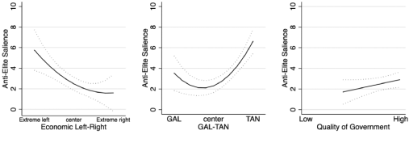
Figure 2 Predicted anti-corruption salience
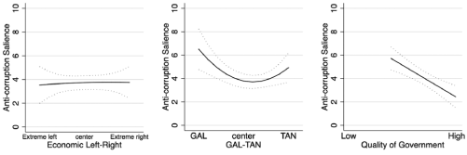

Implications
This research provides a meaningful contribution to a better understanding of party competition in Europe. It unveils a contrasting logic in the functioning of two types of similar party appeals. While anti-elite salience primarily depends on parties’ ideology, anti-corruption salience reflects the environment in which parties operate.
More generally, the anti-elite and anti-corruption questions, newly included in 2014, supplement core items in the CHES that have now been collected over five time points, making the dataset an increasingly useful source of information for dynamic analysis of party positioning across Europe.
For more information, see:
Polk, Jonathan, Jan Rovny, Ryan Bakker, Erica Edwards, Liesbet Hooghe, Seth Jolly, Jelle Koedam, Filip Kostelka, Gary Marks, Gijs Schumacher, Marco Steenbergen, Milada Vachudova and Marko Zilovic (2017). Explaining the salience of anti-elitism and reducing political corruption for political parties in Europe with the 2014 Chapel Hill Expert Survey data. Research & Politics 4 (1): 1-9. doi: 10.1177/2053168016686915. Available also here as an open-access PDF .

« Negative » personalization: party leaders and party strategy
By KATHERINE SULLIVAN | Published: DECEMBER 19, 2016
By Scott Pruysers, University of Calgary
William Cross, Carleton University

The Story
Political parties are increasingly going negative in their campaign advertising and electoral messaging. At the same time, party leaders and candidates are becoming increasingly relevant to considerations of vote choice and to the electoral success of political parties. There is an increasing trend in recent decades towards more candidate-centered politics, individualized local campaigns and a personalization of politics more generally. These trends point to changing electoral and political norms in which the centrality of individual actors has increased while emphasis on the political party has declined. In this sense, we are particularly interested in the targets of negative campaigning, especially from the perspective of personalization. Is it opposing political parties or their leaders who are targeted in routine election campaign communication? Our central contribution is an examination of the inter-party dynamics of campaign personalization and the development of a new concept: negative personalization. We define negative personalization as an emphasis on opposing party leaders in campaign communication more so than on the parties that they lead. In adopting this approach we question whether parties play a role in personalization by negatively personalizing their opponents. In particular, we hypothesize that negative campaign personalization is a common feature of election campaigns and that this negativity is targeted at unpopular leaders more so than popular ones.
The Data
Drawing on data from two recent elections (2011 and 2014) in the province of Ontario, Canada’s largest province, we provide a preliminary empirical look at the dynamics of negative personalization in election campaign material. We do so by examining 53 television advertisements as well as more than 350 party press releases in order to gauge the target of negative party messaging. Additionally, we take a closer look at the campaign dynamics that shaped negative personalization during the 2011 and 2014 Ontario provincial elections.
The Results
First, we provide compelling – albeit preliminary – evidence to demonstrate that negative personalization is a common feature of contemporary election campaigns. Parties routinely attack opposing party leaders in addition to the parties that they lead. In fact, our analysis of the 2011 and 2014 provincial elections in Ontario demonstrate that both television advertisements and press releases are significantly more likely to mention an opposing party leader than an opposing party. This is particularly evident in television advertising where more than half of all campaign ads targeted an opposing party leader compared to only 15% that mentioned an opposing party. The predominance of negative personalization in television advertising is consistent with the broader personalization literature, which has noted the ease with which leaders, or opposing leaders in our case, can be pictured on screen and the impact that these images can have on voter perceptions.
Second, we find clear evidence that negative personalization is indeed a calculated decision. Parties make strategic use of their campaign messaging and in this regard attack their opponents where they are the weakest: party leaders who are popular experience the least negative personalization while relatively unpopular leaders experience the most. This helps to explain why the New Democrat leader escaped negative personalization in 2011 and 2014 while the PC leader did not. It also explains why the Liberal leader was subject to more negative personalization in 2011 than his more popular successor in 2014. Furthermore, an examination of the dynamics of negative personalization over the course of the 2014 Ontario election campaign reveals that the Progressive Conservative strategy responded to shifting public opinion and targeted the Liberal leader the most when her approval was lowest.
Conclusion
While the conclusions presented here need to be tested in other cases before they can be generalized beyond this particular analysis, this note does offer the first theoretical and empirical look at the concept of negative personalization as well as provide suggestions for future research.

Call for Papers: Pre-APSA MEDW Workshop, San Francisco, August 30, 2017
By FILIP KOSTELKA | Published: NOVEMBER 28, 2016
André Blais, University of Montreal
Filip Kostelka, University of Montreal

The Event
The Making Electoral Democracy Work (MEDW) project calls for papers to be presented at a workshop held on August 30, just before the 2017 American Political Science Association (APSA) annual meeting in San Francisco. Proposed papers should deal with the core research themes of the project, which examines how the rules of the game (especially the electoral system) and the electoral context influence the dynamic and reciprocal relationship between voters and parties in democracies. Among other topics, we welcome papers on voter turnout, political participation, vote choice, party competition and evaluations of democratic performance. We will consider with interest all submitted proposals but papers using the MEDW data will be given priority.
How to apply
Send an abstract of not more than 5000 characters with a title (no more than 80 characters), your name and institutional affiliation to andre.blais@umontreal.ca (with filip.kostelka@umontreal.ca in copy) by January 5, 2017.
How to access the MEDW data
The MEDW include pre- and post-electoral surveys from 27 elections held at different levels of government in 5 countries (Canada, France, Germany, Spain and Switzerland) and in 10 regions (Ontario, Quebec, le de France, Provence, Bavaria, Lower Saxony, Catalonia, Madrid, Lucerne and Zürich). For more details, see the codebooks and questionnaires available here. The data are available upon request to André Blais (andre.blais@umontreal.ca). Requests should include an abstract for the proposed study.
Contact
For further information on the workshop, do not hesitate to contact Filip Kostelka (filip.kostelka@umontreal.ca). The PDF version of this call for papers is available here.

“Who is the best football player?” Researchers ask football fans
By FILIP KOSTELKA | Published: NOVEMBER 22, 2016
On December 13, France Football will announce the best performing football player of 2016. Researchers from the Making Electoral Democracy Work (MEDW) project and our international collaborators would like to learn about football fans. To this end, we are holding a simultaneous vote using three different voting systems.
Who should be, according to football fans, the best football player of the year? In addition to answering this question, this project will contribute to our knowledge of voting behaviour, and football in general.
Everyone is invited to participate here. The survey is available in six languages (English, French, German, Italian, Portuguese and Spanish). Please share this survey with your friends across the globe and help both your favourite football player and science.
For more information, see: https://votefoot.org/en

Voter Turnout & Emigration: What Affects Transnational Electoral Participation?
By FILIP KOSTELKA | Published: NOVEMBER 7, 2016
Filip Kostelka, Université de Montréal & Sciences Po, Paris
What is the story?
Migration flows to, but also within, developed democracies have kept intensifying since the end of the Cold War. Consequently, relatively large segments of democratic electorates currently live abroad. This raises the question of emigrants’ engagement in their motherlands’ politics.
In a recent article published in the Journal of Ethnic and Migration Studies, I tackle the topic of transnational electoral participation that results from emigration. My objective is to show how transnational voting rates differ from the domestic rates (i.e. the voting rate in the sending country), what specific factors affect emigrants’ turnout, and, more generally, what implications emigration has for nationwide turnout in the sending countries.
Hypotheses
The literature on political behaviour mostly focuses on migrants’ electoral participation in the receiving country (i.e. the effect of immigration). In contrast, migrants’ participation in the elections of the sending country (i.e. the effect of emigration) has so far been, to a large extent, an uncharted territory. Drawing on the literature on domestic residential mobility (i.e. mobility within a single country), I expect that:
- Transnational voting rates are much lower than domestic ones as emigration increases the costs and reduces the benefits of the voting act.
With regards to the factors that affect transitional voting rates, I hypothesize that:
- The less burdensome the procedures for voting abroad, the higher the transnational voting rate.
- The larger the size of the diaspora, the higher the transnational voting rate (but the lower the overall voting rate).

This last hypothesis is motivated by the fact that large diasporas mean large pools of potential votes and a stronger motivation for political parties to go campaigning abroad and mobilize emigrants (see this news report covering a spectacular transnational campaign event held in 2007 for Romanians in Spain). At the same time, large diasporas mean a large number of voters for whom voting is costlier and less beneficial when compared to voters who stayed back home. I expect that transnational voting rates will never reach the level of domestic voting rates and, therefore, although a rise in the number of emigrants will lead to higher transnational voting rates, it will however also further reduce the overall (i.e. nationwide) voter turnout.

The empirical case: 10 post-communist democracies
To test my hypotheses, I study legislative elections in ten Central and East European democracies (CEE-10) between 1990s and 2012. As Figure 1 shows, the number of CEE-10 citizens living abroad strongly increased especially after 2000. Nevertheless, voter registration was automatic and for life in all ten countries (note that this has recently changed in Bulgaria, see p. 6 in this OSCE report). Therefore, emigrants kept the right to vote and were counted in the overall voter turnout rates as long as they maintained the citizenship.

Figure 1 The Evolution of the Number of Emigrants from the CEE-10
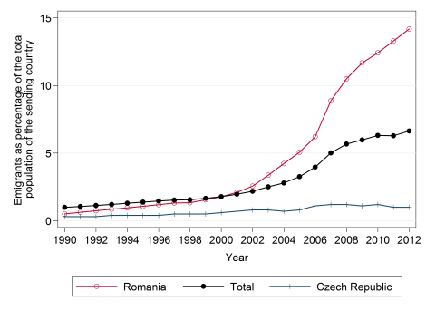
Findings
My empirical analyses corroborate Hypothesis 1. Transnational voting rates, measured as the number of votes case abroad divided by the number of emigrants, are much lower than domestic voter rates. After 2000, they never exceeded 32.1 % (Slovenia’s legislative election of 2008). This means that the growing emigration depresses the nationwide voting rates in the CEE-10. Actually, in those countries, nationwide voter turnout fell dramatically in the first two democratic decades (by 25.1 percentage points, see also this article). According to my estimates, emigration accounts for almost 10 % of this fall (2.1 pp).

Hypotheses 2 and 3 are also validated. In some of the CEE-10, citizens need to (re)register to vote from abroad. According to my models, which control for domestic turnout and other factors, each extra day that separate the registration deadline from the actual election, reduces transnational turnout by 0.1 percentage points. Conversely, diaspora size exerts the expected positive effect. Every increase in the number of voters abroad (as a percentage of the total electorate), boosts transnational voter turnout by 0.7 percentage points.

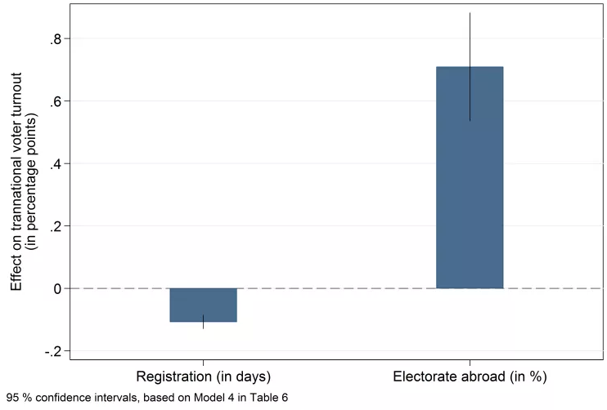
Figure 2 Factors Affecting Transnational Voting Rates (regression coefficients)
Implications
This study demonstrates that emigration is an increasingly salient factor for understanding voter turnout variation over time and across countries. Its findings are not of interest only to researchers who study electoral participation but also to policy-makers in the CEE-10 and elsewhere who are concerned by declining voting rates. Transnational electoral participation by emigrants specifically depends on legal provisions for external voting and diaspora size. The former factor is fully at the reach of legislators.
For more information, see:
Kostelka, Filip (2016). Distant souls: post-communist emigration and voter turnout.Journal of Ethnic and Migration Studies. doi:10.1080/1369183X.2016.1227696

Putting parties and voters into the lab (at the same time!)
By FILIP KOSTELKA | Published: OCTOBER 24, 2016
Damien Bol, King’s College London
André Blais, University of Montreal
Simon Labbé St-Vincent, University of Montreal

What is the story?
Lab experiments are increasingly popular to study elections. In a recent book published at Springer, we present the variety of voting experiments, in the lab and on the field, in showing their respective contributions to research in the domain.
In lab experiments, researchers have the possibility to manipulate the factors that may influence the outcome of an election, such as the electoral system, the distribution of preferences or the party platforms. In doing so, they can to isolate the causes of this outcome and the mechanism behind it.
In a recent paper published in Political Science Research and Methods, we report the results of a one-of-a-kind experiment where we put parties and voters into the lab. We hope this will pave the way for new voting experiments that consider how interactions between multiple actors shape the electoral outcome.

A one-of-a-kind experiment
For each experimental session, we organised 4 series of 5 elections between 17 subjects at experimental lab CIRANO in Montreal. We randomly assigned the 17 subjects to a role: 6 were designated as parties and 11 were designated as voters, and to a position on a scale ranging from 0 to 10 (see Table 1 below, parties are represented in letters, voters are represented Roman numbers). The roles and positions were randomly reshuffled after each series of 5 elections.

Table 1: Positions of voters and parties on the 11-point scale
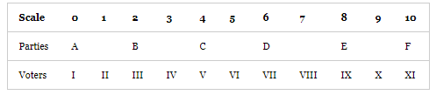
The elections had two stages. First, the parties decided to form an alliance or not with their paired party (the pairs are A/B, C/D and D/E). Then, the voters saw on their screen which parties are participating and had to decide for which party to vote among them.
After the election, the party that received the most votes was declared the winner. If this winning party was not in an alliance with her paired-party, she got 40 points. If there was an alliance the 40 points were divided between the two partners. The distribution of gains between them constitutes an experimental condition. Depending on the series, it is either equal (each party receives 20 points) or unequal (the party that enters the election receives 30 points, while the other receives only 10 points).

Findings
One of the advantages of our experiment compared to observational studies is that we know how many parties could have potentially participated in the elections, that is 6 parties. In reality, researchers can hardly determine how many parties envisioned participating in an election before the campaign. We can thus calculate how much the Effective Number of Parties (ENEP) actually observed in our experimental elections deviates from this theoretical maximum, and the part of reduction that is due to parties forming alliances and to voters voting strategically, that is deserting the party closest to their position if this party has no chance of winning.
Table 2 reports these results. It shows that on average voters reduce 38% of the fragmentation they could theoretically by voting strategically, and parties 60% by forming alliances. Also, we observe that the degree of reduction by parties is larger when the distribution of gains within alliances is equal.
Table 2: Degree of ENEP reduction by voters and parties
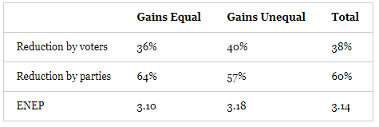
Our conclusion is that the contribution made by party strategic exit is greater than that due to strategic voting. We explain this difference by the nature of the coordination problem and the amount of gains at stake (party coordination is much easier to achieve than voter coordination). Also, in our experiment just as in real elections, parties have much more to gain if they win, and have thus more incentives to behave strategically than voters.

For more information, see:
Damien Bol, André Blais, and Simon Labbé St-Vincent (Forthcoming.) Which Matters Most: Party Strategic Exit or Voter Strategic Voting? A Laboratory Experiment. Political Science Research and Methods

Come for the electoral systems, stay for the debate
By KATHERINE SULLIVAN | Published: SEPTEMBER 14, 2016
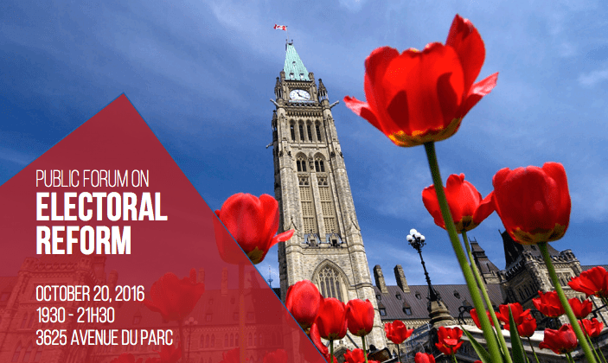
by Katherine V. R. Sullivan, Université de Montréal

There has been ongoing talk of a possible electoral system reform in Canada. But what are the various options and what would be their consequences for voters and parties? In order to offer insights on these questions, the Centre for the Study of Democratic Citizenship and the Research Chair in Electoral Studies at the Université de Montréal will be hosting a public forum on electoral reform on October 20th.
This public forum will begin with a presentation by Professor André Blais on the following four voting systems:
First Past the Post (FPTP)
Alternative Vote (AV)
Mixed-Member Proportional (MMP)
Small District Open List Proportional Representation (SOP)

Four political scientists will then be allowed 12 minutes to argue in favour of each of them. This will be followed by an open debate about the pros and cons of these systems before audience members are invited to ask questions – using a mobile platform called Pigeonhole Live – and then vote for their two preferred options.

The forum will take place on October 20, 2016, from 19h30 to 21h30, at the McGill New Residence Hall (3625 Av du Parc, Montréal) and you can register here http://electrefo.eventbrite.com. The forum will be streamed live by CPAC (https://www.cpac.ca)

I usually vote but I didn’t vote this time
By KATHERINE SULLIVAN | Published: AUGUST 30, 2016
Alexandre Morin-Chassé, Université de Montréal
Damien Bol, King’s College London
The goal of our research project is to improve the quality of post-election survey data on electoral turnout by reducing abstainers’ tendency to lie. Usually, the turnout reported in post-election surveys is much higher than in reality, and this is partly due to abstainers pretending that they have voted. Why do they lie? In every society, there exist social norms that are widely shared by the population. Also, in many countries, voting at elections is the norm and it is common to speak of voting as a duty to fulfil in order to be a good citizen. Because this norm exists and people are aware of it, some abstainers prefer to lie than to report a behaviour that is perceived as socially irresponsible.
Previous research has shown that some people lie even when they complete an online questionnaire, a context where there is no interaction with the interviewer and no risk of being judged. Another psychological mechanism is at play here: the desire to preserve self-esteem. Some of the abstainers share the social norm that voting is a duty. They lie because they prefer to avoid the discomfort they would feel when admitting that they derogate from a norm they endorse.
One way to reduce the abstainers’ tendency to lie is to frame the turnout question in a way that allows these abstainers to claim that they adhere to the norm even if they did not vote. Abstainers who accept the social norm can save face even if they report their true voting behaviour. To test the efficacy of this framing, it is possible to run a survey experiment during which half of respondents are randomly assigned to the classic “yes/no” turnout question, while the other half is presented with a new question. If the new question shows a reported turnout that is closer to the actual turnout, it is presumed that the new version succeeded in reducing lies and thus produces more accurate survey answers. Various studies conducted in the United States have tested which question best succeeds in reducing abstainers’ tendency to lie. Table 1 presents the “classic” and the “face-saving” turnout question wordings.

Table 1. Question wording
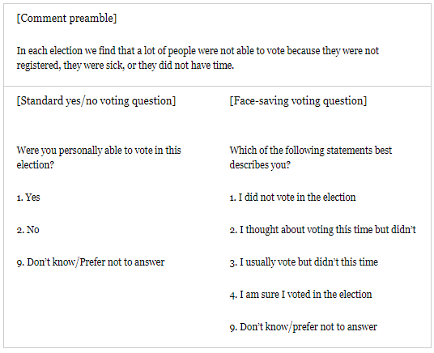
Results from the United States suggest that including face-saving response items in surveys following national elections can reduce reported turnout by a range of 4 to 8 percentage points. However, we do not know whether this new version of the turnout question is also efficient in other countries and whether face-saving response items can also reduce abstainers’ tendency to lie in elections at other levels of government, such as local, regional, or European Elections. Our research aims to fill this gap by analysing 19 surveys experiments in post-election surveys conducted in Canada, France, Spain, Switzerland and Germany for the Making Electoral Democracy Work project.

Figure 1 presents results for each of these 19 survey experiments. The top and the left margins identify the country and the level of the election; the bars represent the difference in percentage points between the turnout measured in the group exposed to the yes/no question and the one measured in the group exposed to the face-saving version.

Figure 1. Treatment effects of the inclusion of face-saving response options on reported turnout
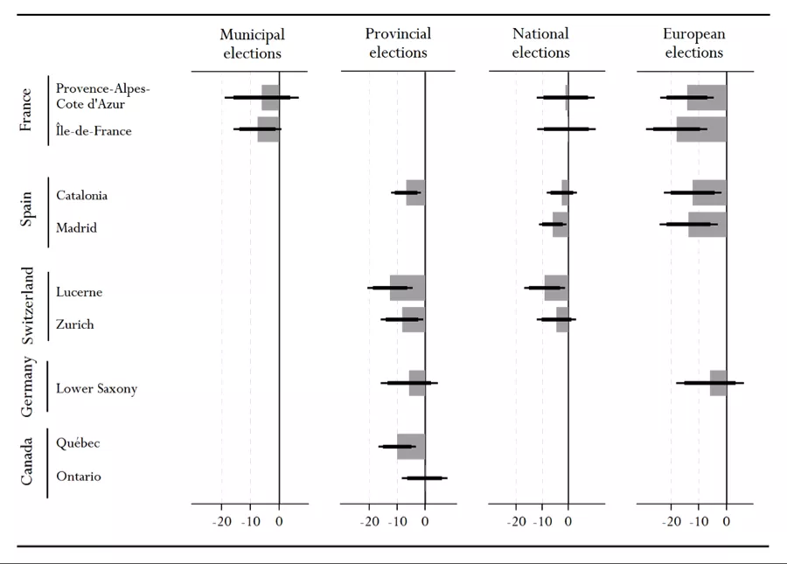
Note: The error spikes represent the 95% and 99% confidence intervals.
In 11 out of 19 surveys, the inclusion of face-saving response items significantly reduced the reported turnout; in 4 other surveys, the effect goes in the expected negative direction, even if it does not reach conventional levels of statistical significance. Finally, in 4 other surveys, the new question produced a turnout level that is virtually identical to the one produced by the traditional yes/no question. When we combine the 19 datasets into a single large one we find that the face-saving question reduces reported turnout by 7.6 percentage points (p<0.001, N=15,185).
Reference: Morin-Chassé, Alexandre, Damien Bol, Laura Stephenson and Simon Labbé St-Vincent. “How to survey about electoral turnout? The efficacy of the face-saving response items in nineteen different contexts.” Political Science Research Methods (accessible online ahead of print). http://dx.doi.org/10.1017/psrm.2016.31

Partisanship, Information, and Perceptions of Government corruption
By KATHERINE SULLIVAN | Published: JULY 19, 2016
André Blais, Université de Montréal
Elisabeth Gidengil, McGill Université
Anja Kilibarda, Columbia University
What’s the story?
Recent research suggests that trust in governments in postindustrial democracies has eroded. In fact, citizens increasingly believe that governments are unresponsive to their needs, and they frequently hold politics and politicians in low esteem. Perceptions of corruption have in turn fed into a democratic malaise. This study analyzes how partisanship and political information influence perceptions of government corruption.
We test four hypotheses:
H1: Partisans of incumbent parties perceive less corruption in government than nonpartisans.
H2: Partisans of opposition parties perceive the same amount of corruption in government as nonpartisans.
H3: The better informed perceive less corruption than the less informed.
H4: The impact of partisanship on perceptions of corruption is weaker among the better informed.

The data
We examine citizens’ perceptions of the degree of corruption in government in 11 elections between 2009 and 2013 by looking at survey data from collected before elections held in Canada, France, Germany, Spain and Switzerland, as part of the Making Electoral Democracy Work project. The respondents were asked to indicate how much corruption they perceived (hardly any, a little, some, a lot) in government. We ascertain the impact of partisanship and political information in diverse settings by looking at a variety of countries and regions within these countries and at elections at different levels (national, subnational, supranational).
The results
Our results confirm the first three hypotheses. Partisans of governing parties systematically perceive less corruption than non-partisans but who identify with opposition parties do not see more corruption than non-partisans. Additionally, the better informed are more prone to challenge the conventional wisdom that there is a lot of corruption in government. We do not find support for the fourth hypothesis, however; the impact of partisanship is not weaker among the better informed.

There is one important exception. In Quebec (and in Quebec only), the better informed perceive more corruption than the poorly informed. This may be related to the fact that the 2012 Quebec election took place amidst allegations of widespread corruption. It is possible that in the context of a new emerging scandal, the well informed are more likely to learn about it and are then more likely to revisit their pre-existing judgments.
Conclusion
Our results clearly show that people view government corruption through a partisan filter when ‘‘their’’ party is in power. However, the workings of the partisan screen have proved to be asymmetrical: There is little evidence that partisans of opposition parties perceive more corruption in government than nonpartisans. Finally, most of the time, the less informed are prone to see more corruption than their better informed counterparts.

For more details, see
André Blais, Elisabeth Gidengil, and Anja Kilibarda. Forthcoming. Partisanship, information and perceptions of government corruption. International Journal of Public Opinion Research (forthcoming)

Will PEI change its electoral system?
By KATHERINE SULLIVAN | Published: JULY 14, 2016
By Katherine V.R. Sullivan, Université de Montréal

What’s the story?
Prince Edward Island is inviting Islanders to take part in an electoral reform plebiscite over a 10-day period between October 29th and November 7th. This extraordinary plebiscite will not only ask citizens to express their preferences about five different electoral systems, it will also allow them to express their preferences, either by traditional paper ballot, by telephone or electronically, using a government issued PIN. Furthermore, all citizens aged 16 or older will be eligible to vote.
The following question will be on the ballot:
“Rank the following electoral system options in your order of preference, 1 through 5 (with 1 being your most preferred and 5 being you least preferred)”.
The 5 options
First-past-the-post
This is the current electoral system, which involves single-member districts. This means that each voter casts a ballot for one candidate. The candidate having received the most votes in each district is elected.
First-past-the-post plus leaders
FPTP+ is similar to the status quo, but with the addition of a seat awarded to a leader whose party obtains a threshold of 10% of the provincial vote.
Preferential voting
This electoral system is used in Australia (lower house) and involves single-member districts. Voters are asked to rank the candidates according to preference. A candidate must then obtain an absolute majority of the votes in order to be elected. If no candidate has a majority, the candidate ranked last is eliminated and that candidate’s votes are redistributed to the other candidates on the basis of voters’ second preference votes. The process continues until a candidate has a majority of the votes and is elected.
Dual Member Proportional
DMP has two-member districts. Each party presents two candidates (primary and secondary) and voters elect a party. The first half of the seats goes to the primary candidate of the party with most votes in each district. After this is done, the number of seats each party “deserves” is computed, the total number corresponding to its share of the vote in the whole province. The number of remaining seats each party should get, which is the total number of seats it “deserves” according to the proportionality rule minus those won in the districts is then calculated. These remaining seats are allocated to the best performing candidates within each party. This should result in candidates from two different parties being elected in most (two member) districts.

Mixed Member Proportional
Finally, MMP is an electoral system used in Germany, New Zealand and Scotland, which gives voters two votes. The first vote is for a candidate in their single-member district and the second is for a party list within the entire province. The candidate with the most votes is elected in each district. After this is done, the number of seats each party “deserves” is computed, that total number corresponding to its share of the vote in the whole province. The number of remaining seats each party should get is then determined, which is the total number of seats it “deserves” according to the proportionality rule minus those won in the districts. These remaining seats are allocated to the candidates that are the top of the party lists. There are thus two types of elected candidates, those who represent specific districts and those who represent the whole province.
Why this matters
PEI’s plebiscite is important as it could lead to a change in the voting system in that province. Furthermore, this could affect the electoral reform debate that has been ongoing at the federal level. Finally, it may also spark a debate over voting age and online voting in Canada.

For more information on PEI’s voting-reform plebiscite, feel free to consult Elections Prince Edward Island’s website.

Correct voting and post-election regret
By KATHERINE SULLIVAN | Published: JULY 7, 2016
By André Blais, Université de Montréal
Anja Kilibarda, Columbia University
What’s the story?
Elections are often seen as a way for citizens to communicate their views. However, much research has shown that many voters are not well informed about the issues of the day. This raises the question whether some people make the wrong choice. That is, whether some may vote in a way that does not best reflect their interests and values and thus regret their decision after the fact.
This possibility has been discussed extensively in the aftermath of the Brexit referendum, as the media reported several instances of “Leave” voters expressing regret over not having chosen to stay instead (Opinium Research, 2016). But is this specific to the Brexit referendum? Or do some people, in every election, come to the conclusion, ex post, that they did not make the right decision? These are the questions that are addressed in this study.
Data
In order to examine the extent to which citizens regret how they voted after Election Day and the factors that lead one individual to be more regretful than another, we rely on data from 11 elections in five different countries. Voters in Canada, France, Switzerland, Germany and Spain were asked ex post whether they thought that the decision they made to vote for a given party was a very good, fairly good, fairly bad, or very bad decision.
Results
First, as shown in Figure 1, we find that the majority of citizens have no regret (that is, they answer that they made a very good decision) when it comes to their vote choice. Indeed, French voters express the least regret, with 69% of respondents believing their choice to have been a very good one, followed by voters in Quebec and Ontario, with 67% and 61% respectively. In most of the European regions surveyed about 50% of citizens express no regret.
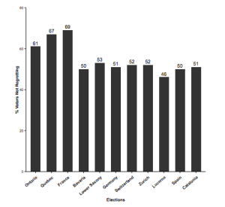
Furthermore, the results suggest that the politically well informed are somewhat less regretful than the relatively poorly-informed. Similarly, those who voted ‘correctly’ tend to be less regretful. Voting correctly means casting a vote that reflects one’s preferences and which is coherent with one’s ideological position. Having voted correctly mitigates regret. Also, the effect of correct voting on regret is greater among the least informed.
Conclusion
This research aimed to assess whether political information and correct voting affect the extent to which citizens regret the choices they made on Election Day. We find that regret is less prevalent among the politically well-informed and those who vote correctly. However, more research needs to be done on what makes voters more or less satisfied with their personal decisions.
For more details, see
André Blais & Anja Kilibarda. Forthcoming. “Correct Voting and Post-Election Regret. “ PS: Political Science & Politics.

A new standard for evaluating the performance of electoral democracy
By KATHERINE SULLIVAN | Published: JUNE 21, 2016
By André Blais, Eric Guntermann & Marc A. Bodet
What is the story?
We propose a simple and original standard for evaluating the performance of electoral democracies: the degree of correspondence between citizens’ party preferences and the party composition of the cabinet.
The criteria
We propose three criteria for assessing the correspondence between citizens’ party preferences and the party composition of governments that are formed after elections:
- The proportion of citizens whose most preferred party is in government
- Whether the party that is most liked overall is in government
- How much more positively governing parties are rated than non-governing parties

The data
We use CSES data that include a party like/dislike question in which respondents are asked to rate each party on a 0-10 scale.
We focus on lower house elections in non-presidential democracies. Our sample includes 87 legislative elections held in 35 countries. We distinguish elections held under PR and under non-PR, and on the basis of disproportionality between vote and seat shares. For each party we compare its ratings in the electorate and the proportion of seats it had in the cabinet that was formed after the election.
Results

Criterion 1: How many citizens have their preferred party in government?
More people have their preferred party in government under PR, and this is due to the fact that PR leads to the presence of more parties in cabinet. As is shown in Graph 1 below, 50% of citizens, on average, get their most liked party in government under PR, compared with 43% in non-PR elections. On this first criterion, PR elections perform better.
Criterion 2: Is the most liked party in government?
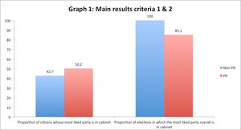
We compute the mean ratings of all the parties in each election to identify the party that is most liked overall and determine whether that party is in government or not. The most liked party was in government after each of the ten non-PR elections, while that was not always the case following PR elections. Namely, in 11 PR elections out of 74 (15%), the most liked party found itself in the opposition. On this second criterion PR elections perform worse.

Criterion 3: Are governing parties better liked than non-governing parties?
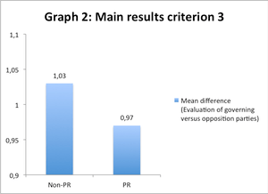
Governing parties are better liked than opposition parties in 82 of the 87 elections. But the mean differential, as can be seen in Graph 2, is slightly more positive in non-PR elections. This is so because PR elections usually lead to the formation of coalition governments that often include at least one small party, and small parties are usually less liked than large parties. On this third criterion PR elections also perform worse.

Conclusion
Coalitions formed under PR lead to the inclusion of more citizens’ most liked parties in government (which is good) but they also allow small less liked parties to enter government (which is not so good). In short, before concluding that one system is better than the other we must decide which aspects of citizens’ preferences matter the most.
For more details, see André Blais, Eric Guntermann, and Marc André Bodet. Forthcoming. « Linking Party Preference and the Composition of Government : A New Standard for Evaluating the Performance of Electoral Democracy. » Political Science Research and Methods.

Do Citizens Feel Well Represented?
By KATHERINE SULLIVAN | Published: APRIL 7, 2016
By Katherine V. R. Sullivan, Université de Montréal
What is the story?
Elections are designed to ensure that citizens’ views are taken into account by the political decision-makers. The hope is that voters will support the candidates/parties that represent their viewpoints and that as a consequence their views will have an indirect influence on the decisions that are made. But do citizens think that elections work as they should, that is, that the outcome of an election is a good reflection of public opinion? Do they feel that their views are well represented in the legislature?
Data
I examine feelings of representation across 27 elections within 5 countries (Switzerland, France, Spain, Germany and Canada) at the national, supra-national and sub-national levels by using data from the Making Electoral Democracy Work (MEDW) project.
I measure respondents’ feelings of representation by combining two survey questions. The first question “How well do you think your views are reflected in the legislature of the province/state/canton/country?” is on a scale from 0 (not at all) to 10 (totally). The second question, also on a scale from 0 (not accurate at all) to 10 (very accurate) goes as follows “How accurately do you think the outcome of the election reflects voters’ views?” I use the mean score given to these two questions.
Findings
Table 1 shows that overall evaluations of representation tend to be slightly positive. The mean is above 5 in 19 cases and below the mid-point in only 8 instances. Voters were most positive with respect to the Bavaria national and regional elections, whereas judgments are most negative in the case of the European elections in Provence and Madrid.

Table 1: Mean score by election
Type | Mean
Bavaria national | 6.20 (0.03)
Bavaria regional | 6.15 (0.03)
Ontario national | 6.01 (0.05)
British-Colombia National | 5.88 (0.05)
Lucerne National | 5.87 (0.06)
Zurich Regional | 5.84 (0.06)
Lower Saxony Regional | 5.81 (0.07)
Lucerne Regional | 5.78 (0.05)
Lower Saxony National | 5.69 (0.08)
Quebec National | 5.58 (0.05)
Zurich national | 5.48 (0.72)
Paris Municipal | 5.45 (0.07)
IDF national | 5.40 (0.07)
Lower Saxony Europe | 5.23 (0.08)
Quebec regional | 5.13 (0.07)
Provence national | 5.09 (0.07)
Catalonia regional | 5.08 (0.07)
Ontario regional | 5.06 (0.07)
Bavaria Europe | 5.00 (0.04)
Marseille municipal | 4.96 (0.09)
Madrid Regional | 4.94 (0.07)
Catalonia Europe | 4.81 (0.07)
IDF Europe | 4.70 (0.07)
Madrid National | 4.67 (0.08)
Catalonia national | 4.52 (0.07)
Provence Europe | 4.51 (0.07)
Madrid Europe | 4.34 (0.07)
Standard deviation presented in parentheses

Table 2 indicates that the Swiss and German electorates have the most positive perceptions and Spaniards the most negative.

Table 2: Mean score by country
Country | Mean
Switzerland | 5.90 (0.03)
Germany | 5.87 (0.02)
Canada | 5.62 (0.03)
France | 5.02 (0.03)
Spain | 4.73 (0.03)
Standard deviation presented in parentheses

Finally, Table 3 shows that citizens tend to be more positive overall about representation at the national and sub-national level and feel more negative about the supra-national level.

Table 3: Mean score by level
Level | Mean
National | 5.73 (0.02)
Sub-national | 5.67 (0.02)
Supranational | 4.82 (0.25)
Standard deviation presented in parentheses

Conclusion
All in all citizens from Switzerland, Germany and Canada have slightly positive views about the representative process while Spaniards are slightly negative. Judgments do not differ between the national and the subnational levels but Europeans are somewhat negative about the European level.

Democracy and football
By KATHERINE SULLIVAN | Published: APRIL 5, 2016
By Ignacio Lago, Univesitat Pompeu Fabra, Barcelona *
The influence of politics on sports and more specifically on football (soccer) has been widely discussed, but no hard empirical evidence can be found in political science, economics or sports science research. We fill this gap by examining whether the competitive balance in football domestic leagues (i.e. the extent to which certain clubs dominate the domestic league) is affected by the country’s political regime, We rely on data from two samples of 47 and 49 European countries from 1950 through 2011 and 1,980 and 1,960 football domestic leagues, respectively,
We argue that domestic leagues are more heavily dominated by the same club in non-democratic regimes than in democracies. Democratic transitions trigger pressures to increase the competitive balance within football domestic leagues in two ways. First, the political manipulation of football decreases with democratization. The link between non- democratic regimes and specific teams, particularly evident in communist countries, breaks when a country experiences a transition to democracy. Secondly, at the same time, with the onset of democracy, capitalist modus operandi are progressively adopted by clubs and football then starts to operate as a market free of price restrictions with no salary caps or draft rights. The economic liberalization that takes place in transitions to democracy disperses resources that undermine the monopolistic dominance of certain teams supported by non-democracies and generates competition among descending and ascending teams.
The first piece of evidence supporting the argument that political regimes affect football domestic leagues is displayed in Figure 1. The relationship between the percentage of domestic leagues won by the most successful club in each country and the number of leagues played under democracy is displayed. As can be seen the competitive balance of football domestic leagues is positively correlated with the length of democracy. The average value of Winner in democracies, 40.75, is substantially lower than in non-democracies, 48.36.
In a second analysis, we examine the competitiveness of domestic leagues in the 13 countries which have experienced a transition to democracy after 1950. In all of them, not one of the most successful clubs during the non-democratic period has been the most successful club after democratization. More specifically, for the most successful club in the non-democratic period, winning the previous league significantly increases the probability of winning the league the next year when the country is not a democracy. However, when the country is a democracy, being the winner of the previous league does not affect its probability of winning the current year. In other words, when countries experience a transition to democracy, dominant clubs in the non-democratic period become weaker competitors.

Figure 1: Winners in football domestic leagues in democracies and non-democracies
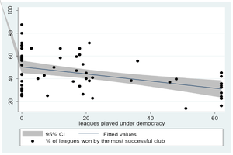
Ignacio Lago, Universitat Pompeu Fabra and GEN
Carlos Lago-Peñas, GEN (University of Vigo)
Santiago Lago-Peñas, GEN (University of Vigo)
“Democracy and Football”, Social Science Quarterly, 2016 (early view)

Is Duverger’s Law Valid?
By KATHERINE SULLIVAN | Published: MARCH 8, 2016
By André Blais, Université de Montréal*

I examine Duverger’s law according to which « the plurality rule leads to a two party system. » I am interested in the party system at the electoral level, that is, the distribution of votes among the parties. Even though I show that the contemporary evidence tends to disconfirm Duverger’s law, I argue that the basic intuition behind the law is valid.
Duverger predicted that only two parties or candidates would receive a significant degree of support as voters do not want to waste their vote on candidates with little or no chance of winning. This of course assumes that they are short-term utility maximizers and are well informed about the chances of the various candidates.
I examine the outcome of the most recent elections in the three established democracies that use SMP: Britain, Canada, and the United States. I simply count the number of candidates with some minimally meaningful level of support, that is, with at least 5% of the vote.
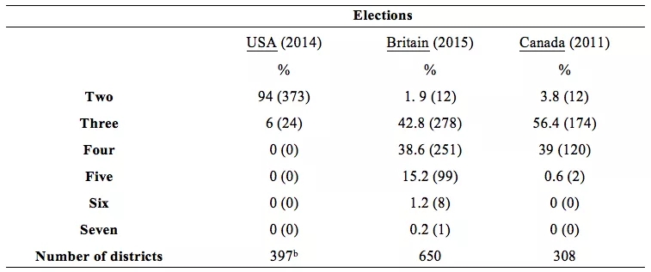
Table 1 shows the distribution of the number of candidates with at least 5% of the votes in the most recent American (Congressional), British, and Canadian elections. The results are clear. In the U.S. the results almost perfectly support Duverger. There are only two ‘serious’ candidates in 94% of the districts. Things are quite different in Britain and Canada. In both countries, there are only two ‘serious’ candidates in less than 5% of the cases. The most typical situation is to have three candidates with at least 5% of the vote. There are ten times as many cases of four candidates (with at least 5% of the vote) than of two candidates in Canada and twenty times as many in Britain. Hence, Duverger’s law is disconfirmed in Britain and Canada.
I conclude that Duverger’s claim that SMP leads to a two-party system is wrong but that he is absolutely right in arguing that under first past the post a significant number of voters desert their preferred party when it is not viable and that this leads to a less fragmented party system.
André Blais, “Is Duverger’s law valid?” French Politics (forthcoming).
References
Blais, André. 2002. ”Why Is there So Little Strategic Voting in Canadian Plurality Rule Elections?” Political Studies 50: 445-454.

Blais, A. 2013. “Evaluating U.S. Electoral Institutions in Comparative Perspective.” In Representation: Elections and Beyond. J.H. Nagel and R.S. Smith (ed.)) Oxford: Oxford University Press.

Blais, A. and R. K. Carty. 1991. ”The Psychological Impact of Electoral Laws: Measuring Duverger’s Elusive Factor. ” British Journal of Political Science 21: 79-93.

Blais, A and P. Loewen. 2009. “The Electoral System and its Effects.” West European Politics 34: 342-356.

Clark, W., and Golder, M. 2006. ”Rehabilitating Duverger’s law: Testing the Mechanical and Strategic Modifying Effects of Electoral Laws.” Comparative Political Studies 39: 679-708.

Cox, G.W. 1997. Making Votes Count. Strategic Coordination in the World’s Electoral Systems. Cambridge: Cambridge University Press.

Downs, A. 1957. An Economic Theory of Democracy. New York: Harper Collins Publishers.
Duverger, M. 1951. Les partis politiques. Paris: Colin.

Gunther, R. 1989. “Electoral Laws, Party Sysrtems, and Elites: The Case of Spain.” American Political Science Review 83: 835-858.

Lago, I. and J. R. Montero. 2009. ”Coordination among Arenas in Multi-Level Countries.” European Journal of Political Research 48: 176-203.

Taagepera, R. and M.S. Shugart. 1989. Seats and Votes. New Haven: Yale University Press.

How to reform European elections?
By KATHERINE SULLIVAN | Published: MARCH 1, 2016
By Damien Bol, King’s College London

What is the story?
The EU is at a critical moment in its development. Many citizens express a negative attitude towards European integration and do not trust European decision makers. A proposal that has been put forward to mitigate this problem, and to help European representatives gain the confidence of the population, is to create a pan-European district in which a small number of MEPs would be elected.
In a recent paper we evaluated this proposal via a unique online experiment where we invited thousands of Europeans to report how they would vote in a pan-European ballot. We find that vote choice in a pan-European district would be substantially affected by the presence of national candidates on the lists. We discuss the implications of our findings and derive some recommandations for European decision makers.

The EuroVotePlus experiment
In the three weeks preceding the 2014 EP election, we conducted an online experiment (for a discussion of the details of this experiment, see this other paper). We created a multi-lingual website, open to all, where users were invited to learn more about European elections in general and the rules used to elect MEPs and to participate in an online voting experiment.
In the experimental part of the website, we invited people to indicate their vote preference in the upcoming European election using the party lists utilized in their district. We also asked all participants, regardless of their country, to indicate how they would vote if 10 additional members of the European Parliament were to be elected in a pan-European district. We simulated a pan-European ballot by creating party lists based on the existing political groups in the European Parliament. We randomly picked, for each respondent, 10 incumbent MEPs from each political group. A screenshot of a pan-European ballot is presented below. The ballot contained the name of the candidate, his/her nationality, and a picture.
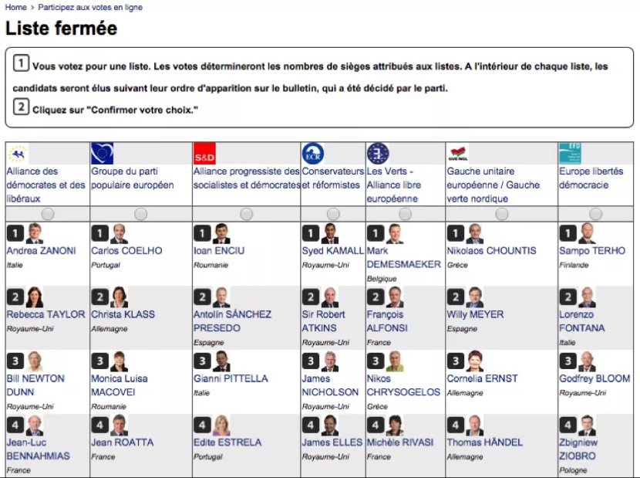
Findings
In the pan-European ballot, people were invited to cast a vote under different electoral rules. We first asked them to cast a vote under closed-list proportional representation for which they could only choose one list. Even if the participants appeared to be ideologically driven, as they voted massively for the pan-European list corresponding to the party they had the intention to vote for in the national ballot, they were strongly affected by the nationality of the candidates appearing on the list. They were 48% times more likely to vote for a list when there was a least one candidate of their country.
We also asked them to vote under open-list proportional representation for which they could choose one list and give extra points to individual candidates of this list. The effects were similar to those observed under closed-list proportion representation, but we observed that the participants were 8 times more likely to give a positive point to candidates of their own nationality.

Recommandations
We derive two concrete recommendations for EU decision makers. First, if a pan-European district is created, we recommend establishing a maximum number of candidates from each EU country on the lists. If this number is not fixed, pan-European parties, anticipating the effect of the nationality of candidates on vote choice, would be likely to nominate candidates from large countries.

Second, if a pan-European district is created, the argument developed in this article lends support to the implementation of a closed-list PR system, instead of an open-list PR system. Since we find that Europeans would give more positive votes to national candidates, the open-list PR system would also lead to the domination of the pan-European seats by large countries.
All in all, although we see the great potential of creating a pan-European district to reduce the EU democratic deficit, we recommend being cautious in setting the precise rules for this election.
For more details, see Damien Bol, Philipp Harfst, André Blais, Sona Golder, Jean-François Laslier, Laura Stephenson, and Karine Van der Straeten. “Addressing Europe’s Democratic Deficit: An Experimental Evaluation of the Pan-European District Proposal.” European Union Politics.

Strategic Voting
By KATHERINE SULLIVAN | Published: FEBRUARY 1, 2016
By Jean-François Daoust (Université de Montréal) and Damien Bol (King’s College London)
What Is The Story?
The concept of strategic voting is widely used by political parties and the media. It is assumed to be a widespread behaviour because Canada has a “winner-takes-all” electoral system. But what is the actual proportion of strategic votes?
To tackle this question, we need to define rigorously what a strategic vote is. There are two very simple conditions for a vote to be qualified as strategic: first, a voter must not vote for her preferred party, and second, she must do so because her preferred party has little or no chance of winning.in her constituency.
Data
Data from the Making Electoral Democracy Work (MEDW) surveys are well suited to analyse the extent to which people vote strategically as they provide indicators of individual preferences, expectations about the various parties’ chances of winning in the respondent’s constituency, and vote choice.
Preferences were tapped by asking people how much they like each party on a scale from zero to ten (from ‘really dislike’ to ‘really like’). For expectations, respondents were asked to evaluate the chances of the various parties winning in their constituency, also on a scale from zero to ten (from ‘no chance at all’ to ‘certain to win’). Finally, vote choice is measured by a self-reported answer in the post-electoral wave.

We use data from two provincial elections and the last federal election.
The Method
The method has two steps. First, we identify respondents who were potential strategic voters, i.e. those whose preferred party was not one of the top two contenders (the two parties perceived to have the highest chances of winning) in their constituency. Second, we identify within this subgroup of potential strategic voters those who voted for their most preferred party among the top two contenders. These voters casted, following our definition, a strategic vote.
Results
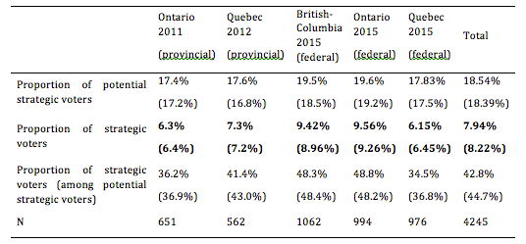
Table 1 displays the extent to which Canadians voted strategically.
Note: Entries are non-weighted proportions. Weighted proportions using actual results for each political party are into parentheses.
Firstly, less than one fifth of the electorate had incentives to cast a strategic vote (i.e. were potential strategic voters). Among those who did have incentives to do so, around 40% desert strategically. At the end of the day, around 8% of Canadians voted strategically in the three largest provinces in the last federal election. We see a relatively substantial increase in Ontario (compared with the provincial election). There appears to be a slight decrease in Quebec.
Conclusion
Measuring strategic voting requires indicators of preferences, expectations and vote choice. In order to ascertain how many citizens act strategically in an election, we must focus on the subgroup of voters with incentives to vote strategically and then analyse if they desert their preferred option in favour of the most preferred party between the top two contenders in their constituency. When we do so, we find that about 20% of voters face a situation where they have to decide whether to vote strategically or not and that about 20% of them (and 8% of all the voters) cast a strategic vote.

The evolution of vote intentions during the 2015 Canadian election campaign
By KATHERINE SULLIVAN | Published: JANUARY 25, 2016
By André Blais and Jean-Michel Lavoie, Université de Montréal
Campaign dynamics
Support for the Conservatives remains remarkably stable during the whole campaign, hovering between 28% and 32%. The Conservatives reached their bottom, at 27%, in late August, possibly because of the Duffy trial. The drop in Conservative support is observed only in Ontario, where Conservative vote intentions decrease from about 37% before the appearance of Wright (August 12) to about 27% by the end of the month. By mid-September the Conservatives were back to about 33% nationally, suggesting that the impact of the Duffy trial had gradually evaporated.
For the rest of the campaign the Conservatives remain at slightly above 30%, with little movement. There is some shift in Quebec, however, as their support increases in the second half of September. Note that the Conservatives also made some gain in British Columbia during the campaign.
Things are quite different for the Liberals. They start at about 27% and end at 38%, an increase of about 10 points. There is a small increase in Liberal support in late August, which is most apparent in Ontario, from about 27% to about 30%, possibly related to the Duffy trial. Liberal support stays at about 30% for the whole month of September. Liberal vote intentions more or less constantly and progressively rise throughout October.
NDP support, for its part, stays around 32% from the start of the campaign to mid-September. This is followed by a very gradual and constant decline throughout the last five weeks of the campaign.
The niqab issue
The big question is whether the NDP decline was the result of the niqab issue. If so, we should observe that the NDP drop was strongest in Quebec since this is where the issue was most strongly debated. That seems to be the case: support for the NDP in Quebec went from about 43% in mid-September to about 25% by election day.

In order to conclude that the niqab issue was the crucial factor in the NDP decline, we would also have to observe that the decline started earlier in Quebec. That seems to be the case as well. The NDP descent in Quebec starts around September 18, which is the day the Conservatives announced their appeal; the party’s descent in Ontario begins only in early October. The evidence suggests that the niqab had a big influence in Quebec, producing a drop of about 10 points for the NDP in late September. Logically, that loss should have been to the benefit of the Conservatives and the Bloc, which were taking an anti-niqab stance. Is it the case? The party that makes the biggest gain in Quebec during that period is the Bloc (from 14% to 20%).
The Liberal surge in October
The last question is: How can we explain the NDP’s continuous decline throughout October, to the benefit of the Liberals? The fact that the movement is very gradual suggests that this is not due to any specific crucial event.

One interpretation is that many voters, especially in Ontario, abandoned the NDP for the Liberals as it became obvious that only the latter could defeat the Conservatives. We cannot directly test that interpretation with these data. We observe, however, that the Liberal gains in Ontario during the month of October come at the expense of the Conservatives as well as of the NDP, which suggests that it was simply the image of the Liberal party and of Justin Trudeau that was constantly improving in the last three weeks of the campaign.
Conclusion
Two major conclusions can be drawn from this analysis. First, specific campaign events do not seem to account for most of the campaign dynamics. The Liberal gains and the NDP losses appear to be mostly gradual, as if Canadians came to like the Liberals a little bit more and the NDP a little bit less as the campaign progressed. The Duffy trial had a temporary effect in Ontario but that is all. There is no trace of any significant shift after any of the leaders’ debates or after the Liberals’ announcement, on August 27, that they would run a deficit if elected, or when the story broke about the drowned Syrian boy (September 2). The only exception is the niqab affair, which had a big impact in Quebec, to the detriment of the NDP.
The second conclusion is that while the Liberals gained ground and the NDP declined during the campaign in each of the three provinces, there were substantial differences in campaign dynamics across the provinces. The shifts were strongest and most gradual in Ontario.
In Quebec, the Conservatives and the Bloc also made some modest gains when the NDP support began to tumble. And in BC, the Liberal surge was particularly modest and late.
NB: We thank Claire Durand for sharing the poll data. We thank her and Laura Stephenson for comments on a previous draft.

Figures 1 to 13 present the evolution of vote intentions during the 2015 Canadian election campaign, starting August 2, until October 18, the day before the election.
Daily estimates correspond to the mean of all the polls that were in the field that day.
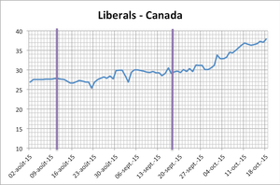
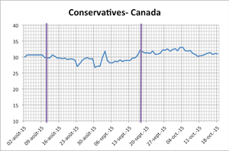
figure 1 figure 2

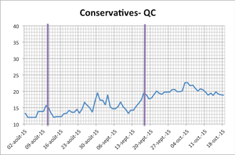
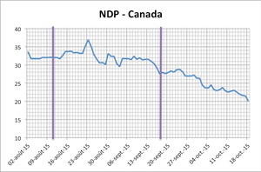
figure 3 figure 4

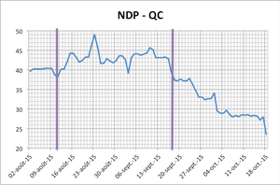
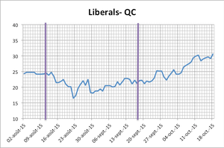
figure 5 figure 6

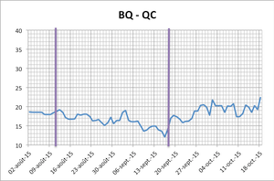
figure 7 figure 8
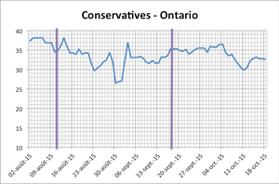

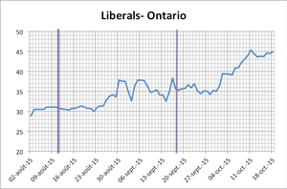
figure 9 figure 10
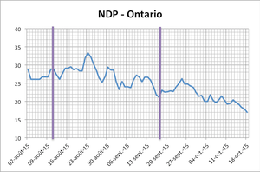

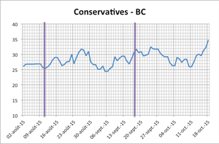
figure 11 figure 12
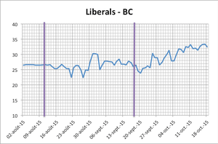

figure 13
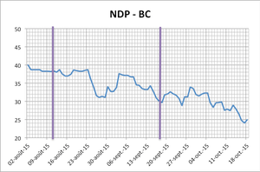

The formation of a new government in Catalonia
By KATHERINE SULLIVAN | Published: JANUARY 15, 2016
By Marc Guinjoan
The former Catalan PM, Artur Mas (left), shaking hands with the newly elected PM Carles Puigdemont (right) in the Parliament on Sunday.
The last Catalan regional elections took place on September 27th 2015. The Catalan government, led by Prime Minister Artur Mas of the center-right nationalist Convergència i Unió (CiU), called early elections after having been unable to convince the Spanish government to hold a referendum on secession in Catalonia. Before the elections took place, the coalition composed of CiU and Convergència Democràtica de Catalunya (CDC) was dissolved. The main (pro-secession) faction within CiU formed an electoral coalition (joint list) with the left-wing secessionist party Esquerra Republicana de Catalunya (ERC). The joint list was called Junts pel Sí (JxS, Together for the Yes).
JxS won the September 27th elections, with 62 deputies elected out of 135. The extreme left-wing secessionist Candidatura d’Unitat Popular (CUP) managed to have 10 deputies elected. Together the secessionist parties had 72 deputies, and thus a majority of seats, against 63 for the anti-secessionist parties, as shown in the graph below.
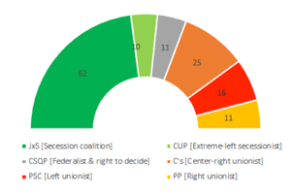
In order to be re-elected PM, Artur Mas could count on the support of the 62 deputies elected under the JxS list, and on the opposition of the 63 deputies from the anti-secessionist parties. This means that he also needed some support from the extreme left secessionist CUP. But during the campaign the CUP had promised not to support Artur Mas because of his austerity measures. So the question was whether Mas, or someone else, could obtain majority support or not. The parties had until January 10 to come to a deal. According to the Constitution, new elections would be automatically called if no candidate had managed to get majority support by that date.

The negotiations between JxS and the CUP lasted several months, and appeared to have ended in a deadlock. After several CUP activist assemblies, including a 1515 vs 1515 vote draw in a massive assembly, the CUP finally announced that it would not support Mas, on January 3, one week before the deadline. The party indicated that it was willing to join the secessionist coalition only if JxS came up with another candidate. As the JxS reiterated its support for Mas, everyone was getting prepared for a new election.
And then, at the very last minute, Artur Mas announced that he had decided not to run as PM, and proposed a new candidate from CDC, Carles Puigdemont, the (now former) mayor of Girona. In short the CDC accepted the condition imposed by the extreme left-wing CUP. In return CUP allowed two of its deputies to vote for Carles Puigdemont (and the other eight abstained). That vote, which occurred just two hours before the deadline, led to the election of Puigdemont as PM and the formation of a secessionist government in Catalonia.
In short the small CUP, with only 10 deputies, eventually managed to impose its condition to the JxS, with 62 deputies. CUP was successful because JxS was concerned that the possibility of not electing a president in an election labelled as a “plebiscite” on Catalan independence would lead to frustration among its supporters. Additionally, although JxS would have probably obtained similar results if new elections had been held, CUP would probably have lost ground, thus complicating the achievement of a majority in favour of secession. In sum, Mas’ last minute resignation allowed CDC to continue holding the position of PM in Catalonia, and represented a powerful but exclusively symbolic gain for the CUP, since there is no indication that the new PM is more leftist than the one who was forced to resign. It remains to be seen who are the long-term winners and losers.

The 2015 election in Spain
By KATHERINE SULLIVAN | Published: DECEMBER 22, 2015
By Ignacio Lago, Universitat Pompeu Fabra, Barcelona
On December 20 2015 the twelfth national election after the restoration of democracy in the seventies was held in Spain. The election revolved around the consequences of the economic crisis, corruption and the relationship between Spain and Catalonia. The two national established parties, PP and PSOE, have been challenged by two new national parties, Podemos and Ciudadanos. As a result the Congress of Deputies in 2015 is the most fragmented we have seen since the II Republic in the thirties, the first democratic experience in Spain.
Four features make this election quite exceptional in the Spanish electoral history.
- Despite winning the election, the ruling party, the center-right Partido Popular (Popular Party PP), has suffered the highest loss of support, 63 seats less than four years ago, since the disappearance of the UCD, the party which lead the democratic transition, in 1982. However, the Socialist Party (PSOE) has not taken advantage of this loss of support. It is again the main opposition party, but with only 90 seats, 20 less than in 2011, its worst-ever results.
- The 29 percent of the votes and 123 (out of 350) seats won by PP in the 2015 election is the lowest support ever reached by the winner of a national election in Spain. In the previous eleven elections the number of seats got by the winner has fluctuated from 202 (in 1982) to 156 (in 1996) and then the selection of a Primer Minister (which demands majority in the first voting in the Parliament and plurality –more yes than no- in a hypothetical second voting) and the formation of a government has never been problematic: no coalition governments have been formed in Spain.
- Two new parties, the far-left Podemos (We can) and the center-right Ciudadanos (Citizens), have very successfully entered the Parliament. In the electoral history before 2015, the most successful third party was the ex-communist Izquierda Unida (United Left) with 21 seats in 1996. In 2015 Podemos has got 69 seats and Ciudadanos 40. As a result, the support of the two main parties, the PP and the PSOE, the 51 percent of the votes (almost 25 points less than four years ago), is the lowest since the founding election in 1977.
- For the first time in Spain the name of the future Prime Minister and the composition of the government is uncertain. The scenario is particularly open as there have been no positive coalition signals before the election, but negative. Only two options are on the table. An agreement or coalition between PP and PSOE or an agreement or a coalition between PSOE, Podemos, and subnational parties. In the former, the problem is that the platforms of the two parties are not closed; in the latter, the main problem is that Podemos is in favour of a referendum about the independence of Catalonia, while the PSOE is clearly against it.

If a Primer Minister is not elected before April …. There will be elections again!
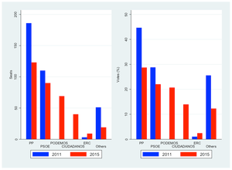
Figure 1: Seats and votes in the 2011 and 2015 elections in Spain

Are the better educated less cynical?
By KATHERINE SULLIVAN | Published: DECEMBER 8, 2015
by Katherine Sullivan
What is the story?
This blog is about political cynicism, which is defined as a “mistrust generalized from particular leaders or political groups to the political process as a whole – a process perceived to corrupt the persons who participate in it and that draws corrupt persons as participants” by Capella and Jamieson (1997; 166). Cynicism is an important attitude that may explain lack of interest in politics and may adversely affect political participation.
I examine the relationship between education and cynicism. The hypothesis to be tested is that cynicism decreases with education (Agger, Goldstein & Pearl 1961). But more specifically I wish to determine whether the relationship is linear or not.
Data
I use surveys from the Making Electoral Democracy Work (MEDW) to examine the relationship between levels of education and cynicism during 6 regional and national elections in three democracies: Canada, France and Spain in 2011 and 2012.
Cynicism is measured with the survey item asking respondents to what extent they agree with the statement: “Politicians make campaign promises they have no intention of keeping”. Those who agree strongly are given a score of 1, those who agree somewhat a score of .66, those who disagree somewhat a score of .33 and those who disagree strongly a score of 0. The mean cynicism score in our pooled data set is 0.82.
Education is divided into three categories: the less educated, the moderately educated and the better educated. The first category ranges from “no schooling” to “completed high school”, the second from “college” to a “bachelor degree” and the third from a master’s degree and above. The overall percentages of less, moderately, and better educated in the pooled data set are 15%, 44% and 41% respectively.
Who is most cynical?
Table 1. Levels of cynicism and education
 | Pooled | Canada | Spain | France
Less educated | 0.026*** | 0.017 | 0.037* | 0.005
Better educated | -0.027*** | -0.052*** | -0.001 | -0.014
Gender | 0.011* | 0.010 | 0.007 | 0.017
Age | 0.001** | 0.001*** | -0.001 | 0.001**
Cons | 0.796*** | 0.780*** | 0.828*** | 0.758***
N | 5999 | 2236 | 1892 | 1871
*p<0.10 **p<0.05 ***p<0.01

Table 1 shows the findings of an OLS regression with the dependent variable being the respondent’s score on the cynicism variable. There are two education dummy variables for the less and the better educated (the reference category being the moderately educated). The findings support the hypothesis that cynicism decreases with education. This is particularly apparent in the pooled results, which merge results from all three democracies (Canada, France and Spain). The relationship however is weak, as the difference between the better and the less educated is only .05 on the 0 to 1 scale. Furthermore, the patterns vary across countries. Education has no impact in France while the only significant difference is between the better educated and all others in Canada and the less educated and all others in Spain.
Table 1 also shows a tiny gender effect of .01, women being slightly more cynical. Finally cynicism also increases with age, at least in Canada and France. The predicted cynicism score is .05 higher for someone who is 70 years old than for a 20 year-old respondent. The impact of age is about the same magnitude as that of education.
These results indicate that the most cynical citizens are the old and less educated, and the least cynical are the young and better-educated citizens.

Examining the Role of the Media in the 2015 Election Campaign
By KATHERINE SULLIVAN | Published: NOVEMBER 10, 2015
By Scott Pruysers
The Bell Chair in Canadian Parliamentary Democracy at Carleton University in association with Making Electoral Democracy Work sponsored a post election panel featuring Rosemary Barton (CBC), Susan Delacourt (Toronto Star), and Paul Wells (Maclean’s).
What was the panel about?
Moderated by Susan Harada, the panellists discussed a variety of topics including the role of social media, changing reporting techniques, the role and appropriateness of editorial endorsements, as well as their own personal experiences with the longest election campaign in modern Canadian history. Perhaps the most common theme of the night was a discussion of the challenges of covering modern election campaigns.
What were the challenges of covering this campaign?
Although all campaigns can be challenging to cover, the panel highlighted a variety of challenges specific to this campaign including a lack of resources and the costs associated with access to party leaders, the propensity for parties to bypass traditional (and national) media outlets, and a sometimes uneasy and antagonistic relationship between the media and political parties. It is worth briefly expanding on the first two of these challenges.
A lack of resources
While leaders tours are an essential part of the national campaign, they are costly affairs for those journalists seeking to travel with the party leader. At approximately $12,000 per week, cash-strapped media outlets are sending fewer and fewer journalists to cover these cross-country tours. Global news, for example, chose not to have a journalist on the tour. While each panellist agreed that being on the tour provides greater access and coverage, Susan Delacourt suggested that the business model simply no longer works. In fact, Delacourt predicted that journalists would find alternate methods of covering the leaders in the future.
Bypassing the national media
Perhaps more troubling for the panel was a sense that political parties are increasingly attempting to bypass the national media in favour of local, regional, and ethnic media outlets. As parties use regionalized campaign tactics and sophisticated voter targeting techniques, tailoring messages for regional and local markets is a key component of their campaign strategy. This is made more challenging for national media outlets as parties continue to bypass the media more generally, transmitting messages and videos directly to voters on social media such as Facebook and Twitter.
Overall the event was a great success. More than 200 audience members attended the panel and a number of audience members participated in an engaging Q&A at the end. Online and social media reaction to the panel was positive as a number of members of the audience tweeted additional comments and questions to the presenters during and after the event. In fact, many stayed for a small reception afterwards in hopes of taking a picturewith the celebrity-like panellists.

What are voters listening to during an electoral campaign?
By KATHERINE SULLIVAN | Published: OCTOBER 19, 2015
By Katherine V. R. Sullivan (Université de Montréal)
What is the story?
There is a consensus that voters are politically uninformed, which can have repercussions on their decisions. Indeed, their vote choice may or may not be a true reflection of their values, opinions and beliefs. Regardless, there are many sources of information during an electoral campaign that may help reduce the informational gap. With the ever-rising popularity and accessibility of digital tools, there is considerable debate on the potential of new media vs traditional media.
On one hand, the new media allow users instant access to multiple sources of information, lower physical barriers and provide a digital public sphere where citizens, journalists and politicians alike can discuss. On the other hand, Internet may simply be a new playing ground for spin-doctors, greater polarization of opinions and digital echo chambers.
Data
Data from the Making Electoral Democracy Work (MEDW) surveys can provide useful insights on this question. Hence, I have analysed data from the 2012 provincial elections in the province of Quebec and the Ontario 2011 election in order to determine what types of media were most used by Canadian voters to acquire political information during the election.
Media types were divided into two categories: new media and traditional media. By new media, we mean Internet and Twitter. The traditional media are the radio, television and newspapers.
What’s popular? What’s not?

Figure 1. Media types as sources of political information
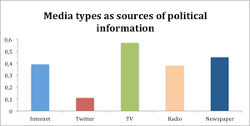
Note: Respondents were asked to rate their use of different types of media on a scale from 0 to 1.
As is shown in figure 1, television was by far the most popular media during the two provincial elections. Indeed, Canadian voters preferred traditional media, such as television and newspapers, to Twitter. However, results show that the Internet was a more popular source of political information than the radio.
Table 1. Media use and socio-demographic characteristics
 | Internet | Twitter | TV | Radio | Newspaper
Age | -0.12* | -0.07* | 0.14* | 0.04* | 0.09*
Female | -0.09* | -0.02* | -0.01 | -0.05* | -0.09*
Education | 0.09* | 0.02 | 0.05* | 0.09* | 0.08*
Ontario | -0.10* | -0.05* | -0.16* | -0.06* | -0.06*
R² | 0.08 | 0.05 | 0.07 | 0.03 | 0.06*
Constant | 0.53 | 0.14 | 0.53 | 0.30 | 0.38
N | 1591 | 1571 | 1600 | 1593 | 1595
Note: OLS regression. The dependant variable is media consumption of political information (0 to1 scale). The independent variables are all dichotomised, Values of 1 indicate older than 35, female, and post-secondary education.* p<.05
Table 1 shows the relationship between the use of the various media and age, education, gender, as well as the differences between the provinces of Ontario and Quebec. We see, as expected, that younger respondents are more prone to use the internet and twitter while the reverse holds for the traditional media. The level of education is also significant in the choice of media. Canadian voters with higher levels of education – post-secondary education in this case – prefer the Internet, radio and newspapers. Finally women tend to make less use of all media sources, both new and traditional.
There is also a discernable difference in media consumption between the two provinces as is shown by the Ontario variable. Quebeckers are more intensive users of all media, both new and old, an indication that they were more interested in general in the provincial election, as indicated by a higher turnout.
Overall, although the Internet holds great promise for access to information and political leaders, it has yet to reach as great an audience as traditional media such as television and newspapers. We see, however, that there is a big age gap in the use of digital and traditional media, and so among youth the Internet has become as important as TV. There is also an educational cleavage, with the better educated making greater use of the internet but that cleavage is very similar to that found in the case of radio and newspaper. The same verdict applies to the gender gap: women make less use of all media. In short, those who use the internet are also those who use the traditional media, with the exception of the young, for whom the internet is becoming a very important source of information.

Which electoral system citizens prefer and why?
By DAMIEN BOL | Published: SEPTEMBER 2, 2015

What is the story?
These last 25 years, 20 referendums have been organized on whether the current set of voting rules should be replaced or not. Some of these referendums took place in long-standing and democracies such as the United Kingdom in 2011.
In a recent paper accepted for publication in Public Choice, we use an original online voting experiment to examine which system citizens prefer. We also study the factors that influence this preference.

The online voting experiment
A few weeks before the first round of the 2012 French Presidential election, we released an interactive website: www.voteaupluriel.org. The website was open to all, but we used French national media to advertise it. In total, more than 5,000 eligible French citizens participated in our experiment and fully completed the protocol.
During our online experiment, we invited participants to report how they intended to vote for the upcoming election using the actual two-round majority system. Then we asked them how they would vote under three alternative voting rules:
- One-round plurality: the candidate with the most votes is elected
- Alternative voting: voters rank order the candidates and the candidates with a majority of first preferences wins (the weakest candidates are subsequently eliminated and their vote reported to the other candidates until one obtains a majority of first preferences)
- Approval voting: voters indicate all the candidates that they approve and the candidate with the most votes (approvals) wins

Results
At the end of our experiment we asked participants which set of voting rules they prefer. The results indicate that they prefer alternative voting (41%), to approval voting (27%), two-round majority (24%), and one-round plurality (8%). See the table below.
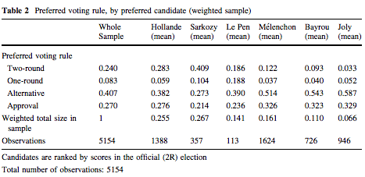
We find that citizens tend to prefer the system that is most favourable to their most preferred candidate. Participants whose preferred candidate was among the top two contenders of two-round majority system (Hollande and Sarkozy) had 20% more chances of preferring this electoral system. See the table below.
We also find that (1) participants dislike voting rules if they vote strategically, i.e. desert their most preferred candidate as this candidate has no chance of winning, and (2) left-wing citizens prefer systems under which they can vote for several candidates (alternative and approval voting) while right-wing citizens prefer one-round plurality and two-round majority.
For more details see, André Blais, Jean-François Laslier, François Poinas, and Karine Van der Straeten. Forthcoming. Citizens’ preferences about voting rules: self-interest, ideology, and sincerity. Public Choice.

The Ups and Downs of Party Support in Canada: 2011-2015
By DAMIEN BOL | Published: AUGUST 17, 2015
By André Blais and Eric Guntermann (Université de Montréal)

What is the story?
In this blog post, we systematically analyze the results of all the polls released between the last federal election (May 2011) and the beginning of the present campaign (end of July 2015) to assess the influence of events on parties’ levels of support since the last election. During these 51 months, the Conservatives were ahead (monthly average) 22 months, the Liberals 23 months, and the NDP six months. And it is the NDP that is leading at the beginning of the campaign.

What we did?
In the figures below, the solid lines show the evolution of monthly average vote intentions for the four largest national parties from May 2011 and July 2015.1 Each data point indicates the mean level of support for a given party in all the polls that were conducted in a particular month.

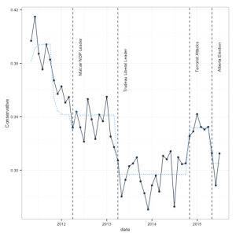
Figure 1 – Conservatives Figure 2 – NDP
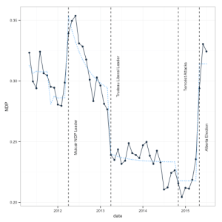

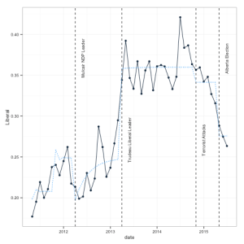
Figure 3 – Liberals Figure 4 – Greens
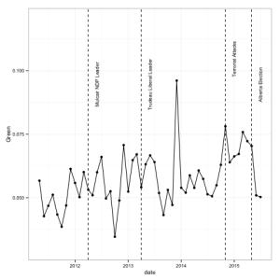

We selected five such events and assess their impact on support for the Conservatives, the Liberals, and the NDP.2
The first event is a honeymoon following the election of the Conservative government in May 2011. Figure 1 shows that support for the Conservatives was particularly high right in the months following the election, and then declined quickly.

The second is the election of Thomas Mulcair as leader of the NDP, in March 2012. We see that the popularity of the NDP did increase after Mulcair’s election, although the change appears to have subsided rather quickly. The third event is the election of Justin Trudeau as leader of the Liberal party, in April 2013. His election was accompanied by a sharp growth in Liberal vote intentions, an impact that appears to have lasted for a good 18 months.

The last two events are the occurrence of terrorist attacks on Canadian soil in October 2014 and the stunning NDP victory in Alberta in May 2015. The former appears to have benefited the Conservatives while the latter was followed by a spectacular increase in NDP support across the country.3
In order to estimate the impact of these five events on vote intentions, we performed an ARIMA estimation.4 For each event we tested alternative models with permanent effects (that is, the variable equals 0 before the event and 1 afterwards) and temporary effects (that is, there is an immediate effect followed by a decay).5 We use the estimation with decay if it produces a better model fit and otherwise keep the more parsimonious model with a permanent effect. We estimated the same model for the three parties.

What we found?
The table below presents the estimated coefficients from ARIMA models. In the figures above, the dashed lines are the predicted values. For each event we tested alternative models with permanent effects (that is, the variable equals 0 before the event and 1 afterwards) and temporary effects (that is, there is an immediate effect followed by a decay). We use the estimation with decay if it produces a better model fit and otherwise keep the more parsimonious model with a permanent effect. We estimated the same model for the three parties.

 | Conservative | Liberal | NDP
Intercept | 0.34 | 0.25 | 0.29
 | (0.00) | (0.01) | (0.01)
Honeymoon | 0.04 | -0.05 | 0.03
 | (0.01) | (0.02) | (0.01)
Honeymoon AR(1) | 0.24 | -0.23 | -0.24
 | (0.20) | (0.29) | (0.29)
Mulcair becomes NDP leader | -0.01 | -0.05 | 0.07
 | (0.01) | (0.02) | (0.01)
Mulcair becomes NDP leader AR(1) | -0.23 | -0.75 | 0.83
 | (0.64) | (0.11) | (0.04)
Trudeau becomes liberal leader | -0.04 | 0.11 | -0.05
 | (0.00) | (0.01) | (0.01)
Terrorist attacks | 0.03 | -0.02 | -0.02
 | (0.01) | (0.01) | (0.01)
Alberta election | -0.03 | -0.07 | 0.10
 | (0.01) | (0.02) | (0.01)
AR(1) | 0.09 | 0.03 | 0.15
 | (0.15) | (0.15) | (0.19)
We find the following:
- The Conservatives enjoyed a honeymoon effect that gave them a boost of about 4 points. The honeymoon seems to have lasted about 6 months and then rapidly disappeared. This boost seems to have been at the expense of the Liberals.
- The election of Mulcair as the leader of the NDP gave that party an extra 7 points, mostly to the detriment of the Liberals. That gain, however, gradually dissipated and had essentially disappeared six months later.
- The election of Trudeau at the helm of the Liberals increased Liberal support by 11 points, at the expense of both the Conservatives and NDP. The impact has been permanent.
- The terrorist attacks were followed by a small Conservative gain of 3 points, to the detriment of both the Liberals and the NDP. The impact seems to have been permanent.
- The NDP victory in Alberta produced a 10 point increase in NDP support, mostly at the expense of the Liberals. It is too early to say whether that effect is permanent or not.

Conclusion
In short, events make an important contribution to understanding over time variations in support for the three major national parties. The most important events have been the election of Mulcair and Trudeau as leaders of their parties and the NDP victory in Alberta.
MEDW members are conducting a thorough analysis of party and voter behaviour in the 2015 Canadian election. Professors Laura Stephenson, Andrea Lawlor, François Gélineau, Bill Cross, Elisabeth Gidengil, and André Blais are involved in this project. The tentative title of the book to be written is: Local/Provincial Battles, National Prize? Electoral Campaigns in a Federal State.

- We thank Eric Grenier, creator of the ThreeHundredEight website for providing the data on vote intentions from May 2011 to May 2015, and Claire Durand, from the University of Montreal, for providing the data from May 2015 to July 2015. The month of each poll was identified on the basis of the median day of fieldwork. The percentages of support were computed on the basis of vote intentions for the five main parties (the Conservatives, the NDP, the Liberals, the Greens, and the Bloc). We excluded the ‘other’ category, which had different meanings in different surveys. There was only one survey in the month of July 2011. For that month we used that survey plus one that took place in late June (23/24). ↩
- As we see in the Figure, support for the Greens hovers around 5% over the whole period. We did perform some estimations for Green support but none of the variables considered here came out significant. So, we do not show the result concerning this party here. In preliminary analyses we took into account the evolution of the unemployment rate but that variable never had a significant effect. ↩
- For the Conservative honeymoon, the variable equals 1 during the first six months and 0 afterwards. For the Mulcair effect, we assume that the it took place in April rather than in March (he was elected on March 24). Similarly, the terrorist attack variable takes the value of 1 starting in November 2014 rather than in October (the attacks occurred on October 20 and 22). ↩
- The time series are clearly non-stationary given that mean levels of support in the first half of the period are different from mean levels in the second half. A simple solution to ensure stationarity is to include a dummy variable that equals 1 after the election of Trudeau and 0 before. In order to make the errors white noise, we determined that an AR(1) component for the errors would be sufficient. Augmented Dickey Fuller tests as well as visual inspection confirm that the series are stationary once the Trudeau dummy is partialled out. ↩
- We cannot test the presence of decay in the case of the Alberta election variable since it is too recent. ↩

The Importance of Three Ideological Dimensions
By DAMIEN BOL | Published: JULY 27, 2015
Mike Medeiros, McGill University
Jean-Philippe Gauvin, University of Montreal
Chris Chhim, McGill University

What is the story?
Politics in regions or countries with a salient ethno-regionalist cleavage take on a unique dynamic. In addition to ideological positioning on economic and social stances, centre-periphery issues add a third ideological dimension that needs to be considered for grasping the complexity of vote choice. Yet, electoral research has rarely given appropriate attention to these three ideological dimensions independently.

In a forthcoming paper in Electoral Studies, we take up this challenge by presenting a three-dimensional ideological model of vote choice. We theorise that the three ideological dimensions have a determining and independent influence on voting in ethno-regional political contexts.

Data
We use pre- and post-election panel surveys from the Making Electoral Democracy Work (MEDW) for the September 2012 Quebec and November 2012 Catalan elections. The three ideological dimensions are captured by creating summative rating scales based on survey questions. While vote intentions are taken from post-electoral questions, controls and main predictors come from the pre-electoral wave of the survey.

Results
The findings support our theoretical assumption. Figure 1 (Quebec) and Figure 2 (Catalonia) illustrate the analytical necessity of presenting the positions of party supporters across the three dimensions. The figures, supported by independent sample t-tests, demonstrate that electors for specific parties in both regions tend to be grouped in different parts of the three-dimensional space.
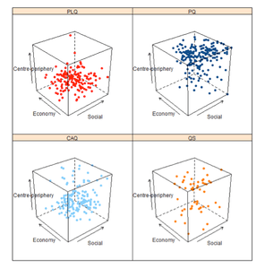
Positioning of Quebec Voters by Party
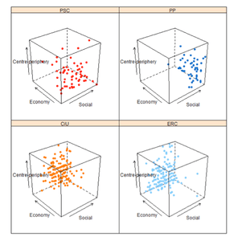
Positioning of Catalan Voters by Party

Furthermore, multinomial logistic regressions, with a series of control variables (age, gender, education, income, political interest, and mother tongue), were used to measure the dimensions’ specific influence on the vote for the four major parties in each region. The results clearly show that the three dimensions were distinct determinants of vote choice for the 2012 sub-national elections in Catalonia and Quebec.

Conclusion
As these data show, economic and social dimensions are not necessarily congruent and must be taken into account separately. It does not necessarily follow that voters who are more socially conservative are also economically conservative. Thus, while previous studies of electoral behaviour in ethno-regional contexts have included the centre-periphery axis, we propose that including this factor should not come at the expense of not considering the importance of the ‘traditional’ economic and social dimensions in structuring political outcomes.
We recommend employing our three-dimensional vote choice model to other party systems divided along the centre-periphery dimension, such as Scotland, Belgium and Bavaria, but also to cases not necessarily structured along this axis but that have been shown to have regions where centre-periphery issues are meaningful, such as Australia and the United States.

MAPP: New Resources on Party Affiliation
By DAMIEN BOL | Published: JULY 8, 2015
Emilie van Haute, Université libre de Bruxelles

What is MAPP and what we do?
MAPP is a working group on Members and Activists of Political Parties. It brings together international scholars interested in the topics of party affiliation, membership and activism. Launched in May 2014, MAPP is also a 3-year research project aimed at ‘understanding the dynamics of party membership’, and funded by the Belgian Fonds national de la recherche scientifique (FRS-FNRS).
The project intends to look at party affiliation as a relationship between supply and demand, between affiliates and their party organization, in a dynamic perspective. We realized that this relationship is not well understood. Too often, parties are considered as disincarnate organizations, or individual members are considered independent of the party they belong to. This is mainly due to the lack of available comparative data on the topic. The project intends to provide this comparative data.

How far are we?
As for Phase 1 (completed), we have undertaken a huge archival work. We have summarized what exists in terms of surveys of party members and activists, and we have archived the survey questionnaires and/or data. It has also lead to the publication of an edited volume with Routledge (Van Haute E., Gauja A. (eds) (2015), Party Members and Activists. London: Routledge). The volume summarizes where we stand and what we know about membership and activism today. It provides a clear picture of who joins political parties, why they do it, the character of their political activism, how they engage with their parties, and what opinion they hold.
Also, we have gathered longitudinal data on party membership for no less than 397 parties in 31 countries. These data allow going beyond national aggregates of party membership. It also allows testing for alternative explanations of party membership fluctuations over time, beyond the traditional macro- and micro-level perspectives. Particularly, party level explanations can be investigated, which will allow to test whether parties can do anything about these fluctuations or whether they are powerless towards their membership levels.
For example, we have calculated the ratios of members/voting age population (M/E) for each party. The figure below displays the average ratios by party family per decade since 1950 (see the figure below, click to enlarge). Significant differences appear. While a general declining trend of party membership is clearly observable, some party families seem to have coped slightly better than others. Indeed, the Conservatives display a lower rate of decline than the Social Democrats. Furthermore, the membership decline among the Social Democrats has slowed down in the last decades. Other party families such as the Christian Democrats and Liberals have faced a slower, non-linear decline, while the Greens have increased their average M/E in the last decades.
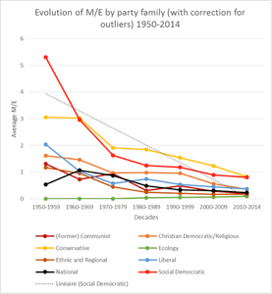
All these data are available on the project website.

What’s next?
Phases 2 and 3 of the MAPP project are based on a comparative analysis of parliamentary parties in 10 countries where experts have previous successful experiences with (online) surveys of party members. The data collection will comprise a local branch survey on the recruitment, management, and retention of party affiliates, as well as a survey of party affiliates (members and, where applicable, supporters). These surveys will allow to better grasp the dynamics of party affiliation, understood as a relation between affiliates and their party.

How do people react to the ‘performance’ of the party they voted for?
By DAMIEN BOL | Published: JULY 2, 2015
By Shane P. Singh, University of Georgia
Note: an extended version of this blog post appeared earlier at Democratic Audit UK

What is the story?
On Election Day, vote shares translate into seats and power in accordance with the electoral rules. In the end, some parties perform well, others do not, and a new government is formed. In the days or weeks following the election, it is not uncommon to see supporters of the parties in power express satisfaction with the democratic process, while those whose voices remain unrepresented in government express their disappointment.
In a paper forthcoming in Party Politics, we examine how the performance of the party one voted for affects his or her degree of satisfaction with the way democracy works. Our goals are (a) to determine whether those whose party performed well in the election become more satisfied with democracy after the election and (b) to shed light on which aspects of party performance matter most.

Data
We use 13 panel election studies that were conducted for the Making Electoral Democracy Work project. Each study was run between 2011 and 2013, and the surveys encompass ten regions within five countries: Canada, France, Spain, Germany, and Switzerland. The surveys each include two waves, usually with about 1,000 persons responding to the pre-election questionnaire in the last two weeks of the campaign and about 800 of them responding to the post-election questionnaire immediately after the election.
Both waves include a question asking respondents how satisfied they are with the way democracy works in their region or country (depending on the type of election). Since we have measures of satisfaction just before and after the election, we are quite confident that any changes observed between the two waves can be attributed to the election outcome rather than some other unobserved factor(s).

Results
We find, without much surprise, that people who voted for parties that were more successful in terms of votes or legislative seats became more satisfied with democracy. But, taking our analyses a step further, we also observe that those who voted for parties that received many votes but few seats—that is, parties that were underrepresented in parliament—became more dissatisfied. This is illustrated in the below figure.
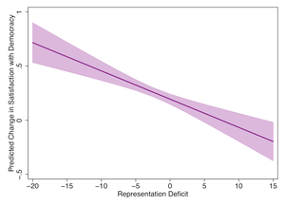

Conclusions
A number of interpretations and predictions can be drawn from our results. For example, we find that satisfaction with democracy is sensitive to representation biases introduced by the electoral system. Indeed, satisfaction with democracy can decrease when a voter supports a party that turns out to be underrepresented in the legislature, as compared to the proportion of votes it obtained. This suggests that voters are more satisfied—or at least less dissatisfied—when seats are proportional to votes.
Yet, our findings also present a challenge to this interpretation. Our analyses show that voters do not show the same dissatisfaction when representation biases lean in their favor. On the contrary, our models suggest that, if two parties were to obtain the same share of votes but a different share of seats, those voters who supported the advantaged party would experience a bigger increase in satisfaction. In short, voters’ reactions to representation biases depend on whether their party is advantaged or disadvantaged in a quite predictable way.
For further details, see André Blais, Alexandre Morin-Chassé, and Shane P. Singh. Forthcoming. Election outcomes, legislative representation, and satisfaction with democracy. Party Politics.

Strategic voting in Quebec: an analysis of the 2012 provincial election
By DAMIEN BOL | Published: JUNE 9, 2015
By Jean-François Daoust, University of Montreal

What is the story?
Despite the fact that the Quebec mass media often refer to strategic voting in their coverage of provincial elections, there is, to date, no research on that topic that specifically focuses on Quebec provincial elections. In a recently accepted article, I filled this gap in analyzing the 2012 Quebec provincial election survey of the Making Electoral Democracy Work project. First, I examined the extent to which voters engage in strategic behaviour; second, I analyzed the individual factors that influence their proclivity to cast a strategic vote.

How many strategic voters?
I followed a classic approach. In a first step I identified the survey respondents that could have potentially casted a strategic vote, that is, those whose preferred party was not one of the top two contenders in their district. These respondents had incentives to desert their preferred party and to cast a vote for one of the two viable parties in order to increase their chances to affect the final electoral outcome. 34% of respondents were potential strategic voters.
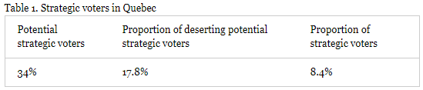
Then, I calculated the proportion of potential strategic voters that deserted their preferred party and voted for another one. They were 18%. Finally, I checked the proportion of those deserters that voted for their preferred party between the top two contenders in the district. These were strategic voters and they represented 8% of the whole sample. Table 1 shows, step-by-step, how I ended up having 8% of strategic voters.

The determinants of strategic voting
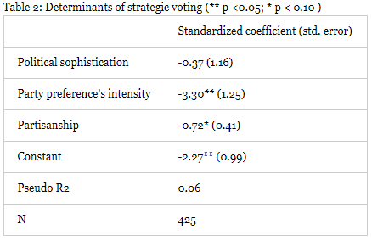
To answer the second research question, I looked at the determinants of strategic voting. Table 2 reports the results of a logistic model predicting the probability of casting a strategic vote. I found that partisanship and the intensity of party preference have a strong negative effect on the proclivity of casting a strategic vote. However, contrary to what I expected, sophisticated voters do not seem to act more strategically than the less sophisticated

Conclusion
My article is the first academic research on strategic voting in a provincial election in Canada. I provided a first systematic account of this behaviour in Quebec.
For further details, see Jean-François Daoust. Forthcoming. Vote stratégique au Québec: Analyse de l’élection de 2012. Politique et sociétés.

How to improve the functioning of democracy in Quebec and Canada? (3)
By DAMIEN BOL | Published: MAY 12, 2015
By Rébecca Morency (Laval University)

What is the story?
On April 8-9 2015, MEDW co-organized a conference on the state of democracy in Quebec and Canada. Its goal was to assemble professors, politicians, and specialists from various associations of the civil society and from the media to discuss various issues related to the functioning of democracy. In a series a blog posts, we will sum up some of the main arguments and recommendations that emerged out of this conference.
In previous blog posts, we described the arguments made by the participants regarding various ways to increase turnout and decrease political apathy of young citizens (see here), and to regulate party advertising (see here). In this post, we sum up the discussions of another panel where participants discussed the possibility of replacing the first-past-the-post (FPTP) system used to elect the Quebec National Assembly by some sort of proportional representation (PR). The participants were: Jean-Pierre Charbonneau (former Quebec deputy, Parti Québécois), Marc André Bodet (Professor at Laval University), Yves Boisvert (journalist at La Presse), and Jean-Claude Rivest (Canadian senator, independent).

The case for PR in Quebec
Charbonneau reminded the audience that, in Quebec, the FPTP system has been questioned for about 100 years.
He and Bodet agreed that a PR system would favour a more diverse representation of the various ideological groups of the population. It would reduce the unfair distortion between vote and seat shares that we sometimes observe in Quebec elections. Although FPTP tends to favour the formation of stable majority governments, it is important to remember that these governments are rarely supported by a majority of voters.
As a consequence, citizens may positively perceive the introduction of a PR system in Quebec. In this case, as Boisvert and Rivest argued, it may potentially help addressing the problems of declining political participation and growing political apathy.

The case against PR in Quebec
Bodet emphasised the ineluctable trade-off between FPTP and PR. PR systems ensure the fair representation of a diversity of opinions and ideologies in the parliament, but also reduce government stability and policy efficiency. FPTP has the exact opposite effect. The choice between FPTP and PR is then a matter of priorities.
Bodet, Boisvert, and Rivest expressed some concerns regarding the introduction of a PR system in Quebec. This system would further increase the domination of party leaders over their back benchers, as these leaders would be in charge of forming party lists. In the same vein, this might increase political patronage and other malpractices.

Bodet also argued that the replacement of small constituencies by large districts in case PR is adopted would also harm the link between citizens and their representatives.

Conclusion
The participants of this panel did not agree on whether it would be a good idea to replace the FPTP system by some sort of PR system to elect the Quebec National Assembly. In any case, given that political parties have an ambivalent relationship with the electoral system through which they are elected, a referendum, potentially with a qualified majority, would have to be organized in case of reform.

New data on Quebec elections / Nouvelles données sur les élections québecoises
By DAMIEN BOL | Published: MAY 4, 2015
David Lublin, Professor of Government in the School of Public Affairs at American University, is pleased to announce Quebec Vote, a new website in French and English containing constituency election results for all general elections to the National Assembly from 1966 through 2014. The database includes candidate names as well as votes cast in each constituency. It is free to download and available for public use. David is grateful to the Ministère des Relations Internationales of the Government of Quebec for a grant that made this site possible. He hopes to add data from earlier elections soon.

David Lublin, Professeur de Gouvernement à la School of Public Affairs de l’American University, est fier d’annoncer le lancement de Quebec Vote, un nouveau site web en français et en anglais qui rapporte les résultats électoraux, par circonscription, de toutes les élections de l’Assemblée Nationale du Québec entre 1966 et 2014. La base de données inclut les noms des candidats et les voix qu’ils ont obtenues dans leur circonscription. Elle peut être téléchargée gratuitement et utilisée par tous sans restriction. David souhaite remercier le Ministère des Relations Internationales du gouvernement québécois pour la bourse ayant permis la création du site web. Il espère ajouter les données d’élections antérieures prochainement.

How to improve the functioning of democracy in Quebec and Canada? (2)
By DAMIEN BOL | Published: APRIL 19, 2015
By Sarah Lachance (Laval University)

What is the story?
On April 8-9 2015, MEDW co-organized a conference on the state of democracy in Quebec and Canada. Its goal was to assemble professors, politicians, and specialists from various associations of the civil society and from the media to discuss various issues related to the functioning of democracy. In a series a blog posts, we will sum up some of the main arguments and recommendations that emerged out of this conference.
In a previous blog post, we described the arguments made by the participants regarding various ways to increase turnout and decrease political apathy, especially among young citizens. In this post, we sum up the discussions of another panel regarding a crucial aspect of democracy in Quebec and Canada: party advertisements. This panel gathered André Larocque (Mouvement démocratique pour une constitution du Québec), Tasha Kheiriddin (National Post) and Thierry Giasson (Laval University).

Party advertisements and fair competition
Giasson claimed that party advertisements fulfill an important democratic function. They constitute a source of information for citizens regarding the upcoming election. However, they are also very expensive (especially television advertisements), which might potentially disadvantage smaller and poorer parties, thus threatening the fairness of electoral competition
Giasson reminded the audience that some of the practices operated by media firms tend to reinforce this unfair situation. The media impose very high prices for party advertisements. The Canadian electoral law that states that the media should apply a preferential price to parties during campaigns is not implemented in practice.

Finally, Larocque pointed that this unfair situation might also contribute to a general feeling of cynicism regarding politics among citizens.

Regulating party advertisements
All participants in this panel agreed upon the existence of a problem with party advertisements and fair competition. However, none of them advocated a radical ban of these advertisements, which would be difficult to implement in the era of the web 2.0. They all favoured some sort of regulation, such as a limitating the amount of money spent on party advertisements during a campaign or the fixation of relatively cheap advertisement prices by the media for all parties.
Larocque also mentioned the possibility for the State to publicly fund the campaign of the parties engaged in the election. This would ensure that all parties have the same amount of money available for advertisements and that the electoral competition is fair.
However, Kheiriddin offered a counter-argument. If the State funds party campaigns, it means that citizens give money to all the parties through taxation. Hence, this would go against the very principle of freedom of speech, as politically engaged citizens would not be able to choose which party they want to support.

How to improve the functioning of democracy in Quebec and Canada? (1)
By DAMIEN BOL | Published: APRIL 14, 2015
By Alexandre Blanchet, University of Montreal

What is the story?
On April 8-9 2015, MEDW co-organized a conference on the state of democracy in Quebec and Canada. Its goal was to assemble professors, politicians, and specialists from various associations of the civil society and from the media to discuss various issues related to the functioning of democracy. In a series a blog posts, we will sum up some of the main arguments and recommendations that emerged out of this conference.

In the first panel, the participants debated various ways to increase turnout and decrease political apathy, especially among young citizens. The panels gathered Michel Venne from the Institut du nouveau monde, Emily Barette from C-I-V-I-X, Eugénie Dostie-Goulet from the University of Sherbrooke, and Léo Bureau-Blouin, former deputy for the Parti québécois.

Voting age and civic education course, and other education-related activities
Venne strongly advocated the creation of a mandatory civic education course in Quebec’s high schools. This course would aim at familiarizing teenagers with the general ideas of democracy and politics. He also argued that we should lower the voting age to 16, and impose an official ceremony that would mark the acquisition of the voting right by young citizens.
Barette expressed some doubts about the creation of a mandatory civic education course in Quebec’s high school. She pointed out that the course was largely ineffective in Ontario, where it was introduced years ago. This failure is mostly explained by the disengagement of the teachers themselves,who often feel uncomfortable with the topic. Instead, she encouraged the organisation of more practical activities such as voting games and simulations. C-I-V-I-X frequently organizes this type of activities with young citizens from less favourable socio-economic background and this is always a success. Combined with a lowering of the voting age to 16, she argued that this helps developing the democratic conscience of young citizens.
Dostie-Goulet agreed that lowering the voting age to 16 is likely to induce some voting habit among young citizens. She also mentioned the various obstacles that would make the creation of a civic education course in Quebec high schools difficult. In particular, she argued that the topic is somehow already covered in another course of the curriculum (i.e., Univers social section). Hence she advocated a more incremental approach based on the organization of various punctual activities such as voting games and simulations, and other projects specifically intended for high school teachers that would raise their awareness regarding the problem of political apathy among young citizens.
Finally, Bureau-Blouin positioned himself in favour of a civic education course in high schools. However, he also expressed some concerns related to the feasibility of such a reform. He reminded the audience that the curriculum is already rather full. He then also encouraged the punctual organization of more practical activities such as those organized by C-I-V-I-X and argued that governments should financially support them. He also agreed that the voting age should be lowered to 16.

Conclusion
During the conference on the state of democracy in Quebec and Canada, several participants debated various ways to increase turnout and decrease political apathy, especially among young citizens. While all them agreed that introducing a mandatory civic education course in high schools would be a good idea, many expressed doubts regarding the feasibility of such a reform. They advocated a more incremental approach based on the punctual organization of practical activities such as voting games and simulations. All participants also agreed upon lowering the voting age to 16.

Assessing the Mechanical and Psychological Effects of District Magnitude
By DAMIEN BOL | Published: MARCH 16, 2015
By Romain Lachat (Universitat Pompeu Fabra)

What is the story?
Under proportional representation (PR), the number of representatives elected may be very different from districts to districts. Portugal, for example, has very small districts where only 2 representatives are elected, and others that are much larger, such as Lisbon where 48 representatives are elected (for the 2005 national election). In a recent article, we used this specific institutional context to test how district magnitude affects electoral results.

The mechanical and psychological effects of district magnitude
The smaller district magnitude is, the more difficult it is for small parties to be elected, because of two inter-related effects. First, the ratio between the votes a party received and the seats it obtains cannot be fully proportional if the number of seats to be filled is low. For example, it is rather obvious that many small parties will not obtain any seats if they are only two seats to be filled in the district (and this is true regardless of the electoral formula used to assign those 2 seats). This is the mechanical effect of district magnitude.
Second, parties and voters, being aware of this mechanical effect, adapt their behaviour consequently. Parties may for example decide not to compete in districts in which they have very few chances of having a seat, or to invest fewer resources in the campaign there. In the same vein, voters may defect from their preferred party if its electoral chances are low, and opt for a party that has better prospects. This is the psychological effect of district magnitude.

Results
In our article, we focused on the 2005 national election in Portugal. As mentioned above, district magnitude varied drastically across the country, which provides a great opportunity to test its effect. We relied on official results and on survey data from the Comparative Study of Electoral Systems. We compared the actual electoral results with simulations of what would have been these results if all districts were as large as the largest one (District magnitude = 48).
We showed that small parties would fare substantially better if the districts were larger. The share of seats of small parties would increase between 4 and almost 20%-points (depending on how large the original district was). We also showed that this change would be mainly due to the mechanical effect of district magnitude. Figure 1 illustrates this argument in showing how the number of seats going to small parties (left-hand panel) and the effective number of parliamentary parties (right-hand panel) would vary if all electoral districts were as proportional as the largest district.
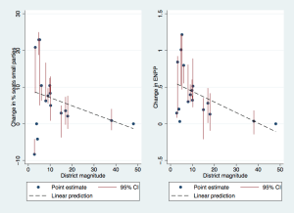
Figure 1

On the opposite, we found that the psychological effect of district magnitude on the electoral outcome was inexistent. Our data revealed than only about 2% of Portuguese voters did not vote for their preferred party for strategic considerations in the 2005 national election. This number is too small for the psychological effect to have an independent impact on the electoral outcome.
For further details and analyses, see Lachat, Romain, André Blais, and Ignacio Lago. Forthcoming. Assessing the Mechanical and Psychological Effects of District Magnitude. Journal of Elections, Public Opinion and Parties.

Voting Correctly in Lab Elections with Monetary Incentives: The Impact of District Magnitude
By DAMIEN BOL | Published: MARCH 8, 2015
By André Blais (University of Montreal)

What is the story?
In a recent article, we examined how electoral rules influence correct voting in lab elections. We defined a correct vote as a vote that maximizes a subject’s payoff. We found that correct voting is more frequent under plurality than under proportional representation (PR).

The lab experiment
We organized twelve experimental sessions, six in Brussels and six in Montreal. In each of them, 21 subjects were invited to play the role of voters in a series of 24 consecutive elections. For each election, they had to decide to vote for one out of four parties. We varied our main treatment variable, i.e. the district magnitude (DM) from single-member plurality (DM=1) to a pure proportional system (DM=21), from sessions to sessions.
At the beginning of each session, we randomly assigned a “voter profile” to each subject (this voter profile was randomly reshuffled every three elections, just as the number of subjects with a given profile). This profile determined the voter’s preferences regarding the four parties. The general idea was that each subject strongly preferred one party and strongly disliked another one, and the two others in between. The payoff structure depended on two features: the proportion of seats each party won and the voter profile. The payoff of each subject increased with the number of seats obtained by the parties that she liked. Finally, before each election, subjects were informed about the distribution of profiles among them and where subsequently asked to indicate how many votes they thought each party would obtain.

The findings
All in all, 73% of the votes cast in the various elections were “objectively” correct, that is, the decision made by the participant maximized her payoff, given the actual votes cast by the other participants. The percentage is almost the same (74 %) with the subjective approach, when we use the participants’ anticipation about the results rather than the actual votes.
We found that the participants voted more correctly (whether defined objectively or subjectively) in single-member plurality elections than in multiple-member PR elections. But we found little difference whether DM was 3, 5, 7, 9 or 21, and so the contrast is between plurality and PR.

Conclusion
In a recent article, we showed that correct voting, as defined there, is more frequent under the plurality rule than under PR. The reason is simple: it is easier for voters to figure out whether they should vote sincerely for their preferred party or strategically support another one when the only way to win a seat is to have more votes than all the competitors. The plurality rule has many perverse consequences but people easily understand the logics. Things are not so easy with PR.
For more information, see André Blais, Jean-Benoit Pilet, Simon Labbé-St-Vincent, and Rafael Treibich. Forthcoming. Voting Correctly in Lab Elections with Monetary Incentives: The Impact of District Magnitude. Party Politics.

Conference on the state of democracy in Quebec and Canada
By DAMIEN BOL | Published: FEBRUARY 27, 2015
On April 8 and 9, the Making Electoral Democracy Work project will organize a two-day conference on the state of democracy in Quebec and Canada. The goal is to gather professors, politicians, and specialists from various associations of the civil society and from the media to discuss about this issue. It will be held at the National Assembly of Quebec, in Quebec city. This event is co-organized by the Chaire de recherche sur la démocratie parlementaire (Laval University).
Below you’ll find the full-program of this conference (in French).

Programme : 8 avril

12h30-13h00 : Accueil des participants

13h00-13h30 : Mots d’ouverture

Thème 1 : Participation citoyenne et représentation

13h30-15h00 : L’éducation civique

- Proposition débattue : Il faut introduire un cours obligatoire de formation des compétences civiques dans le curriculum scolaire des jeunes Québécois et Canadiens.
- Emily Barrette (CIVIX)
Eugénie Dostie-Goulet (Université de Sherbrooke)
Léo Bureau-Blouin (ex-PQ)
Michel Venne (INM)

15h00-15h30 : Pause-café

15h30-17h00 : Les femmes en politique
- Proposition débattue : Nous devons forcer les partis politiques à présenter autant de candidatures féminines que de candidatures masculines aux élections.
- Karine Vallières (PLQ)
Julie Miville-Dechêne (CSF)
Françoise Boivin (NPD)
Fatima Houda-Pepin (ex-PLQ)

17h00-18h00 : Réception

18h00-20h00: Souper-conférence des anciens présidents au restaurant Le Parlementaire
- Discussion portant sur : « Les conditions nécessaires à l’adoption d’une réforme parlementaire. »
- Souper-conférence animé par Bernard Derome avec Louise Harel et Peter Milliken.

Programme : 9 avril

8h00-8h30 : Accueil des participants

Thème 2 : Le rôle des élus et le fonctionnement des institutions parlementaires

8h30-10h00 : La période des questions
- Proposition débattue : Les questions devraient être soumises au gouvernement par écrit à l’avance.
- Gilbert Lavoie (Le Soleil)
Réjean Pelletier (Université Laval)
Lise Ravary (Journal de Montréal)
Benoît Charette (CAQ)

10h00-10h30 : Pause-café

10h30-12h00 : Le processus législatif
- Proposition débattue : Il faut réduire la discipline partisane en permettant des votes libres sur toutes les questions non budgétaires.
- Agnès Maltais (PQ)
Jean-François Godbout (Université de Montréal)
Stéphane Dion (PLC)
Pierre-Paul Noreau (Le Soleil)

12h00-13h30 : Dîner

Thème 3 : Les partis politiques et les institutions électorales

13h30-15h00 : La réforme du mode de scrutin
- Proposition débattue : Il faut adopter un mode de scrutin proportionnel pour avoir des gouvernements qui représentent mieux la diversité des points de vue.
- Jean-Pierre Charbonneau (ex-PQ)
Marc-André Bodet (Université Laval)
Yves Boisvert (La Presse)
Jean-Claude Rivest (Sénateur indépendant)

15h00-15h30 : Pause-café

15h30-17h00 : Le financement des partis politiques
- Proposition débattue : Il faut interdire la publicité électorale venant des partis afin de minimiser le rôle de l’argent dans les élections.
- André Larocque (Mouvement Démocratie et Citoyenneté du Québec)
Tasha Kheiriddin (National Post)
Thierry Giasson (Université Laval)
Maxime Pednault-Jobin (UMQ, Maire de Gatineau)

17h00 : Fin du colloque

Sponsors
Élections Canada
Directeur général des élections du Québec (DGEQ)
Institut du Nouveau Monde

Registration
Registration is free, but compulsory. If you want to attend the conference, please send an email to colloquedemocratie@pol.ulaval.ca before March 20, 2015. The email should include your name, your institutional affiliation, and the panels/meals you want to attend.

Like turkey not voting for Christmas: Why Sweden cancelled the snap election
By DAMIEN BOL | Published: FEBRUARY 12, 2015
By Patrik Ohberg (University of Gothenburg) and Annika Fredén (Lund University)

What is the story?
Sweden has lived an unprecedented political turmoil these last months. In a preceding blog post, we pointed out that the rather unique Swedish political culture of compromise was threatened by the success of the populist anti-immigration Sweden Democratic Party. The minority government that was appointed right after the 2014 national election was not able to make its budget approved by the parliament. The Prime Minister Stefan Löfven decided to call a snap election that was supposed to be held on March 22, 2015.
However, there will not be a snap election next March. Right after Christmas, the political culture of compromise of Sweden knew a revival. The main parties managed to sign a major agreement, called the ‘December agreement’, as to avoid the organization of a snap election. In this post, we describe this agreement and its consequences.

The December agreement
On December 27, the Prime Minister and leader of the Social Democratic Party Stefan Löfven signed an agreement with the party leaders of all the parties of the two main coalitions. The Swedish party system revolves around two coalition blocs: a centre-right and a centre-left coalition. The agreement states that the budget of the coalition that obtains the largest vote share at a national election, and which typically forms the next government, will be automatically approved. It will thus make life easier for minority governments in the future. Their budget will be automatically approved even if only a minority of the parliamentarians supports it. The agreement is supposed to last until 2022.
The reason for this agreement lies in the recent evolution of the Swedish party system. The populist anti-immigration Sweden Democratic Party is increasingly popular among voters. The party came third at last national election with 13% of the votes. It thus controls a substantive portion of the parliamentary seats that is still growing from election to election. This makes the formation of minority governments very likely in the future. However, the Sweden Democrats are not part of any coalition and are thus, by default, excluded from government and power. In order to exert some influence, they decided, from now on, to systematically vote in favour of the opposition’s budget to create a gridlock. The party leaders said that they would continue this strategy until their demand for stricter immigration policies has been met. The agreement is thus a way to cut the grass under the strategy of the Sweden Democratic Party.

The consequences
Although the December agreement is a sign that the Swedish political system somehow goes back to normal, the turmoil of these last months is not without consequences, especially for parties of the centre-right coalition. First, most of the parties composing this coalition have started to rethink their position regarding immigration. For example, some of them recently indicated they would be in favour of stricter conditions for granting permanent residency.
Also, the leaders of the Christian Democratic Party and of the Liberal People’s Party are on the verge of being replaced. This might in turn lead to a re-positioning of these two parties as well and a weakening of the centre-right coalition. Although the crisis is over and Sweden has seemingly returned to a politically stable period, we will surely still see the consequences of the political crisis in the coming months.

Competing Without Chances (II)
By DAMIEN BOL | Published: JANUARY 23, 2015
By Marc Guinjoan, Universitat Autònoma de Barcelona

What is the story?
In real-life elections, it is not uncommon for some parties to compete even if they have no chance of winning or gaining parliamentary seats. According to most theories of party competition, the existence of a cost of entry (i.e., the cost of running a campaign or to even to qualify as a candidate) should deter non-viable parties from competing. How can we thus explain the presence of non-viable parties?
In a recent book, I address both the organisational and institutional factors that explain the decision of political parties to compete without chances. In a recent blog post, I dealt with the organisational factors; today, I address the institutional explanations of this phenomenon.

Explaining votes in favour of non-viable parties
Most theories of party competition assume that voters do not vote for a party if they think that this party has no chance of being elected in their district. They do so as to maximize the chances that their single vote will make a difference in the final electoral outcome (we talk about a strategic vote, in contrast to a sincere wasted vote for a non-viable party). However, in reality, we observe that parties that stand no chance of being elected receive votes. This might be an explanation for why these non-viable parties decide to compete.
As I mentioned in my previous blog post, many democracies are composed of various electoral arenas that overlap on a given territory (e.g., local, regional and national elections). One can assume that the vote share received by a party in a given arena is at least partly a function of the vote share this party receives in other arenas of the same territory, or even of the same arena but in other territories. Thus, the institutional architecture of the State and the way the territory is divided into electoral districts are very important when it comes to explaining the persistence of non-viable parties.
To study this issue, I constructed an original dataset that covers 46 democracies, 240 elections, and around 26,000 districts. I calculated, at the national level, an aggregated measure of the number of votes cast in favour of non-viable parties using the difference between the effective number of electoral parties and the effective number of viable parties (the parties that obtain at least a seat + the first runner-up party) that compete in each district.

How the institutions affect votes for non-viable parties
My empirical analyses show that, in countries using a mixed-member system combining proportional representation and single-member plurality in overlapping constituencies such as Germany, an increase in the share of seats a party gets in the proportional tier has a positive effect on the votes received by this party in the plurality tier (even if this party is not viable in this latter tier).
I also demonstrate that the degree of power granted to a sub-national entity such as a region is a strong determinant of the vote share obtained by non-viable parties. For example, regional parties that are successful at the sub-national level still receive votes at the national level even if they are not viable in this electoral arena. In the same vein, I find that the presence of an ethno-linguistic cleavage in a territory increases the number of votes received by parties that have no chance.
Finally, I show that there is an effect of district magnitude, and particularly of the variation in the number of elected candidates by district in a given electoral arena. In countries where there are very large and very small districts, the parties that are non-viable in small districts take advantage of the fact that there are viable in large districts. There is thus a contamination effect.
For more information, see the book “Parties, Elections and Electoral Contests: Competition and Contamination Effects” (Ashgate Publishing, 2014).

Competing Without Chances (I)
By DAMIEN BOL | Published: JANUARY 20, 2015
By Marc Guinjoan, Universitat Autònoma de Barcelona

What is the story?
In real-life elections, it is not uncommon for some parties to compete even if they have no chance of winning or even of gaining parliamentary seats. According to most theories of party competition, the existence of a cost of entry (i.e., the cost of running a campaign or to even to qualify as a candidate) should deter non-viable parties from competing. How can we thus explain the willingness of some non-viable parties to compete?
In a recent book, I address both the organisational and institutional factors that explain the decision of political parties to compete without chances to gain even a single seat. In this blog post, I deal with the organisational factors; I leave the institutional explanations for an upcoming blog post.

A multi-arena logic
Most theories of party competition assume a perfect independence between electoral arenas. However, many democracies are composed of various arenas that overlap on a given territory (e.g., local, regional and national elections). It is therefore reasonable to think that, in reality, parties make decisions regarding entry in a multi-arena logic.
To investigate this issue, I have conducted in-depth interviews with party elites and campaign managers in Canada and Spain between 2010 and 2011 (some of them have been conducted within the MEDW project). In some cases, the actors decided to withdraw their candidacy or to join a coalition because they were non-viable (as it would have been predicted by party competition theories), in others they decided to compete even if they had no chance of winning.

Two organisational factors
It is not uncommon to see that, in a given territory, parties decide to compete in an election where they are viable and in another where they are not. This phenomenon, labelled as electoral contamination or contamination effect, is generated by two organisational factors.
1. Economies of scale
First, the overlap of electoral arenas generates economies of scale for political parties. If a party is already present in a given territory because it is viable in one arena, the cost for competing in another arena is low (for e.g., a group of candidates and activists are already present and active). Therefore, this party can decide to compete even if they have no chance of winning due to the relatively marginal cost of entry. However, my interviews show that the mere presence of economies of scale is not enough to explain the decision of non-viable parties to enter elections.
2. Political externalities
Second, there are sometimes positive political externalities for a party to compete in an arena where it is not viable (and negative externalities not to compete). From my interviews, I show that parties gain of visibility, a promotion of the party label (particularly for large parties), an activation of local party section, and the possibility of raising awareness about certain issues (particularly for ideologically rigid parties) by competing on a separate platform.
Analogously, the decision to withdraw from competition has negative political externalities such as a damage of reputation (particularly for parties that decide to present joint candidacies with other parties) and a tension with the local grass-root members.
For more information, see the book Parties, Elections and Electoral Contests: Competition and Contamination Effects” (Ashgate Publishing, 2014).

Gender Quotas in Single Member Districts
By DAMIEN BOL | Published: JANUARY 13, 2015
By Gabrielle Bardall, University of Montreal

What is the story?
Single-member district (SMD) electoral systems have a bad reputation as far as women’s political representation is concerned. In comparison to proportional representation-based systems (PR), they have been widely considered to disfavour the election of women for a plethora of reasons. In particular, the single most effective tool in use today for enhancing women’s representation – the gender quota – has been viewed as excessively complicated or ineffective when applied in SMD systems.

Yet, over four billion people in 64 countries (or 53% of people living in countries with elected national parliaments) use a SMD system to elect their national parliaments. As SMDs are here to stay, and if the equality agenda is to move forward, we need to understand how gender quotas can work in SMD systems. In this blog post, I sum up the findings of a recent paper where my co-author Skye Christensen and I discuss the functioning and efficiency of gender quotas in SMD systems.

Types of gender quotas in SMD systems
The world of quotas is generally broken down between nomination quotas (or input quotas) and reserved seats (output quotas). Nomination quotas set limits on who can be nominated as candidate, for instance by setting a specific minimum threshold for women or minority candidates. Reserved seats specify certain mandates for these categories of candidates.

A nomination quota typically requires a minimum percent of each sex among candidates of a party in either (a) the collection of all SMDs of the country, or (b) in specially created PR-districts. The first option is applied in pure majority/plurality systems (such as in France) and the second creates a mixed system with both majority/plurality seats and PR seats.

Options for reserved seats are more varied. First, there is super-districting for which an additional tier of women representatives elected under plurality, majority or PR on a separate district, but joining the same elected body, as seen in Uganda.

Second, there are rotational quotas, as used in India’s local elections, where a proportion of the regular SMDs are reserved for women candidates one term out of three. Different districts fall under the reservation for each electoral cycle – through a rotation system – so that a portion of seats are reserved for any election, and over subsequent cycles the impact is spread geographically.

Third, there are alternate threshold systems that establish two thresholds for being elected: one based on greatest absolute number of votes (such as in any regular plurality system), the other based on greatest percentage of votes within a subset of candidates (in this case, women). Under this approach, all candidates (male and female) compete together in a single race and the candidate with the greatest number of votes wins the seat. Subsequently, an additional number of reserved seats are filled by those women candidates who received the highest proportion of votes without winning a majority/plurality in their district.

Finally, there are PR-tier systems, which indirectly elect women candidates based on results in direct elections held under majority/plurality races in a proportional fashion. While effective in raising the numbers of women in office, the PR-tier system is often criticized for marginalizing and undermining the legitimacy of the women elected under the system.

Use and efficiency of gender quotas in SMD system
Table 1 shows the use of the five gender quotas presented above in today’s democracies. Almost all the options perform as well or better than gender quotas in PR systems. They thus constitute effective innovations in SMD systems to ensure gender equality in parliamentary representation. Each of these systems has its advantages and drawbacks, as do the quotas used in PR Systems. A review of these cases reveals that quotas in SMDs are no more complicated or less effective than quotas used under PR.
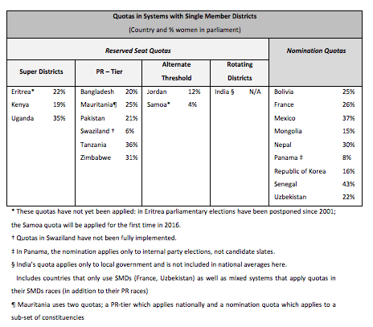
Table 1: Gender quotas in SMD systems
For more information, see Skye Christensen and Gabrielle Bardall. 2014. “Gender quotas in single-member district electoral systems.” European University Institute Working Paper Series. Robert Schuman Centre for Advanced Studies Global Governance Programme-134, 2014/104.

Sweden: An unprecedented crisis in a (lost?) political stability heaven
By DAMIEN BOL | Published: DECEMBER 15, 2014
By Annika Fredén (Lund University)
Elina Lindgren (University of Gothenburg)
Patrik Öhberg (University of Gothenburg)

What is the story?
On December 3, two months after the national election, the Swedish Prime Minister Stefan Löfven called a snap election. This is an unprecedented phenomenon in a country that is considered by many as a political stability heaven. The last snap election was held in 1958. This long period of political stability was due to the Swedish political culture favouring compromises over conflicts, and based on the good will of the political parties represented in the national parliament.
The newly elected minority government, a coalition between the Social Democrats and the Greens, was not able to get its budget through parliament, and the Centre-right opposition’s budget received more votes. The government then decided to hold a snap election on March 22, 2015. In this post, we explain the causes of this budget’s crisis.

A new actor: the Swedish Democrats
The Swedish Democratic party is a relatively new party on the Swedish political scene. Although it was founded in 1988, the party only received its first seats in the national parliament in 2010. At last September election, it doubled its representation, from 20 to 49 out of 349 seats, and became the third bigger party of the country.
The new formation is a populist party, which main goal is to cut immigration. Since it has a controversial history and used to be close to several neo-Nazi organisations, the Swedish political class refuses to include it in talks and negotiations. The Swedish Democrats are neither part of the Centre-right opposition coalition, nor of the governing Red/Green coalition. Breaking with the Swedish culture of compromises and political good will, the party voted in favour of the opposition’s budget. The common practice was that parties that are not part of any coalition abstain to vote on the budget, which has the effect of allowing the adoption of budget of the government.
The Swedish Democrats’ decision to support the opposition’s budget was strategic. Sweden being one of the most liberal countries in this respect among OECD countries, they argued that they could never support a budget that is too generous regarding immigration. They explicitly targeted the Green party, and made it responsible for this generosity. However, the opposition’s budget proposal does not differ in any substantive sense regarding immigration. As the Swedish Democrats are isolated in the political system, their decision to block the government’s budget was motivated by a willingness to shake up the country’s current policy in the domain.

A strategic move of the Prime Minister
The Prime Minister and leader of the Social Democratic party Stefan Löfven surprised many experts in calling a snap election. This decision was probably also driven by strategic considerations. In taking it, he might indeed expect to remain in office, and even to increase his coalition’s parliamentary seat share.
The opinion polls conducted just a few days after his announcement showed that the prospects for the three biggest parties, the Moderate party (i.e. the senior partner of the opposition centre-right coalition), the Social Democratic party, and the Swedish Democrats, are really good (see Table 1 below). Most of the citizens who voted for these parties last September said that they would remain loyal to their respective party next March (80%). This is much bigger than the proportion of loyal voters among other parties’ supporters (50%-75%), in particular, the newly formed Feminist Initiative, which failed to reach the 4% electoral threshold (43%). On the consequence of this threshold and on the Feminist Initiative’s failure, see this previous blog post.
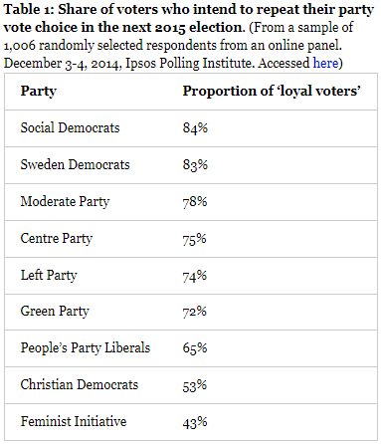
However, all these prospects are rather uncertain as we are only at the beginning of this new campaign, which started only a few months after the last one ended. Besides, given the unprecedented nature of this crisis, the new election could also be an opportunity for new ideas and candidates to take a step forward.

The Voting Game: a Civic Education Activity offered to Disadvantaged Youth
By DAMIEN BOL | Published: NOVEMBER 13, 2014
By Valérie-Anne Mahéo, McGill University

What is the story?
In Canada, as in other industrialized democracies, low and declining turnout rates among youth have become a central democratic problem. This problem is especially acute among disadvantaged and less educated youth, who are less likely to vote than the rest of the population.

In this blog post, I present a civic education activity that was conducted by the MEDW project and the Centre for the Study of Democratic Citizenship1 , in collaboration with the NGO Apathy is Boring. This activity took the form of a voting game. The goal was to raise the awareness of less educated and under-privileged young Canadians about several issues related to elections.

The voting game
Between the summer of 2013 and the summer of 2014, we organized 20 workshops in the province of Quebec. These workshops reached close to 300 disadvantaged or unemployed young people. The participants were aged 18 to 30 and were taking part in youth employment or training programs. The workshops lasted between 1.5 and 2 hours.
The participants played the voting game in small groups of 9 to 16 people. They were told that they were part of a soccer team that has to decide the color of their jerseys (black, grey or pink). This decision was made through a vote with clickers and the results were directly projected on a screen. Each participant had one vote. The winning color was the color that obtained the most votes. In each workshop, we organized 6 rounds of vote (see Picture 1). The first three rounds were played in silence, while the participants could communicate with each other during the last three.
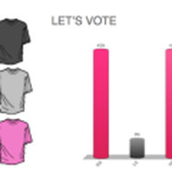

Picture 1: Excerpt of the instructions (click to enlarge)

Each participant was given a set of ordered preferences for colors (with a most preferred and least preferred color). If the group elected the preferred or second preferred color of a participant, he/she received points (more if his/her preferred color won). At the end of the game, we calculated all the points obtained in all the votes. The ultimate goal for the participants was to win the most points: the more they had points, the more chances they had to win free movie passes.
The ‘groups with preferred colors’ were uneven and some had different orders of color preferences. Therefore, the participants had incentives to think strategically about their vote. It was sometimes better (in terms of winning points) to vote for their second preferred color. We believed this would raise their awareness about elections and the multi-facets strategies of the vote.

The participants’ feedback
After the voting game, participants were offered to share their impressions. Many participants said that they did not realize there were different ways of voting and hadn’t thought about voting ‘strategically’ before. Conversations usually broadened and participants discussed elections and voting more generally (see Picture 2). While these youth were typically disengaged, they were not apathetic about politics and had lots to say on the matter.
Picture 2: Participants discussing
These workshops elicited meaningful dialogues about politics and democratic participation. They were lively and interesting with a small number of youth going so far as to encourage their peers to vote for their favorite political party. Few youth however said they would vote in the next election.
While the voting game was effective in teaching youth about the different ways to vote, it was not very effective in mobilizing them to vote. This result is in line with past research that has shown that one single civic education activity may not be enough to stimulate a change in political behaviour. However, the immediate repercussions of these workshops reinforced the positive message of civic engagement. Typical remarks from the employment centers’ coordinators were that of excitement and optimism. They were grateful to have their youth participate in discussions on topics that are not usually addressed in their training or employment programs.

- The researchers involved were André Blais (University of Montreal), Elisabeth Gidengil (McGill University), Valérie-Anne Mahéo (McGill University), Sara Vissers (McGill University), and Carol Galais (University of Montreal). ↩

Strategic voting under PR: Evidence from a survey experiment in Sweden
By DAMIEN BOL | Published: OCTOBER 22, 2014
By Annika Fredén, Lund University

What is the story?
In this blog, we often talk about strategic voting. As a reminder, we define strategic voting as voting for a party that is not one’s preferred party in a willingness to affect the electoral outcome. Typically, strategic voting concerns voters who prefer a party that has little chances of winning an election. Instead of wasting their vote in voting for this party, they cast a vote for their second (or third) preferred option that has better chances of winning.
There is another version of strategic voting that occurs in proportional representation (PR) systems. Under PR, parties usually form coalitions. When a small party risks falling below the minimal score required to have a representation in parliament (the ‘electoral threshold’), the supporters of the senior coalition partner sometimes decide to cast their vote for this small party in order to allow it to reach the threshold for the collective sake of the coalition. This is called ‘threshold insurance voting’. In previous blog posts, we show that this type of practice exists in Sweden and Germany.
In the present post, I show that a crucial condition for threshold insurance voting to occur is that the coalition lines be crystal clear. To do so, I draw upon recent survey experiment conducted during the 2014 Swedish general election’s campaign.

Coalition politics in Sweden
The Swedish party system is divided into two blocs. On the right, four parties form a coalition called the ‘Alliance’. The Alliance governed Sweden from 2006 to the 2014 general election. The coalition lines are well defined and all parties ran a common platform during the campaign.
On the opposite side, the left-wing bloc is far less established. During the campaign, Stefan Löfven, the leader of the Social Democratic Party (the largest left-wing party, which has a long tradition of governing alone in minority governments), said he was open to discussion with other parties at both sides of the political spectrum. A link with the Green Party was quickly established. The two other left-wing parties, the Left Party (far left) and the Feminist Initiative, a new formation that had just won a seat at the last European election in May declared they would support a Social Democratic government. However, the parties did not manage to coordinate as much as the right-wing coalition. At the end of the day, the left-wing parties decided to run separate campaign platforms.
The incumbent right-wing coalition lost many seats during the 2014 general election. The Social Democratic Party and the Green Party formed a minority government, while the Feminist Initiative failed to reach the 4% electoral threshold and thus gained no seat in parliament.

A survey experiment
The week before the 2014 general election, the polls released in the media revealed that the Feminist Initiative and the Christian Democratic Party (a small member of the right-wing coalition), were very close to the 4% electoral threshold. There was thus a unique opportunity to test whether the coalition signal – very clear in the case of the right-wing coalition, quite ambiguous in the case of the left-wing coalition – has an impact on the level of threshold insurance voting.
I ran a survey experiment 6 days before Election Day, through the online panel survey maintained by the laboratory LORE (University of Gothenburg). I randomly assigned different poll information to the 5,000 respondents. The reported level of support for all the parties was as released in the most recent polls. I only changed the predicted score of the Feminist Initiative and Christian Democratic Party. A third of the respondents saw these parties below the 4% electoral threshold at 2.5%, at exactly 4%, or at 5.5%. Then I asked respondents how they would vote if the polls looked like the poll they were presented.
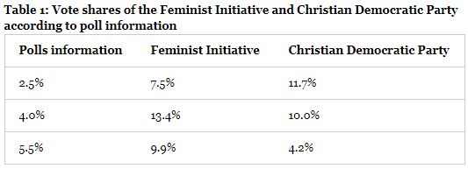
The results show that vote intentions in favour of the Christian Democratic Party are significantly higher when the party is reported at the electoral threshold level or below (10-11% compared to 4% when it is reported as being above the electoral threshold). On the opposite side, vote intentions for the Feminist Initiative are less affected by the polls information (the level varies between 7%-13%). It seems like the party gains vote intentions when it is reported above the 4% threshold. The complete results are shown in Table 1 below. It is worth noting that highly educated people are over-represented in the sample. The vote intentions for the Feminist Initiative are higher than in the overall population.

Conclusion
Strategic voting is a common practice in PR systems, in Sweden as in other established democracies. In the 2014 Swedish general election, I ran a survey experiment to assess how coalition signal affects strategic voting for small parties. The results show that the new Feminist Initiative, that was not part of a well-established coalition, would gain much less from threshold insurance voting than the Christian Democratic Party, a member of a well-defined right-wing coalition.

“Non, je ne regrette rien”: Citizens’ Reflections on Their Electoral Choices
By DAMIEN BOL | Published: OCTOBER 8, 2014
By Anja Kilibarda and André Blais, University of Montreal.

What is the story?
The MEDW survey data is well suited to exploring citizens’ ex post facto judgments about their voting decisions. In this blog post, we report the cross-national differences in respondents’ reflections on their electoral choices and systematically compare voters to abstainers. We show that most voters believe that they made the right choice, while abstainers are not so sure.

Voters’ Reflections
In the post-election MEDW surveys, we asked respondents whether they considered that voting/not voting was a good or bad decision. Those who voted were also asked about whether they believed their decision to vote the way they did—for whichever party or candidate they did—was a good or bad decision. The Likert-type response options ranged from “a very bad decision” to “a very good decision.” In the figures below, regional and national elections within countries were collapsed since the results did not substantially vary, as were the regions surveyed within each election.

Figure 1 shows the percentage of voting citizens across the six countries covered by the MEDW survey that believe their decision to vote was a very good decision. Perhaps unsurprisingly, in nearly every case, a substantial majority of respondents feel they made a very good choice in turning out on Election Day. The proportion is highest in Canada and France where fully about 77% and 76% of respondents, respectively, believe voting in the particular election was a very good decision. The proportion is lowest in Belgium, where only a slight majority of the population believes they made a very good decision.
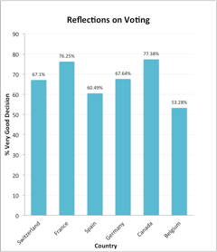
Figure 1
This result is interesting in light of the fact that Belgium represents the only country surveyed wherein voting is mandatory. It is possible that lacking the ability to choose whether to turn out or not decreases an individual propensity to judge voting as a good decision. Indeed, it could be argued that deciding to vote in Belgium is not a genuine decision at all. The three middling cases are Switzerland, Spain, and Germany, where the percentage of respondents very satisfied with voting is in the 60s.

Abstainers’ Reflections
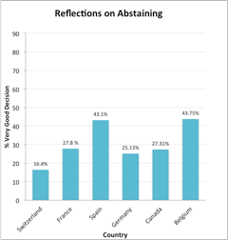
Figure 2 reports the percentage of abstainers who believe their decision to not vote in the relevant election was a very good decision. Given the social norm to vote, the proportion of people judging their decision to abstain as very good is relatively low across the board. In Switzerland, only 16% of people believe their decision to vote was a very good one. In France, Germany, and Canada, these numbers hover around 26%.
Figure 2
Interestingly, the percentages are nearly double in Spain and Belgium. A relatively high proportion in Spain might be explained by higher levels of disillusionment with democratic processes in light of persisting corruption. Transparency International considers the Spanish government to be the most corrupt of the governments of our six countries. Moreover, Spanish citizens perceive more corruption in their national government than citizens of the six other countries (see this former MEDW blog post). Given that corruption has been found to discourage voter turnout (see for example Anderson and Tverdova, 2003), it is reasonable to suspect that it might also encourage abstaining individuals’ justification of their choice as a good one.
In Belgium, deciding not to vote entails taking a risk of having to pay a fine. As such, it seems to make sense that those who took that risk feel strongly they made a good decision. It is possible they spent more time deliberating and are thus more likely to have made a well thought out decision. Engaging in high-risk behaviour may also fortify a choice-supportive bias: because the emotional cost of abstaining is relatively high for the average person, the strength of the ex post facto justification of the cost needs to be correspondingly high. Overall, in each country, the proportion of abstainers who believe they made a very good choice is much lower than the proportion of voters who believe the same.

Voters’ Reflections About Party Choice
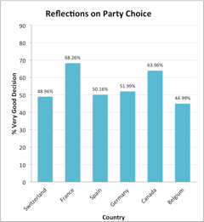
Finally, Figure 3 represents the distributions for the percentages of people who believe they made a very good choice in voting the way they did (that is to say, for the political party or candidate for whom they voted). The proportion very satisfied is highest in France, where slightly over 68% of respondents believe they made the right party choice. It is second highest in Canada, where approximately 64% of respondents in Ontario and Quebec, the provinces surveyed, believe they made a very good party choice. Belgium once again has the lowest proportion of very satisfied respondents with only 45% of the population believing their decision to vote for the party they did was a very good one.
Figure 3

This outcome is perhaps due to a high number of competing parties leading to a greater propensity for voters to make an error in their choice, perhaps because collecting sufficient campaign information to make a correct choice is more difficult (see for example Lau et al. 2014). Indeed, Belgium and Switzerland both had the greatest number of parties competing in their respective elections and both show the lowest proportions of citizens satisfied with their choice, between 44-49%. That said, Spain and Germany report only slightly more very satisfied respondents, at 50% and 52%, respectively, despite having about half the competing parties as Belgium and Switzerland.

Conclusion
Taken together, these results show that voters tend to believe they made a good choice in voting and abstainers tend to be regretful of not having voted. Belgium is something of an outlier in both cases, perhaps due to its mandatory voting regulation. And abstaining Spaniards tend to be particularly satisfied with their abstention. Yet in almost all cases, only about half of voters are happy with their party choice, a number that is surprising in light of people’s tendency for post hoc rationalization.

References
Anderson, C. J. and Tverdova, Y. V. 2003. “Corruption, Political Allegiances, and Attitudes Toward Government in Contemporary Democracies.” American Journal of Political Science 47(1):91–109

Richard R. Lau, Parina Patel, Dalia F. Fahmy and Robert R. Kaufman. 2014. “Correct Voting Across Thirty-Three Democracies: A Preliminary Analysis.” British Journal of Political Science 44: 239-259

Cross-national patterns in early voting and time-of-voting-decision
By DAMIEN BOL | Published: OCTOBER 8, 2014
By Simon Labbé St-Vincent, University of Montreal

What is the story?
A perfectly rational voter waits until the very last moment of the campaign to make a decision regarding his or her vote. In doing so, he or she has the possibility to gather a maximum of information about all the parties and all the candidates and increase his or her probability to pick the good one. However, in reality, many voters make a decision early in the campaign, sometimes they even cast their vote before Election Day. In this entry, I use the MEDW survey data to highlight the variations between country regarding time-of-voting-decision and early voting. I then see whether these behaviours are associated to the level of attention given to the electoral campaign.1

Early voting
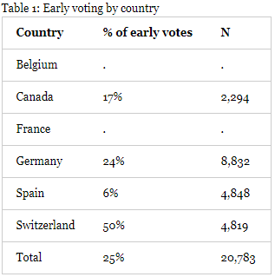
In all but two countries surveyed (i.e., France and Belgium), voters could decide to cast a vote before Election Day.2 Among all respondents, 25% had already voted at time we circulated our pre-election MEDW survey (typically 5 to 10 days before the election). However, this figure varies quite a lot between countries. As shown in Table 1, about 50% the electorate (and an overwhelming majority of voters) cast an early vote in Switzerland, about 20% in Canada and Germany, and only 6% in Spain.
This variation is probably due to the electoral law concerning early voting. For example, in Spain, the rule changed just before the elections we surveyed. The legislator made it more difficult for voters to be eligible for early postal voting.

Time-of-voting-decision
In the post-election MEDW survey (conducted within a week after Election Day), we asked voters when during the campaign they decided to vote the way they did. They could choose between a few months, a few weeks, a few days before Election Day, or on Election Day. Figure 1 reports the proportion of respondents having picked each of these categories by country. Overall, 61% of respondents made their decision a few months before the election.
We also observe some variations between countries. About 75% of respondents in Belgium said they decided how to vote months before Election Day, about 70% in France, 65% in Canada, 60% in Germany and Spain, and only 30% in Switzerland. The low level of ‘very’ early deciders in Switzerland is compensated by a larger number of respondents reporting having decided weeks before Election Day (45%), which is more than twice as much as the overall average in the other 5 countries (20%). There are fewer variations in the proportion of Election Day’s deciders between countries: from a minimum of 3% (Switzerland) to a maximum of 10% (Spain).
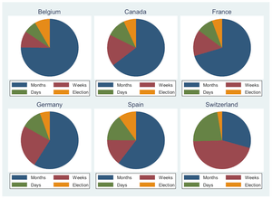
Figure 1: Time-of-voting-decision by country

Campaign attention, early voting and time-of-voting-decision
From these figures, an interesting question is ‘were those early voters and early deciders less attentive to the electoral campaign?’ In the MEDW post-election survey, we asked people to report, on a 0 (no attention at all) to 10 (a lot of attention) scale, their level of attention to the electoral campaign on five different medias: television (mean=5.6, n=22k), newspapers (mean=4.6, n=22k), radio (mean=3.9, n=22k), internet (mean=4.0, n=22k), and Twitter (mean=1.2, n=12k). From these data, I create an index, ranging from 0 to 10, capturing the maximum (self-reported) attention given to any of these four medias (mean 6.8, n=22k).
I compare the maximum level of attention of early and late deciders/voters. Voters who have decided how to vote ‘months before’ the election score higher on the attention index (7.4 compared to 6.7 for the rest of the electorate, n= 17k). The same observation can be made for early voters: their attention is on average of 7.3 (compared to 6.6 for other voters, n=16k, excluding France and Belgium). Results show that early deciders/voters are, contrary to our expectation, more attentive to the electoral campaign. One explanation is that voters do not pay attention to the electoral campaign to become more informed about the various parties and candidates. They might simply keep themselves informed, as they are genuinely interested in politics in general. Obviously, further analyses need to be performed to really understand the cross-national patterns of early voting and time-of-voting-decisions.

- The survey samples used to calculate the frequencies of this blog entry are those listed in this other blog post. ↩
- Belgians living abroad could cast an early vote if they asked their embassy to participate in the election through ‘postal voting’. However, this is only one way among others for Belgian expatriates to participate in a national election. ↩

Expectations in Mass Elections: Back to the Future?
By DAMIEN BOL | Published: OCTOBER 3, 2014
By Marc Guinjoan, Universitat Pompeu Fabra

What is the story?
Voters’ expectations regarding electoral results are crucial in democratic elections. To make an informed choice, voters should be able to evaluate the chances of winning of each political party. In a recent article, we examine whether voters were able to anticipate the result (in their district) of the upcoming 2011 Ontario provincial election and to update their perception of the chances of each party compared to previous election results.

Method
To address this question, we use the MEDW 2011 Ontario pre-election survey data that was conducted within the two weeks preceding Election Day. In the survey, we asked individuals to assess the chances of each parliamentary party to win a seat in their district, on a scale from 0 (no chance at all) to 10 (certain to win).
We then compare individuals’ perception of the chances of each party to actual results of 2011 and 2007 Ontario provincial elections in their district. In Ontario, 107 provincial representatives are elected in single-member districts using plurality rule. In both the 2007 and 2011 elections, three parties sent representatives to the provincial parliament: the Liberals (incumbent), the NDP and the Conservatives (see the results of the 2007 and 2011 Ontario elections).
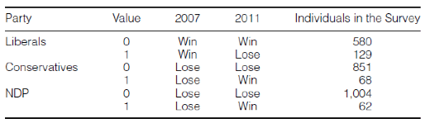
Our main independent variable is the nature of the party competition in the district of the individual. It is operationalized as follows: we assign the value 0 to voters in districts where a Liberal candidate won in 2007 and 2011, and the value 1 to voters in districts where the party’s candidate won in 2007 but lost in 2011. We do a similar coding for the two opposition parties (Conservative and NDP). This coding is summarized in Table 1.
Table 1: Coding of the main independent variable

With the help this coding, we assess whether individuals relied on 2007 election’s results to evaluate the chances of each party in their district (in that case, we talk about adaptive expectations), or whether they were able to update their perception of parties’ chances (through polls for instance) to match the context of the upcoming 2011 election (rational expectations).

Results
We perform an OLS regression with data clustered by electoral district. In our models, we control for political awareness, perception of the closeness of the election in the district, and party identification.
Our results suggest that individuals have rational expectations. In districts where the Liberals won in 2007 but lost in 2011, they perceived that the chances of winning of the candidate of this party were 1.20 points lower than those in districts where the Liberals won in both 2007 and 2011. Similarly, in districts where the Conservatives lost in 2007 but won in 2011, they perceived the chances of the candidate of this party were 1.34 points higher than those in districts where the Conservatives lost in both 2007 and 2011. This difference of perception is similar for individuals in districts where the NDP lost in 2007 but won in 2011 (compared to those in districts where the NDP lost in both 2007 and 2011).

Conclusion
Our analysis suggests that voters are able to form rational expectations about an upcoming election. In particular, they are able to update previous election results with information about the reality of the local party competition in the upcoming election. Our study makes an important contribution to the literature on voter coordination in democratic elections.
For further details and analyses, see Guinjoan, Marc, Pablo Simón, Sandra Bermúdez and Ignacio Lago. Forthcoming. Expectations in Mass Elections: Back to the Future? Social Science Quarterly.

Which election matters most (least)?
By DAMIEN BOL | Published: SEPTEMBER 29, 2014
By Simon Labbé-St-Vincent, University of Montreal

What is the story?
Modern democracies are typically composed of several levels of governments. Elections at higher government levels (supranational or national elections) are sometimes considered more important than regional or municipal elections since they involve more voters, and since the governments usually have larger budgets. An alternative hypothesis is that local and regional elections are more important since local and regional government deal with issues that are closer to the daily lives of voters. In this entry, I compare the importance voters give to elections across government levels in the six countries covered by the MEDW survey data.

The surveys
Within the MEDW project, we are conducting (regionally-based) pre- and post-election panel surveys in 6 countries: Belgium, Canada, France, Germany, Spain and Switzerland. Our surveys cover elections at supranational (European), national (federal), regional (cantonal, provincial, state) and local (municipal) government levels (Table 1 presents the samples that have been surveyed to date). In each of them, we ask respondents to rate the importance of elections at these 4 government levels on a 0 to 10 scale; 0 meaning the election is ‘not important at all’, and 10 that it is ‘extremely important’.
Table 1: List of MEDW survey samples
Country | Election | Region | N
Belgium | 2014 Regional-National-European | Brussels | 688
 |  | Flanders | 944
 |  | Wallonia | 932
Canada | 2011 Provincial | Ontario | 1,266
 | 2012 Provincial | Quebec | 957
France | 2012 Legislative | Ile-de-France | 919
 |  | Provence | 958
 | 2014 Municipal | Marseille | 691
 |  | Paris | 1,162
 | 2014 European | Ile-de-France | 929
 |  | Provence | 999
Germany | 2013-2104 State-Federal-European | Bavaria | 5,651
 | 2013 State | Lower Saxony | 927
 | 2013 Federal | Lower Saxony | 931
 | 2014 European | Lower Saxony | 930
Spain | 2011 National | Catalonia | 926
 |  | Madrid | 962
 | 2012 Regional | Catalonia | 973
 | 2014 European | Catalonia | 955
 |  | Madrid | 950
 | 2011 Cantonal | Lucerne | 1,202
 |  | Zurich | 1,155
 | 2011 Federal | Lucerne | 1,088
 |  | Zurich | 1,037

Importance of elections across government levels
In Figure 1, I show the mean importance voters give to elections by government level and by country. On average, European elections are rated at 5.3 (n=21,431, excluding Canada and Switzerland), national elections at 7.3 (n=28,254), regional elections at 7.0 (n=22,576, excluding France) and municipal elections at 7.0 (n=24,427). I thus find some support for the hypothesis that the higher the election level, the higher the perceived importance. However, the difference between national and regional/municipal (7.3 versus 7.0) is remarkably small. Moreover, there is one major exception: the European elections are considered as the least important elections (and this is true in all 3 European countries covered).
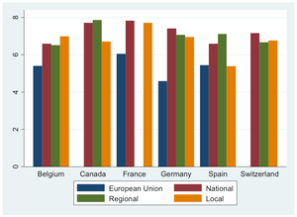
A couple of final observations. First, in the five federal countries (all but France), national and regional elections are equally important. Second, in four out of six countries (except Canada and Spain), local elections are as important as national elections. The MEDW data provide a golden opportunity to understand why some citizens, in some regions/countries, perceive some levels of elections to be more/less important than others.
Figure 1: Importance of elections at different levels (means)

To vote or to abstain? An experimental test of rational calculus in FPTP and PR elections
By DAMIEN BOL | Published: SEPTEMBER 25, 2014
By André Blais, University of Montreal

What is the story?
Many economists and political scientists explain the decision to vote or to abstain using a rational choice model. In a recent article, we tested the rational choice model of voting in the lab. We performed numerous experiments in Brussels, Montreal, and Paris, in which participants had to decide whether to vote or not in a number of first past the post (FPTP) and proportional representation (PR) elections. The overwhelming thrust of the evidence we found is inconsistent with the rational choice model, both in FPTP and PR elections, both at the aggregate and individual levels, and in both static and dynamic terms.

Protocol
In each experimental session, we organized two series of ten elections with a group 21 participants. For each election, there were two parties (named A and B) located respectively at 5 and 15 on a 0 to 20 scale. Each participant was randomly allocated a different position on the scale (random draw with no replacement). One participant was thus located at each of the 21 positions.
At each election, participants voted for party A, for party B, or abstained. A participant’s gain equalled 16 points minus the distance between the winning position and the participant’s position. Voting cost 1 point. How votes translate into winning positions depended on the voting rule. There were two series of ten elections, one series under FPTP and one under PR. Under FPTP, the winning position is that of the party with the most votes (there is a random draw in case of a tie). Under PR, the winning position depends on the relative support given to the two parties. The winning position was a weighted average of the candidates’ positions (5 and 15), where the weight given to a candidate’s position is the vote share obtained by that candidate. For example, if 70% of the votes go to A, the winning position was 8.

Results
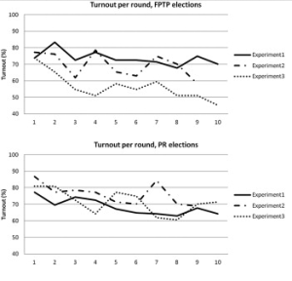
In the article, we tested the predictions of rational choice theory from three different angles. First, we compared aggregate turnout with the Nash equilibrium predictions. Figure 1 reports the evolution of the proportion of participants voting by elections under both FPTP and PR. In both instances, we observed a slight decrease of this proportion throughout elections. However, were not able to draw any relation with the Nash equilibrium predictions (according to theory, turnout should be higher under FPTP than under PR.
Figure 1: Evolution of aggregate turnout.

Second, we compare individual decisions with those derived from a rational calculus and count the number of decisions that were consistent with the rational recommendation. We found that in most cases participants made the wrong choice, that is, they voted even if their expected payoff was negative or they abstained when the payoff was positive.
Finally, we determined, still at the individual level, whether, at the margin, participants were more likely to vote as the expected payoff increased. The hypothesis was partially confirmed in FPTP elections. On the one hand, the participants were indeed more likely to vote when the stakes were higher, which is in line with the predictions of rational choice. On the other hand, contrary to the theory, the participants were not more prone to vote if their decision was pivotal. Moreover, the theory performed very poorly in PR elections because the participants were more inclined to vote when turnout in their group was high and when the party they supported was strong, which is exactly the opposite of what the theory would recommend.

Conclusion
We concluded that the rational choice model is not very useful in making sense of the decision to vote or abstain during elections. Many analysts reached this conclusion in the past. However, previous research was based almost entirely based on survey data. The evidence presented here indicates that the verdict is the same when we move to the lab.
The fact that the rational choice model is not supported in the lab is quite telling. If it the model is of little help to understand people’s behaviour there, it is probably even worse in real-life elections. There are indeed various factors biasing the tests in favour of the rational model in the lab. Most of the participants were university students. The elections that they participated in are emotion free. The participants were told after each election how many points they won and they had every incentive to think about how best to maximize their points and ultimate monetary payments. Furthermore, because of the small number of voters in the lab the probability of being pivotal was not infinitely small (as it is the case in real-life elections). Yet, people’s behaviour systematically diverges from the predictions of rational choice.
It would seem, then, that, as Barry1 claimed a long time ago, when it comes to making sense of the turnout decision we may have to learn more from sociologists than from economists.
For further details and analyses, see André Blais, Jean-Benoit Pilet, Karine Van der Straeten, Jean-François Laslier, and Maxime Héroux-Legault. 2014. To Vote or to Abstain? An Experimental Test of Rational Calculus in First Past the Post and PR Elections. Electoral Studies, 36: 39-50.

- B. Barry (1978). Sociologists, Economists, and Democracy. University of Chicago Press, Chicago. ↩

Pre-APSA workshop
By DAMIEN BOL | Published: SEPTEMBER 1, 2014

Synopsis
On August 27, 2014, we held a Pre-APSA workshop in Washington DC. The purpose of the workshop was to present papers that use the data gathered within the Making Electoral Democracy Work project. The papers presented were located within the fields of political behaviour and comparative politics and addressed the main question of MEDW project that how the rules of the game (especially the electoral system) and the electoral context (especially the competitiveness and salience of the election) influence voters’ and parties’ behaviour.

Organizers
- André Blais (University of Montreal)
- Damien Bol (University of Montreal)

Program
(* presenters)
Welcome (9.00-9.15AM)

Panel 1: Party Strategies and Party Systems (9.15-10.45AM)

Chair: André Blais (University of Montreal)
Discussants: Matt Golder (Penn State University) and Indridi Indridason (University of California, Riverside)
- Determinants of the Choice for Personalization Strategies in Election Campaigns
Marian Bohl* (University of Zurich)
- The Personalization of Politics and Party Leaders
Bill Cross (Carleton University)
Scott Pruysers* (Careton University)
- Assessing Ideological Content In Party Preferences: Political Dimensionality in Five Democracies
Eric Guntermann* (University of Montreal)
Liron Lavi (Tel Aviv University)

CoffeE Break (10.45-11.15AM)

Panel 2: Turnout and Voting Behavior (11.15AM-12.45AM)

Chair: Sona Golder (Penn State University)
Discussants: Martial Foucault (Sciences Po Paris) and Damien Bol (University of Montreal).
- Directional Economic Voting
Gulcan Saglam* (Georgia State University)
Ryan E. Carlin (Georgia State University)
- How to Survey about Turnout? A Replication Study of the Face-saving Question in Five Democracies
Alexandre Morrin-Chassé (University of Montreal)
Damien Bol* (University of Montreal)
Laura Stephenson (University of Western Ontario)
Simon Labbé St-Vincent (University of Montreal)
- EuroVotePlus: Voting for European Representatives?
Jean-Francois Laslier* (Paris School of Economics)
André Blais (University of Montreal)
Damien Bol (University of Montreal)
Sona N. Golder (Pennsylvania State University)
Philipp Harfst (Ernst-Moritz-Arndt University of Greifswald)
Laura Stephenson (University of Western Ontario)
Karine Van der Straeten (Toulouse School of Economics)

Lunch Break (12.45AM-2.00PM)

Panel 3: The Strategies of the Vote (2.00-3.30PM)

Chair: Bill Cross (Carleton University)
Discussants: Jean-François Laslier (Paris School of Economics) and Karine Van der Straeten (Toulouse School of Economics)
- What Determines Rental Votes? Party Signals vs Individual Preferences
Thomas Gschwend (University of Mannheim)
Steffen Zittlau (University of Mannheim)
Lukas Stötzer* (University of Mannheim)
- Small Parties in Sub-State Systems: The Case of Canadian Provinces
Marc A. Bodet (Laval University)
Allan Craigie (University of British Columbia)
Laura Stephenson* (University of Western Ontario)
Charles Tessier (Laval University)
- Timing is Everything? The Correlates and Effects of Time-of-voting-decisions
Michael McGregor* (Bishop’s University)
Laura Stephenson (University of Western Ontario)

Coffee break (3.30-4.00PM)

Panel 4: MEDW Team meeting (for MEDW team members only, 4.00-6.00PM)

Sponsors
- APSA Organized Section on Representation and Electoral Systems
- APSA Organized Section on Elections, Public Opinion, and Voting Behavior

Pre-IPSA Workshop
By DAMIEN BOL | Published: JULY 23, 2014

Synopsis
On July 18, we co-organized a Pre-IPSA workshop (the day before the 2014 IPSA World Congress in Montreal) with the Electoral Integrity project. The papers presented investigate how citizens and parties act within different electoral contexts in a comparative perspective and how the quality of any electoral contest and common electoral malpractices affect citizens and elites in countries worldwide. The purpose of this workshop was to put together papers using multiple methods and approaches to tackle questions related to the impact of electoral context on the functioning of democracy.

With about 30 papers presented, more than 70 participants from very different countries (Argentina, Australia, Belgium, Canada, Denmark, India, Mexico, United Kingdom, and United States), and about 10 NGOs and international/national electoral agencies represented, we can say that this workshop was a success. Below, you’ll find the full-program.

Program
- Introduction to the Making Electoral Democracy Work and the Electoral Integrity project
Pippa Norris (Harvard University)
Elisabeth Gidengil (McGill University)
Ferran Martinez i Coma (University of Sidney)

Panel 1: Campaigns and the Vote (09.30-11.00)

Chair: Karin Riedl (City University of New York)
Discussant: Peter Miller (University of Pennsylvania)
- Negative Campaigning in Multicandidate Contests
Indridi indridason (University of California, Riverside)
Matt Golder (Pennsylvania State University)
Thomas Gschwend (University of Mannheim)
- Campaigns and Cross-Level Partisanship
Laura Stephenson (University of Western Ontario)
Éric Bélanger (McGill University)
- The Impact of Electoral Systems on Personal Vote Strategies: A Field Experiment on German MPs
Damien Bol (University of Montreal)
Thomas Gschwend (University of Mannheim)
Thomas Zittel (Goethe University Frankfurt)
Steffen Zittlau (University of Mannheim)
- Perceptions of Corruption: Does the Level of Government Make a Difference?
André Blais (University of Montreal)
Elisabeth Gidengil (McGill University)
Anja Kilibarda (University of Montreal)

Panel 2: Determinants and consequences of Electoral Integrity (9.30-11.00)

Chair: Chad Vickery (IFES)
Discussant: Allyson Benton (CIDE)
- Bullets over Ballots: How Electoral Exclusion Sparks Political Violence and Chills Participation
Brian Klaas (University of Oxford)
- Gender and Electoral Integrity: Combating Violence against Women in Politics
Mona Lena Krook (Rutgers University)
- Capturing Campaigns’ Effects on Democratic Satisfaction: Evidence from a Panel Study in Uganda
Nicholas Kerr (University of Alabama)
Jeff Conroy-Krutz (Michigan State University)
- Beat Me If You Can: The Fairness of Elections in Dictatorships
Masaaki Higashijima (Michigan State University)

Panel 3: Voting turnout (11.30-1.00)

Chair: Katharina Jaronicki (University of Pennsylvania)
Discussant: Damien Bol (University of Montreal)
- Compulsory Voting, Voter Turnout, and Income Inequality
John Carey (Dartmouth College)
Yusaku Horiuchi (Darmouth College)
- Elections as Poor Reflections of Preferences under Compulsory Voting
Shane Singh (University of Georgia)
- High Turnout in the Low Countries: Partisan Effects of Turnout in Belgium and The Netherlands
Peter Miller (University of Pennsylvania)
Ruth Dassoneville (University of Leuven)
- Swing Voters and Motivated Cognitive Reasoning
Matthew Byrne (University of British Columbia)
Pascal Doray-Demers (University of Montréal)
- Cooperating for Fairness: The Role of Electoral Institutions in Generating Legislation Aimed at Protecting Vulnerable Sectors in Society in the Sub-Saharan African Region
Karin Riedl (City University of New York)

Panel 4: Perceptions of Electoral Integrity (11.30-1.00)

Chair: Mona Lena Krook (Rutgers University)
Discussant: Brian Klaas (University of Oxford)
- Electoral Rules, Performance and Perceptions of Electoral Integrity
Todd Donovan (Western Washington University)
Shaun Bowler (University of California, Riverside)
- Distrust without Controversy: Determinants of Perceptions of Election Transparency in Contemporary Argentina
Julia Pomares (CIPPEC)
- Voter Participation and Attitudes toward Electoral Processes and Electoral Integrity: A Comparative Analysis of Survey Data from Ukraine and Indonesia
Staffan Darnolf (IFES)
Rakesh Sharma (IFES)
- (How) Does Electoral Integrity Affect Turnout?
Ferran Martinez i Coma (University of Sydney)
Minh Trinh (Harvard University)

Panel 5: Breakout Roundtables

In this breakout session, led by a practitioner, groups at each table were asked to discuss two issues: What are the practical barriers to knowledge sharing among practitioners and scholars in the research communities? What could be done to strengthen these networks? Each table group selected a rapporteur to report back the key points during the final 15-20 minutes.
- Niall McCann (UNDP)
- Chad Vickery (IFES)
- Staffan Darnolf (IFES)
- Betilde Munoz-Possian (OAS)
- Marc Mayrand (Elections Canada)
- Annette M. Fath-Lihic (International IDEA)
- Martin Schaaper (UNESCO)
- Nathaniel Heller (Global Integrity)

Panel 6: Representative and direct democracy (2.30-4.00)

Chair: Elisabeth Gidengil (McGill University)
Discussant: Patrick Fournier (University of Montreal)
- Campaigning in Direct Democracies: Initiative Petition Signing, Voter Turnout, and Acceptance
Katharina Jaronicki (University of Pennsylvania)
- The Conditioning Impact of Electoral and Party Systems on Electoral Volatility
Benjamin Ferland (McGill University)
Ruth Dassonneville (University of Leuven)
- How to Survey about Turnout? Evidence from a Randomized Wording Experiment in Five Democracies
Alexandre Morin-Chassé (University of Montreal)
Damien Bol (University of Montreal)
Laura Stephenson (University of Western Ontario)
Simon Labbé St-Vincent (University of Montreal)

Panel 7: Forensics, Campaign finance, and the Law (2.30-4.00)

Chair: Lonna Atkeson (University of New Mexico)
Discussant: Walter Mebane (University of Michigan)
- Equity and Transparency in Campaign Financing: Implications for the Integrity of Elections
Betilde Munoz-Possian (OAS)
Alejandro Urizar (OAS)
- Does the Decentralization of Electoral Manipulation Strengthen National Electoral Authoritarian Regimes? Evidence from Mexico
Allyson Benton (CIDE)
- The Causes and Consequences of Electoral Autonomy in Latin America and Africa
Alejandro Trelles (University of Pittsburgh)
- Canadian Election Administration on Trial: The “Robocalls” Case and the Opitz Decision
Michael Pal (University of Toronto)
- The Portfolio of Electoral Manipulation: The 2008 Recall Referendum in Bolivia
Francisco Cantu (University of Houston)

Panel 8: Strengthening Integrity Institutions (2.30-4.00)

Chair: Larry LeDuc (University of Toronto)
Discussant: Paul Gronke (Reed College)
- Evaluating Election Management Bodies
Pippa Norris (Harvard University)
- Drawing the line: districting, redistricting, and electoral accountability
Chad Vickery (IFES)
Erica Shein (IFES)
- New Electoral Systems in Southern Africa: Trends and Challenges
Jørgen Elklit (Aarhus University)
- Election Management Bodies, Confidence and Voter Turnout
Holly Ann Garnett (McGill University)

Panel 9: Roundtable (4.30-6.00)

- Controversies in Electoral Integrity in the Canadian Fair Votes Act
Elisabeth Gidengil (McGill University)
Pippa Norris (Harvard Univeristy)
Richard Johnston (University of British Columbia)
Marc Mayrand, Chief Elections Officer (Elections Canada)
Maxime St-Hilaire (University of Sherbrooke)

Organizers
- Ferran Martinez i Coma (University of Sydney)
- Elisabeth Gidengil (McGill University)

Simultaneity of Local Elections and Turnout in the 2014 European Election in Germany
By DAMIEN BOL | Published: JUNE 4, 2014
By Arndt Leininger, PhD candidate, Hertie School of Governance, Berlin

What is the story?
As pointed out in a preceding blog entry, in Germany, the turnout rate at the 2014 European election was higher than at the preceding 2009 European election. The overall difference is of 4.8 percentage points (from 43.3% in 2009 to 48.1% in 2014).
Many political observers explain this increase by to the fact that local elections and referendums were held on the very same day in several local entities. Local elections were held in 11 out of 16 German states, while there was a state-wide referendum in Berlin. In this entry, I bring further evidence confirming the existence of a causal relationship between the simultaneity of local elections and a high turnout rate at the European election using official election returns and demographic/socioeconomic data.

Association between simultaneity of local elections and turnout
As reported in Figure 1, the turnout rate at the 2014 European election in Germany varied quite drastically from one state to the other. The first observation one can make is that the turnout is higher in nearly all the states where simultaneous local elections (or a simultaneous state-wide referendum as in Berlin) were held. It is important to note that the subsequent analyses were conducted in considering that no simultaneous local elections were held in Berlin. The results presented hereafter can thus be considered as conservative estimates of the effect of simultaneous elections on turnout in European elections.
A simple comparison of turnout rates between states with and without local elections reveals a statistically significant difference of 5.8 percentage-points: 49.6% on average for states with simultaneous local elections (excluding the state of Lower Saxony where local elections were only held in a few local entities) and 43.8 for states without them. When I use more fine-grained disaggregated data, i.e. at the sub-state “regional” level, I find an even more striking difference of 8.9 percentage points (50.9% v/s 41.9%).
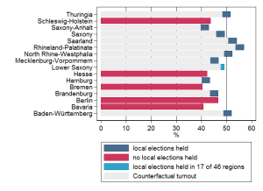
Figure 1: Turnout rates at the 2014 European elections in Germany (state level), click to enlarge

In order to more precisely estimate the effect of simultaneous local elections on the turnout rate at the 2014 European election, I ran random intercept models regressing the turnout rate at the regional level by whether or not simultaneous local elections were held in the region, and adding control variables such as population density, the proportion of people receiving unemployment benefits, local business tax revenues (as a proxy of wealth) and the proportion of high school graduates. The coefficient of interest remains relatively unaffected by the inclusion of these controls: The turnout rate at the European elections is 3.2 percentage-points higher in regions where simultaneous local elections were held (significant at a level of 0.05).

What would have been the turnout rate without local elections?
Based on these estimations, it easy to calculate what would have been the turnout rate at the European election if the local elections were not held the very same day. To do so, I subtract the average effect of 3.2 percentage points from all regional turnout rates. Then, based on actual population figures, I calculate what would be the number of voters under this scenario. The results are shown in Figure 1: 46% of Germans (instead of the actual 48.1%) would have shown up to the polling stations if there were no local elections held the very same day.

Confirming causality
The observation that the simultaneous organization of local elections is associated with higher turnout rate does not forcefully mean that there is a causal relationship between the two. A better test of this causal statement is to check whether the simultaneity of local elections effect remains after controlling for the turnout rate at the previous European election in 2009. However, even when I add this extra variable in the regression presented above, this effect remains largely unchanged (and is still statistically significant at a level of 0.05). What is more, in the 3 German states (Brandenburg, Hamburg and North Rhine Westphalia) where simultaneous local elections were held in 2014, while not in 2009, the results demonstrate that the turnout rate increased by 10 percentage points in these three states.

Concluding remark
A quick analysis of the election returns at the regional level suggests that the fact of holding a local election the very same day increased turnout at the European election by about 3 percentage points. Without these simultaneous local elections, federal turnout rate would have been around 2 percentage points lower. As demonstrated in a previous blog entry, this effect is highly relevant politically speaking, as low turnout seems to have benefited the Eurosceptic party AfD.

The 2014 European Election in Germany: Do Eurosceptics Benefit from Low Turnout Rates?
By DAMIEN BOL | Published: MAY 27, 2014
By Steffen Zittlau, PhD candidate, University of Mannheim

What is the story?
The results of last Sunday’s European election in Germany are not surprising. For the most of it, they are very similar to those of the German federal election held last September (see our previous blog entry): The party of the federal chancellor Angela Merkel, the Christian Democrats (CDU/CSU), won by a comfortable margin over the Social Democrats (SPD).

In the German media, a specific attention was given to the right-wing Eurosceptic party Alternative für Deutschland (AfD). The party failed, by a very small margin, to pass the 5% representation threshold in the last federal election. In this European election, the party obtained 7% of the votes and 7 seats in the European parliament.

To explain the good score of the AfD, political commentators in Germany pointed the role of low turnout. According to them, this low turnout benefited far-right and Eurosceptic parties in all European countries. During the campaign, the mainstream parties also used this claim to encourage their supporters to vote. This hypothesis constitutes now the main explanation of the electoral success of the AfD (and other similar parties in other European countries). Is it really the case though? In this blog entry, I offer a first test of this hypothesis.

A first test of the ‘low turnout benefited the AfD’ hypothesis
The rationale behind the hypothesis positing that the AfD benefited from a low turnout rate is that the supporters of the party are more likely to vote at a European election than the supporters of other parties. The AfD was founded in 2013 in reaction to the decision of the European Union to bail out some member states (Greece, Ireland, Portugal, Spain and Cyprus) to save the European monetary system. The party strongly criticises this policy, and in general the functioning of the European institutions. It is then reasonable to think that its supporters consider European issues as highly salient. Therefore, as the European election is (allegedly) more about European issues than any other election, supporters of the party are supposed to be more likely to turn out at this election than the supporters of other parties.

To test this hypothesis, I rely on official data of last Sunday’s election and check whether the score of the AfD was greater in regions where turnout was low.
First, we observe substantial variations in turnout between regions, ranging from 41% in Bavaria to 57% in Rhineland-Palatinate. This large variation is partially explained by the fact that municipal elections were also held last Sunday in 10 out of 16 German regions. On average, the turnout rate was 5 percentage points higher in regions where municipal elections were held simultaneously.

Before running the test, I correct the data by taking into account the fact that turnout is usually higher, and some parties traditionally stronger, in some regions. I use the last federal election as the baseline, and calculate the ratio between turnout at the European election and turnout at the last federal election. The same correction is used for the AfD’s vote share. For example, a ratio of 1.8 indicates that the AfD’s vote share was 80% higher at the European election than in the federal election.
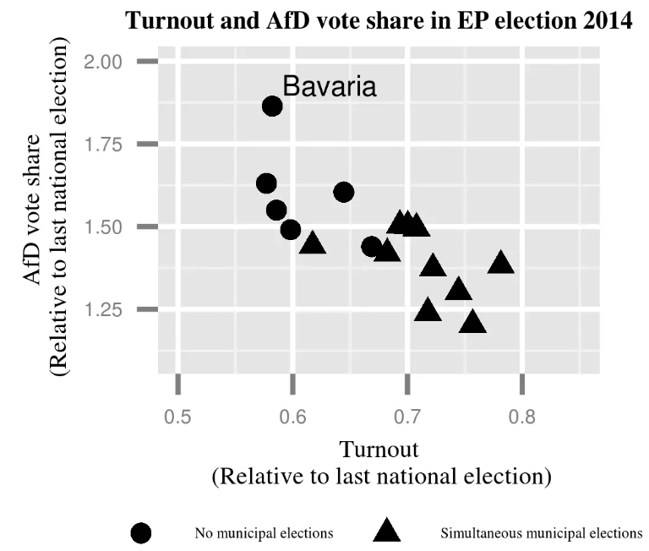
Figure 1: The Relationship between Turnout and AfD’s Vote Share (click to enlarge)

Figure 1 clearly shows that AfD’s vote share at the European election was much greater in regions where turnout was low. If we were to believe the predictions of a simple OLS model, the score of the party would have been roughly equal to its score at the federal election if turnout had been the same (i.e. at a turnout ratio of 1). Bavaria deviates from this finding though: The AfD was able to nearly double its vote share compared to the last national election. The low turnout only partially explained the score of the AfD in the region.

Concluding remarks
The findings of my first test of the hypothesis positing that the AfD benefited from a low turnout rate suggest that specific parties might benefit from low turnout, especially if they own the issue related to the election of the day. This gives them the possibility of mobilizing their supporters more than other parties. My analyses also show that holding other elections simultaneously does not only influence the turnout rate, it can also alter the result of an election.

EuroVote+: An online study on next European election
By DAMIEN BOL | Published: MAY 6, 2014

What is the story?
The Making Electoral Democracy Work research team has launched the online study EuroVote+.
EuroVote+ is a study focused on the election of the next European Parliament. It has three objectives: (1) to provide information to the general public about how the Members of the European Parliament (MEPs) are elected in the various European countries, (2) to gather opinions about voting procedures in Europe, and (3) to carry out a scientific study of voting behaviour under different electoral systems.

The website is available in (almost) all European languages (German, English, French, Italian, Spanish, Dutch, Romanian, Polish, Swedish…) and provides information about three electoral systems that are used to elect the European Parliament: The closed list system, the open list system, and the ‘panachage & cumulation’ system. Users are then invited to imagine how they would cast their vote if these electoral systems were used in their country (seen Screen Shot below).
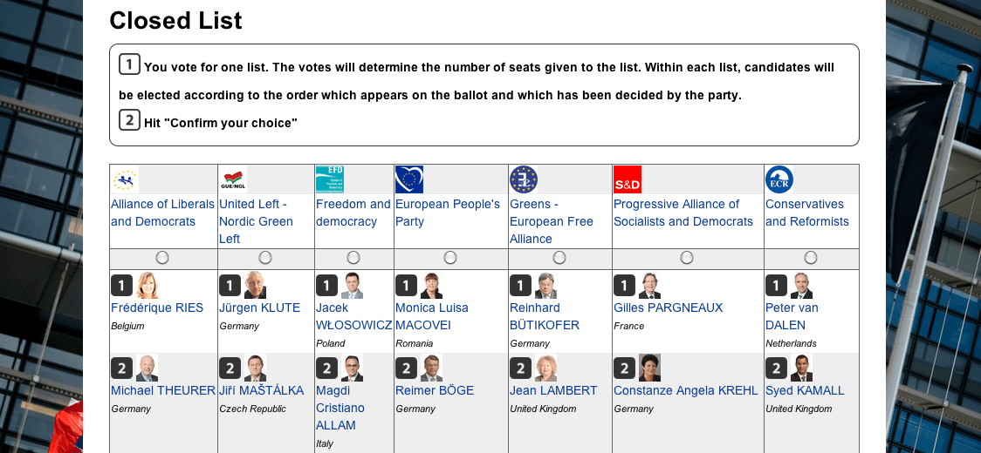
Screen Shot
Users can also indicate how they would cast their vote if there was an additional single pan-European district. After casting these votes, they are finally invited to respond to a very brief questionnaire.

Voting in the EU: The Lowdown
The European Parliament is elected through the principle of Proportional Representation (PR), which states that each party obtains a number of seats that is proportional to the number of votes it obtains. That being said, the variant of PR used varies across European countries. In particular, the possibility given to voters to mark a preference for an individual candidate within a party list differs: In Germany, France or Spain for instance, voters can only vote for a party list and cannot express a preference for any individual candidate within this list. In the Netherlands, Sweden or Latvia, on top of voting for a party, voters express a preference for individual candidate within the party list. Finally, in Luxembourg, a voter can vote for candidates from different party lists.
In previous blog entries, we described in more details the electoral system used to elected MEPs in Finland, Latvia, and Luxembourg.
All MEPs are currently elected on a national basis (or on a regional basis in countries which have several regional electoral districts). Some people have mentioned the possibility of electing part of the European Parliament through a single pan-European district as way to enhance the Euro-wide visibility of the European election. This proposal was never adopted.

Research team
For more information, please contact the research team in charge of EuroVote+:
- Jean-François Laslier (Paris School of Economics, France)
- André Blais (University of Montreal, Canada)
- Sona Golder (Penn State University, US)
- Laura Stephenson (University of Western Ontario, Canada)
- Karine Van der Straeten (Toulouse School of Economics, France)

How to read polls? The failed 2014 early election strategy of the Parti Québécois
By DAMIEN BOL | Published: APRIL 29, 2014
By Claire Durand, Professor at the University of Montreal
Blog [in French]

What is the story?
On March 5, 2014, the Parti Québecois (PQ, center-left sovereignist) called an early general election in the Canadian province of Quebec. The party was at that time leading a minority cabinet and was hoping to comfort its position in securing a majority of seats in parliament. The situation was (seemingly) good for the PQ, as some polls estimated that the party was somewhat ahead of its main competitor, the Parti Libéral du Québec (PLQ, center-right federalist) in the general population and several points ahead among French-speaking voters.
However, a month later, on April 7, this strategy appeared to have been a disaster. The PQ lost the election by more than 15 points. What is worse, the PLQ obtained a comfortable majority of seats. What happened? In this text, I show that the polls were not wrong; the incumbent party just misinterpreted them.

Polls in Canada and Quebec
Two ‘catastrophes’ recently occurred in Canadian polling. In the Alberta 2012 election, polls conducted at the end of the campaign predicted that the Wildrose Party would obtain about 10 points more than its main opponent, the incumbent Progressive-Conservative Party. On Election Day, the exact opposite occurred. The Progressive-Conservative Party won by 10 points over the Wild Rose Party. The second catastrophe occurred during the British Columbia 2013 election where polls conducted during the last week of the campaign predicted a victory of the New Democratic Party (NDP) over the incumbent Liberal Party by an average of 8 points. Ultimately, the Liberal Party won the election and ended up 4 points ahead of the NDP.
In Quebec, polls are known to be more reliable. However, they are also known to systematically underestimate the score of the PLQ. In the 2012 Quebec election for example, the party was underestimated by close to 4 points. A number of reasons may explain this phenomenon. Among them, one can mention the possibility that PLQ voters tend to hide their preferences to pollsters more than other voters and to less participate in elections.

Raw versus corrected scores in 2014 Quebec polls
By default, pollsters allocate non-disclosers (those who do not indicate a vote intention) among the parties proportionally to their strength among disclosers (those who do indicate a vote intention). Figure 1 shows the evolution of vote intentions in Quebec in 2014 according to polls published in the media. In February, three polls put the PQ ahead of the PLQ. In early March, at the time when the party called an early election, the party was leading by 2-3 points. According to this figure, the early election strategy of the incumbent party made sense.
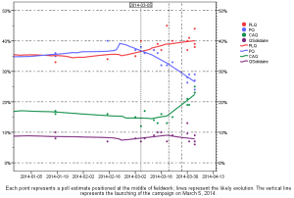
Figure 1. Evolution of vote intentions in Quebec in 2014 (as published).

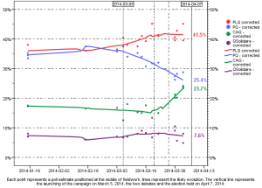
Until 2002, pollsters in Quebec used to correct for the overestimation of PLQ by attributing the vote of non-disclosers in the following way: 60% to the PLQ, 30% to the PQ, and 10% to the third party (nowadays represented by the CAQ). I have continued working with a non-proportional attribution of non-disclosers since then but I decided to modify the formula and attribute 50% of non-disclosers to the PLQ and 25% each to the PQ and the third party. This formula gave good estimations of the vote in recent elections (2003, 2007, 2008 and 2012). Figure 2 reports the corrected vote intentions using this formula. As we can see, the situation of the PQ in early March was far from being advantageous. The PLQ was ahead by 1-2 points. If the PQ had used this number, they would have been more careful before calling an early election.
Figure 2. Evolution of vote intentions in Quebec in 2014 (corrected).

Montreal Voting Experiment Workshop
By DAMIEN BOL | Published: APRIL 8, 2014
On March 28 and 29, we held at the University of Montreal a two-day workshop specifically dedicated to voting experiments. This workshop, organized within the Making Electoral Democracy Work project, aimed at presenting latest laboratory, field and survey experiments related to elections. With 36 papers presented and about 70 participants from the US, the UK, Canada, Germany, France, Spain, Sweden, and the Netherlands, the workshop was a huge success.
Below you’ll find the full-program of this workshop.

Program: March 28

Panel 1: Voter reaction to number of candidates/Polarization
Chair: Konstantin Vossing (Harvard University)
Discussant: Elisabeth Gidengil (McGill University)
- Candidate extremity, information environments, and political polarization: Three experiments in a dynamic process tracing environment
Mona S. Kleinberg (Rutgers University)
Richard R. Lau (Rutgers University)
- Choice difficulty and the compromise effect in candidate choice
Renan Levine (University of Toronto, Scarborough)
- Party voices and citizen efficacy: An experimental study
Fred Cutler (University of British Columbia)
Paul J. Quirk (University of British Columbia)
Benjamin Nyblade (University of British Columbia)
- More is less (representation): Choice set size, information acquisition, and correct voting in multimember districts
Saul Cunow (University of California, San Diego)

Panel 2: Accountability/responsibility/fraud

Chair: André Blais (University of Montreal)
Discussant: Elizabeth Zechmeister (Vanderbilt University)
- The winner takes it all? Revisiting the micro foundations of the incumbency advantage
Catherine De Vries (University of Oxford)
Sara Hobolt (London School of Economics)
Hector Solaz (University of Birmingham)
- Protecting the polls: The effect of observers on election fraud
Joseph Asunka (University of California, Los Angeles)
Sarah Brierley (University of California, Los Angeles)
Miriam Golden (University of California, Los Angeles)
Eric Kramon (University of California, Los Angeles)
George Ofosu (University of California, Los Angeles)
- Pivotal decision maker, agenda power and collective responsibility attribution
Raymond Duch (University of Oxford)
Randy Stevenson (Rice University)
- Policy deliberation and voting behavior: A campaign experiment in the Philippines
Thomas Fujiwara (Princeton University)
Daniel Rubenson (Ryerson University)
Gabriel Lopez Moctezuma Jassan (Princeton University)
Leonard Wantchekon (Princeton University)
Cecilia Lero (University of Notre Dame)
- Greater expectations: A field experiment to improve democratic accountability in Mali
Jessica Gottlieb (Texas A&M University)

Panel 3: Effects of Polls on Turnout and Voting Decision

Chair: Henry Milner (University of Montreal)
Discussant: Aina Gallego (Institute of Public Goods and Policy)
- Expectation and voter turnout
Rafael Hortala-Vallve (London School of Economics)
André Blais (University of Montreal)
- Experiments on the effects of opinion polls and implications for laws banning pre-election polls
Shaun Bowler (University of California, Riverside)
Todd Donovan (Western Washington University)
- Getting out the vote: Information and voting behavior
Yi-Yi Chen (Washington University in St. Louis)
- How twittered exit polls can shape electoral outcomes under PR systems with electoral thresholds
Thorsten Faas (Johannes Gutenberg-University Mainz)
Sascha Huber (University of Mannheim)
- An experimental analysis of the impact of campaign polls on electoral information seeking
Jason Roy (Wilfried Laurier University)
Shane Singh (University of Georgia)
Blake Andrew (Montreal)
Patrick Fournier (University of Montreal)

Panel 4: Methodology

Chair: Philipp Harfst (University of Greifswald)
Discussant: Noam Lupu (University of Winsconsin, Madison)
- Examining the (potential) sampling bias in laboratory voting experiments
Damien Bol (University of Montreal)
Simon Labbé St-Vincent (University of Montreal)
Jean-Michel Lavoie (University of Montreal)
- Individual behavior under evaluative voting: A comparison between laboratory and In Situ experiments
Herrade Igersheim (University of Strasbourg)
Antoinette Baujard (University Jean Monnet)
Frédéric Gavrel (University of Caen Basse-Normandie)
Jean-François Laslier (Paris School of Economics)
Isabelle Lebon (University of Caen Basse-Normandie)
- Through the polling booth curtain – a visual experiment on citizens’ behavior inside the polling booth
Michael Bruter (London School of Economics)
Sarah Harrison (London School of Economics)
- Patterns of strategic voting in run-off elections
Karine Van der Straeten (Toulouse School of Economics)
Jean François Laslier (Paris School of Economics)
André Blais (University of Montreal)

Program: March 29

Panel 5: Strategic voting

Chair: Bill Cross (Carleton University)
Discussant: Dominik Duell (New York University)
- Strategic voting and personality traits
Cengiz Erisen (TOBB University)
André Blais (University of Montreal)
- Strategic voting, proportional representation, and coalition governments: A laboratory experiment
Michael F. Meffert (University of Leiden)
Thomas Gschwend (University of Mannheim)
- Simultaneous analysis of turnout and voting under proportional representation: Theory and experiments
Aaron Kamm (University of Amsterdam)
Arthur Schram (University of Amsterdam)
- The structural determinants of strategic voting
Mark W. Petersen (Bethany College)
Matthew S. Dabros (Western Connecticut State University)
Suzanne L. Parker (Purdue University)
- Thresholds, expectations and coordination: A lab experimental study of strategic voting
Annika Fredén (Lund University)

Panel 6: Deciding Correctly/Voter information

Chair: Damien Bol (University of Montreal)
Discussant: Richard Lau (Rutgers University)
- Deciding correctly: Variance in the effective use of party cues
Jennifer L. Merolla (Claremont Graduate University)
Laura B. Stephenson (University of Western Ontario)
Elizabeth J. Zechmeister (Vanderbilt University)
- Information acquisition and voting mechanisms: Theory and evidence
Sourav Bhattacharya (University of Pittsburgh)
John Duffy (University of Pittsburgh)
Kim Sun-Tak (National Taiwan University)
- Hide or seek: An experimental study of the effects of evading and acquiring information on voting behavior
Konstantin Vossing (Harvard University)
Till Weber (City University of New York)
- The secret ballot and ethical voting
Rebecca B. Morton (New York University)
Kai Ou (New York University)

Panel 7: Voter reaction to mobilization and communication techniques

Chair: Marc-André Bodet (Laval University)
Discussant: Shane Singh (University of Georgia)
- Why does political mobilization work? The role of norms and reciprocity: Theory and experiment
Pedro Robalo (University of Amsterdam)
- Isolating the effects of electoral participation on political trust
Victoria Shineman (University of Pittsburg)
- Why do words matter? Effects of emotive and vague words on voters’ interpretation and evaluation of intentions with election pledges
Elina Lindgren (University of Gothenburg)
- Changing issue ownership through priority signaling: An experimental approach
Johan Martinsson (University of Gothenburg)
Stefan Dahlberg (University of Gothenburg)
- The effects of voter ID notification on voter turnout: Results from a large-scale field experiment
Jack Citrin (University of California, Berkeley)
Donald P. Green (Columbia University)
Morris Levy (University of California, Berkeley)

Panel 8: Selection of voting rules/Comparison of voting rules

Chair: Patrick Fournier (University of Montreal)
Discussant: Shaun Bowler (University of California, Riverside)
- Beware of politicians seeking to change voting rules: An experimental analysis of voting rule selection
Kaisa Herne (University of Turku)
Ryan Kendall (University of Southern California)
Maria Maunula (University of Turku)
Katri Sieberg (University of Tampere)
- Choosing voting systems behind the veil of ignorance: A two-tier voting experiment
Matthias Weber (University of Amsterdam)
- Candidate entry under plurality and majority runoff
Damien Bol (University of Montreal)
André Blais (University of Montreal)
Jean-François Laslier (Paris School of Economics)
- To vote or to abstain? An experimental test of rational calculus in first past the post and PR elections
André Blais (University of Montreal)
Jean-Benoit Pilet (University of Brussels, ULB)
Karine Van der Straeten (Toulouse School of Economics)
Jean-François Laslier (Paris School of Economics)
Maxime Héroux-Legault (University of Toronto)

Program chairs
- André Blais (University of Montreal)
- Jean-François Laslier (Paris School of Economics)
- Karine Van Der Straeten (Toulouse School of Economics)

Sponsors
Centre for the Study of Democratic Citizenship (CSDC)
Centre d’Etudes en Recherches Internationales (CERIUM)
Center for Interuniversity Research and Analysis of Organization (CIRANO)

How people (don’t) cast their vote during an economic crisis
By DAMIEN BOL | Published: FEBRUARY 5, 2014
By Kelly Rowe, Universitat Pompeu Fabra

What is the story?
Economic voting theory predicts that during a real or perceived economic downturn, people hold the incumbent government responsible for the bad economic situation and punish it by casting a vote for an opposition party. However, it is also said that, under similar circumstances, people are too concerned with holding ‘body and soul’ together to be bothered to vote. Economic downturns are thus also associated with low turnout rates.
In a recent article, I show that these two theories can be linked together to better understand patterns of voting behaviour in times of economic crisis. In particular, I argue that whether people decide to abstain or to punish the incumbent parties depends on the electoral offer, or in other words, on the existence of viable opposition parties.

Evidence from the OECD
In this article, I first analyze the turnout rate at the last national election held before the start of the 2008 economic crisis and the one that immediately followed 2008 in 34 OECD countries. The differences in turnout between the two elections are disclosed in Figure 1. I then run regressions predicting this difference by a series of independent variables, among which the effective number of parliamentary parties at the second election covered. Regression results show the greater the number of parties the more positive the turnout difference. This suggests that individuals in countries with more parties are mobilized by the economic crisis and use the opportunity of having more parties/alternatives to vote against the incumbent and express an economic vote. In contrast, citizens in countries with fewer viable parties abstain and fail to express an economic vote.
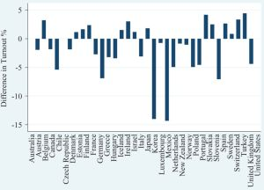
Figure 1: Difference in turnout (%) for the OECD countries

Evidence from Spain
To confirm this finding, I also analyze post-election survey data from the 2011 national election in Spain, ie. the first one after the start of the economic crisis. Spain has been one of the countries most badly hurt by the economic crisis, which makes its study particularly interesting. I run multinomial regressions predicting a vote for the incumbent, for an opposition party, or abstention. Here, the key independent variables are to what degree the respondents believe the incumbent government is responsible for the economic crisis and the number of viable parties in the respondent’s district.
Results show that economic voting did indeed take place in Spain in the 2011 election; the more respondents hold the incumbent government responsible for the economic crisis, the more likely they are to vote for an opposition party (see Figure 2). Furthermore, this probability increases with the number of viable parties in the respondent’s district. We can also see in Figure 2 that those who blame the government for the economic crisis are the most likely to abstain. However, this likelihood diminishes as the number of viable parties increases. From this we can infer that combination of incumbent blame attribution and the number of viable parties is necessary for voicing an economic vote versus not voicing one.
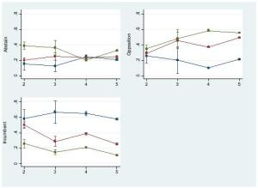
Figure 2: The Effect of Incumbent Blame Attribution and the Number of Viable Parties on Voting Behaviour (blue- no responsibility; red- some responsibility; green- high responsibility)

Concluding remarks
The relationship between the state of the economy and electoral choice depends on the number of parties or the choices available to voters at the district level. If there are no options available for a citizen who is disappointed with the government’s management of the economy, she will likely abstain – and thereby weaken the effect of the economy on electoral results. On the other hand, if there are viable opposition parties, she will likely vote for one of those parties – thereby strengthening the effect of the economy.. Put simply, parties matter for the economic voting voice to count.
For more details, see Rowe, Kelly T. (2013). “Making Voice Count: Economic Voting and the Number of Parties.” Party Politics, published online.

Strategic Voting under PR: Evidence from the 2010 Swedish General Election
By DAMIEN BOL | Published: JANUARY 22, 2014
By Annika Fredén, Lund University

What is the story?
The concept of strategic voting is well-known in anglo-saxon politics. It refers to the tendency of some voters not to vote for their preferred party if this party has no chance of winning in their district. These strategic voters then happen to cast a vote for their second (or third) preferred party on the basis that this party is viable. In that sense, they increase the probability that their vote will make a difference in the final electoral results.
Strategic voting also exists in continental European democracies where the principle of proportional representation (PR) is applied. In a recent article on the 2010 Swedish general election, I show that many of the supporters of the centre-right Moderate party strategically cast a vote in favour of the Christian democrats. In this entry, I first explain the multi-faced concept of strategic voting in PR systems and I then examine in more details what happened in Sweden during that election.

Strategic voting in PR systems
As mentioned above, the concept of strategic voting, which was originally put forward to understand the choices made by voters in elections held under plurality such as in the US or the UK, is also useful to grasp the reality of elections organized under PR. In PR elections as well many voters prefer not to cast a vote for their preferred party as a way to influence the electoral result. The calculus is however more complex.
Strategic voting under PR relies on the existence, in many continental Europe democracies, of a minimum vote share a party must obtain to be included in the seat allocation process (usually around 4% or 5%). This electoral threshold is made to prevent the explosion of the number of parliamentary parties. All parties falling below the threshold have no seat in parliament. Therefore, supporters of small parties that are unlikely to pass the electoral threshold, may prefer, just as supporters of non-viable parties in plurality democracies, to cast their vote for larger parties.
However, in most PR democracies, the formation of a coalition of parties is often required for a majority of seats in parliament to emerge. After the election, the parties of the largest coalition (in terms of seats) typically take the government office and split the portfolios among themselves. This creates incentives for voters to cast another type of strategic vote. When a party of a coalition is at risk of falling below the electoral threshold, supporters of another party of this coalition might prefer to switch their vote in favor of this endangered party. If the small party does not pass the electoral threshold, the coalition will have fewer seats. In saving the small party, strategic voters then increase the probability for their preferred party enter government. This type of strategic voting, typical of PR systems, is sometimes labeled ‘threshold insurance voting’.

Evidence from 2010 Swedish General Election
The 2010 Swedish general election is a perfect example of threshold insurance voting. The national parliament is elected through a PR system with a 4% electoral threshold. Before the election, party leaders made it clear that there will be two large coalitions: The first was formed by all centre-right parties (the incumbent coalition), and the second was formed by all left opposition parties.
The centre-right coalition consisted of four parties. Among them, the Christian-democratic party was clearly at risk of falling below the electoral threshold (as polls reported). However, in the end, the party made it to the parliament and the centre-right coalition stayed in office. Data from the 2010 Swedish national election study indicate that this would not have been the case without threshold insurance voting. If we look at the link between vote choice and party preferences, we see that a majority of respondents who voted for the Christian democrats were supporters of the largest party of the centre-right coalition, ie. the Moderate party (see Table 1).
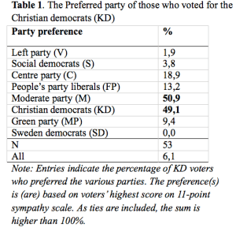
Another question of the pre-election survey is useful to demonstrate the existence of threshold insurance voting in the 2010 Swedish general election. Respondents were asked whether it is important for them that a party might not reach the 4% threshold. The results of a multivariate conditional logit model, where controls for party identification and numerous socio-economic variables are added, report that the predicted probability of voting for the Christian democratic party increases by 24 percent when the respondent was concerned about the threshold.

Concluding remarks
Strategic voting does occur in PR election. The 2010 Swedish general election is a perfect example of a specific type of threshold insurance voting. The Christian democrats were saved by supporters of their senior coalition partner. The campaign conducted by the Moderate party probably played a key role in their decision. Their leader, who also is the prime minister, outspokenly encouraged his supporters to vote for the centre-right coalition (and so, implicitly, not only for his party). In Germany, the senior partner of the centre-right coalition (ie., the CDU) did not encourage its supporters to save the liberal party (ie. FDP) that was at risk of falling below the threshold. As a consequence, the FDP did not obtain enough votes and was kicked out of parliament (see a previous blog entry).

Next September, another general election will be held in Sweden. Coalition signals are likely to be different this time, however. The left coalition was dissolved after their defeat in 2010. It will be very interesting to see how voters react to this new context.
For more detailed analyses, see Fredén, Annika (2014). “Threshold Insurance Voting in PR Systems: A Study of Voters’ Strategic Behavior in the 2010 Swedish General Election.” Journal of Elections, Public Opinion and Parties. Published online.

Call for papers: New insights in the study of electoral behavior and turnout
By DAMIEN BOL | Published: JANUARY 9, 2014
Proposals are invited for a workshop entitled, “New insights in the study of electoral behavior and turnout”, to be held in conjunction with the annual Nordic Political Science Association conference to be held in Gothenburg, Sweden, 12-15 August 2014. The workshop warmly welcomes studies examining all aspects of electoral behaviour and turnout from institutional, neighbourhood, network or individual-level perspectives or a combination of these levels. Comparative approaches are also encouraged. Papers utilizing data from national election studies, government registers, or natural or survey experiments are particularly welcome.
Deadline for submission of proposals: January 18, 2014.
Proposals should be sent to:
- Hanna Wass (University of Helsinki)

Electoral reform, values, and party self-interest
By DAMIEN BOL | Published: JANUARY 7, 2014
By Damien Bol, Postdoctoral fellow, University of Montreal

What is the story?
These last decades, the possibility of changing the electoral system has been brought at the political agenda of many established democracies. In 2011, the Tory-LibDem government organized a referendum on whether to replace the first past the post system (FPTP) used to elect the British House of Commons by an Australian-like alternative voting system (AV). In the 1990s, the Italian government implemented a slightly modified variant of the German mixed-member system (MMP) for the election of the lower house of the national parliament. About 10 years later, the decision was made to turn back to a proportional representation system (PR) with a seat bonus for the largest coalition. During the 2012 presidential election campaign in France, several candidates (among which the current President Hollande) proclaimed their preference in favour of introducing some dose of proportionality in the two-round system (TRS) used for legislative elections.
According to the conventional wisdom, those attempts are changing the electoral system are nothing more than strategies operated by political actors to ensure their re-election. It is often taken for granted that parties support electoral reform because they anticipate seat payoffs from the psychological and mechanical effects of the new electoral system. In a recent article, I show that in such situations, parties are also concerned about values and the possibility of achieving social goals that benefit the entire society.

Electoral reforms in OECD countries
Major electoral reforms are more frequent that what people usually think. By major I mean a reform that breaks with the principle of representation in use to elect the lower house of the national parliament. Many believe that this type of reform never happens, or if it does, it only happens during exceptional historical moments. For example, the decision of the CDU and the SPD to implement a system that combines a pluralitarian and a proportional component to elect the German Bundestag occurred during the reconstruction phase that followed World War II. The pure PR system that was previously used was blamed for having allowed Hitler’s national socialist party to get into the national parliament.

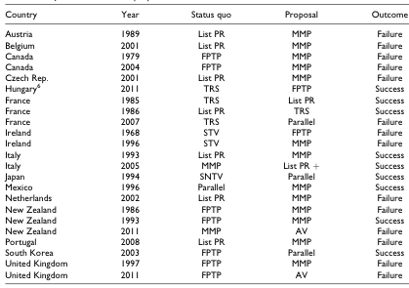
Even during stable periods of the world political history, the possibility of changing the electoral system is frequently brought to the political agenda. After consulting a wide series of historical pieces, I collated 23 “serious” proposals of major electoral reforms in OECD countries from 1961 to 2011 (see Table 1 below). By serious I mean proposals that were at one point on the political agenda of the government because they were drafted by a committee specifically appointed by the government, subject to a referendum, or submitted to parliament by (one of the) government party(ies). Although only 40% of these proposals were ultimately implemented, this number is not insignificant. The electoral system is not as stable as it seems.
Table 1: Major electoral reforms in OECD countries, 1961-2011

Values versus self-interest
How can we explain party support for electoral reform? In systematically assessing the position taken by 115 parties on the proposals reported in Table 1, it appears that the willingness to ensure a re-election is not the only factor at stake. All of these proposals would modify the degree of inclusiveness of elections. Introducing a PR system in the United Kingdom for example, as it was suggested by some of the Labour leaders in 1997, would give a greater representation to ethnic minorities and other underprivileged people. We also know that it would decrease the imbalance between male and female representatives.

One can thus wonder whether parties that usually defend these social groups support electoral reform proposals that go into that direction. The answer is yes, they do. Table 2 reports the standardized coefficient estimates of models predicting party support for the more inclusive electoral system (regardless of whether it is the status-quo or the proposed electoral system) by their expected seat payoffs and by how much they emphasized the political inclusion of these social groups in previous electoral platforms. The results reveal that both factors explain an important part of the story and that both are relevant empirically to understand party support for electoral reform.
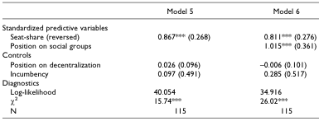
Table 2: Coefficient estimates of fixed-effect logit models

Parties do not only behave in their self-interest while it comes to change the electoral system. Regardless of how many seats they might expect to win or to loose, the willingness to remain coherent with their electoral platform is an important factor to understand their support or opposition to a reform proposal. In public debates, there is a tendency to refer to political actors as being machiavellian and driven by a hunger for power. However, it is important not to forget that politicians are also human beings and that their behavioral patterns are complex.
For all detailed analyses, see Bol, Damien (2013). “Electoral Reform, Values and Party Self-interest.” Party Politics, published online.

The Irish Constitutional Convention: Giving Citizens a Voice in Constitutional Debates
By DAMIEN BOL | Published: DECEMBER 17, 2013

By David Farrell, Professor of Politics, University College Dublin.
http://www.ucd.ie/research/people/politicsintrelations/professordavidfarrell/

What is the story?
In late 2012, the Irish government established a Constitutional Convention. This emerged out of a compromise between the two parties (Fine Gael and Labour) that came to power in the wake of the 2011 ‘electoral earthquake’, while Ireland was reeling from the worst economic crisis in the country’s history.
The newly formed coalition’s ‘Programme for Government’ sought to marry the sometimes quite disparate manifesto promises of both parties. This resulted in the constitutional convention set up to examine diverse issues such as (among others) the length of the Irish President term, the voting age, the Lower House electoral system, same-sex marriage, and the participation of women in politics and public life.
It was to take a further 18 months before the Convention was finally established. Chaired by Tom Arnold (the former chief executive of the leading Irish international charity, Concern), the other 99 members of the Convention consist of 66 citizens and 33 elected legislators. Whereas the parties could determine by themselves how to select their members, the citizen members were selected at random by a survey company, which had a brief of ensuring that the membership was a fair reflection of the population in terms of gender, age, region, education and socio-economic status.
The launch of the Irish Constitutional Convention attracted little by way of positive reaction. Criticisms fell into 3 groups: its composition, its agenda, and its limited advisory role. In this entry, I will deal with these 3 criticisms and provide a preliminary assessment of the Convention.

The membership
The main point of contention was over the mixing of ordinary citizens with elected politicians. The argument was that elected politicians would be likely to dominate the discussions and intimidate the citizen members.
A point of detail that many of the critics may not have picked up on is the modus operandi that surrounds deliberative processes such as this, namely the practice of having the members distributed in tables of 7-8 persons, each with a trained facilitator whose role is to ensure that all members are given an equal right to participate in the discussions in an atmosphere of mutual respect. Moreover, the politician members have made every effort not to steal the limelight, particularly in the plenary discussions (as can be seen from the streamed video feed of these discussions).

The agenda
The second area of criticism was over the agenda of the Constitutional Convention, which was seen at the same time as too limited and overly crowded. The first point relates to the fact that the list of themes is too restrictive, not dealing with the fundamental issues of constitutional reform that many called for. The criticism of the crowded nature of the agenda related specifically to the fact that the Convention was given just 12 months to conclude its work, with space and resources for 9 or so weekends of meetings.
It is too soon to offer detailed consideration of these points, but some preliminary remarks are in order. First, in the parliamentary resolution that established the Convention it is explicitly stated that its work is not limited solely to the themes set by government. We will have to see what other themes the Convention members may wish to take up that might result in additional recommendations for constitutional reform.
Second, it is now apparent that the Convention members are minded to read their brief quite liberally, moving beyond the confines of the specific questions posed. This willingness to extend the agenda of the Convention has been expressed regularly, starting at its January 2013 weekend gathering – its first full meeting. There the Convention considered two themes: whether to reduce the voting age to 17, and whether to reduce the President’s term of office to five years. Having read the briefing materials, heard from experts and advocacy groups, and deliberated over the relevant arguments, the Convention members took decisions that undoubtedly went beyond their brief. For example, they proposed to reduce the voting age to 16 rather than 17. In the same vein, they also proposed to reduce the age of candidacy for presidential candidates and to give citizens a direct role in the process of nominating Presidential candidates.

The role of the Convention
The third main area of criticism is more fundamental, namely that the Convention can only make recommendations. Its role is advisory rather than declaratory. This leaves the final power with the government to determine whether or not its recommendations will ever see the light of day in the form of referendum questions.
It will not be that easy for the government to sweep the recommendations under the rug. A point of detail that appears not to have been taken on board by some is the fact that the government has given a commitment to respond and in timely fashion by way of a formal ministerial statement to the Parliament. The common practice of simply ignoring unpalatable reports, of letting worthy documents gather dust in a damp civil service cellar is thus ruled out.
Based on the response to the first report – which was debated in July 2013 – there is some reason for optimism that the government is taking this process seriously. The government has agreed to hold referendums on two of the three recommendations made in this first report and to refer the third recommendation – giving citizens a say over the nomination of presidential candidates – to the relevant parliamentary committee on the (quite reasonable) ground that the details of how this might work needs further consideration.
Obviously, it is too soon to ascertain the full impact of the Irish Constitutional Convention. However, it has certainly had some impact already on the quality of democracy in Ireland. Emulating the same principles of deliberative democracy used in the British Columbia, Ontario and Dutch citizens’ assemblies, this provides a useful addition to our contemporary system of representative democracy. Something for other countries to emulate?

What went wrong with rental voting in the 2013 German election?
By DAMIEN BOL | Published: NOVEMBER 13, 2013

By Lukas Stötzer, Steffen Zittlau & Thomas Gschwend, University of Mannheim

What is the story?
Rental voting is a specific form of strategic voting that occurs in proportional representation systems with stable coalitions.1 It supposes that supporters of a senior coalition party switch their vote in favour of the junior coalition partner if this junior partner is scoring so low in polls that is it likely to be ejected from parliament, and if this implies that the overall coalition does not get a majority of parliamentary seats.

In Germany, the pro-business liberal FDP, the traditional junior partner of the conservative CDU, has traditionally been the main beneficiary of rental votes. CDU supporters have oftentimes helped the FDP to overcome the 5% threshold. One of the most impressive examples of vote-coordination in the history of German politics occurred during the January 2013 state election in Lower Saxony. The FDP was polling at around 4-6 % during the run-up to the election but ultimately received 10% of the votes. The gap between the projected and actual results comes from the decision of many of the CDU supporters to cast a rental vote (see our previous blog entry). However, the CDU and FDP narrowly failed to gain enough seats to form the Lower Saxony government. This caused quite some stir inside the CDU. Party leaders in Lower Saxony, as well as in Berlin, felt that their party had been weakened by this strategic desertion to the FDP.

For the first time in post-war Germany, the September 2013 federal election resulted in the ejection from the lower house of the national parliament of the FDP. With its 4.8% of the votes (and only 4.2% in Lower Saxony), the party fell below the 5% threshold. This came as a big surprise to many political analysts (like us…) that anticipated rental voting. The seats brought by its junior partner would have been crucial the CDU. Without their favorite coalition partner in parliament and all the wasted votes that were casted for the FDP, the CDU now faces a costly government-formation process as they will have to enter a Grand Coalition with the social democrat SPD.
How could we explain the huge difference between the Lower Saxony and the federal election results? In this entry, we offer two competing explanations of rental voting and take a look at the empirical evidence brought by MEDW survey data.

Two competing explanations of rental voting
There are two competing explanations of rental voting. On the one hand, supporters of a senior coalition partner might choose to switch their vote in favor of the junior coalition partner by themselves. If they perceive the junior partner to be in danger and if they support the coalition as a whole, they should operate this strategic decision. The difference observed between Lower Saxony and German results should thus comes from variations in the level of support to the CDU-FDP coalition, or variations in the perceived likelihood of the FDP to fall below the 5% threshold.
On the other hand, rental voting might be driven by party campaign strategies. The difference observed between Lower Saxony and German results should thus be explained by variations in the signal given by the CDU to their supporters. In Lower Saxony in January, some CDU candidates encouraged their supporters to cast rental votes in favour of the FDP. The subsequent defeat in this state election however pushed the party leaders to send a clear signal to their supporters not to operate such type of strategic voting during the September federal elections.

Evidence from both elections
To test these two competing explanations, we use pre- and post-election panel survey data collected within the framework of the MEDW project during the Lower Saxony state election in January 2013 and during the German federal election in September 2013. Both of these surveys were conducted with only Lower Saxony citizens.
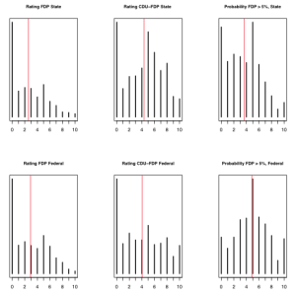
From Figure 1, we see that the FDP and the CDU-FDP coalition were just as popular in the Lower Saxony during the state (above) and the federal election (below). Only the perceived likelihood that the FDP would enter parliament is slightly lower for the German federal election (by one point on the ten-point scale, the red bar is the mean). It thus seems likely that variations in the number of rental votes effectively casted in the two elections cannot be explained by variations in these factors.
Figure 1: FDP support, CDU-FDP coalition support, and perceived probability of the FDP to enter parliament (Lower Saxony election, above; federal election, below)
To test this with more certainty, we estimate, for both elections, a hybrid multinomial-conditional logit model predicting voting behavior as a function of the factors at play in rental voting (various controls are also used). Figures 2 and 3 present the simulated probability of voting for the FDP minus the probability to vote for the CDU for CDU supporters who poorly rate the FDP. For each election, we present two scenarios: one in which the voter perceives the probability that the FDP enters the parliament as low, and one where the perceived probability is high. The results for the Lower Saxony state election (Figure 1) clearly reveals the expected pattern: The probability to cast a vote for the FDP as opposed to the CDU increases substantively for voters that support a CDU-FDP coalition, but only if they perceive the FDP to be at risk of falling below the electoral threshold (left-hand side). These voters are almost twice as likely to cast a vote for the FDP than to cast a vote for the CDU.
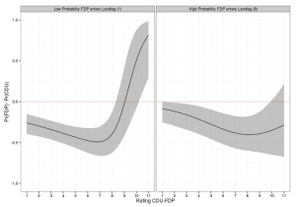
Figure 2: Probability to vote for the FDP (compared to CDU) as a function of levels of support to the CDU-FDP coalition (Lower Saxony election)

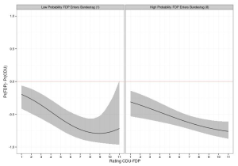
From Figure 3, we see that the coalition support even has a marginally negative effect on the probability to vote for the FDP (compared to the CDU) at the federal election. More importantly, we see that this effect is not influenced by how the voter evaluates the chances of the FDP to receive more than 5% of the votes.
Figure 3: Probability to vote for the FDP (compared to CDU) as a function of levels of support to the CDU-FDP coalition (federal election)

Conclusion
For the first time in history of post-war Germany, the FDP was ejected from the lower house of the German parliament. It fell below the 5% threshold and, contrary to what happened during Lower Saxony elections held last January, CDU supporters did not save the junior coalition partner. From our analysis, it appears that the reason for this difference does not come from the distribution of factors usually associated with rental voting. The more likely explanation is thus that the CDU campaign strategy played a crucial role in the FDP defeat. While the FDP has campaigned heavily for rental votes from CDU supporters during the last week before the election, the CDU has massively counteracted these attempts. Throughout the campaign, the CDU sent the message that their supporters should cast all their votes for the CDU if they want to keep Angela Merkel as their chancellor. Ironically, if the FDP had received 0.2 percent additional votes, this gamble would have paid off perfectly for the CDU, since it would have been able to form their preferred coalition government, in which they would have played the all-commanding role (see our previous blog entry). As it now stands, the CDU’s success in preventing rental votes resembles more the won battles of a certain Greek King, Pyrrhus of Epirus.

- The term ‘rental vote’ was coined by Michael Meffert in Meffert, Michael F., and Thomas Gschwend. 2010. Strategic Coalition Voting: Evidence from Austria. Electoral Studies 29: 339-349. ↩

How Do Mainstream Parties React to the Rise of Extremist Parties?
By DAMIEN BOL | Published: OCTOBER 11, 2013

By Indridi Indridason, Professor at the University of California, Riverside

What is the story?
In many European countries, the last decades have been marked by the rise of extremist parties such as the FN in France, the UKIP in the United Kingdom, or the PVV in the Netherlands. Extremist parties are often seen as threats to democratic systems because of their illiberal values. Yet extremist parties rarely enter government and, therefore, have limited influence on policy. However, the popular perception is that mainstream parties sometimes co-opt some of the issues extremist parties advocate, such as greater restrictions on immigration. A problem with this perception is that it based on countries where extremist views enjoy a sizable support. The counterfactual, that is, how mainstream parties would behave if there was no extremist party, is not considered. In this article, I present a theoretical model of electoral competition in the presence and in the absence of an extremist party under both first past the post (FPTP) and majority run-off electoral rules and derives predictions about the final policy implemented by the government.

A model of electoral competition under FPTP
I consider a simple spatial model in which two mainstream political parties compete with an extreme party under a FPTP system. The mainstream parties are assumed to choose their policy platforms strategically so that the policy implemented by the government is as close as possible to their ideological position. In contrast, the extremist party is assumed to be ‘expressive’, that is it simply campaigns on its most preferred policy position and does not adapt its platform. For the sake of convenience, the extremist party is here assumed to be far-right.
The counterfactual considered in this model is the policy implemented by the government when the extremist party does not compete. This equilibrium is well-known: Both parties adopt the platform that corresponds to the median voter’s preferred policy. In other words, both mainstream parties tend to move to the centre of the ideological spectrum. As a consequence, the policy eventually implemented by the winner, no matter which party wins, is centrist.
However, when an extremist party presents a candidate, it is shown that there is an equilibrium where (1) the winner of the election is always one of the mainstream parties and (2) the policy platform of the winning party is more left-leaning than what it would have been without an extremist party. In other words, in the presence of an extremist right party, mainstream parties tend to move to the left on the ideological spectrum. One way to make sense of this result is to think about the far-right voters. These voters always support the extremist party. As mainstream parties have no chance to capture them, they will concentrate on left-wing voters. From the perspective of the mainstream parties, the presence of a right extremist party truncates the distribution of voters on the right. Their median voter of the mainstream voters is further to the left than the median voter of all the voters. Figure 1 offers a graphical representation of this idea. Assuming that voters are normally distributed along the left-right spectrum, the median voter in the situation where there is no extremist party (above) is more right-wing than in the situation where there is a one (below). The shaded area represents the fringe of voters that vote for the extreme party.
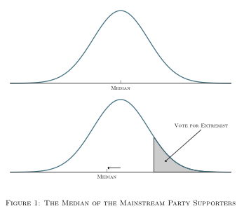

The model of electoral competition under majority run-off
Formal theorists have long been aware of this incentive for mainstream parties to move away from an extremist’s policy position under FPTP. However, this incentive has not been characterized in the context of majority run-off elections. In majority run-off elections, mainstream parties also move away from the extremist party but they do so to a smaller extent. One concern of the mainstream parties is to prevent the extremist from qualifying for the second round, which means that sometimes one of the mainstream parties has to `sacrifice’ its chance of winning by adopting a policy platform closer to the extremist party in order to deprive it of votes. This party thus adopts a platform closer to the extremist party. In effect, this gives the appearance of the party co-opting the policies of the extremist party whereas the government policy is at the end further away from the extremist party.

Conclusion
Contrary to what many people think, the presence of an extremist right-wing party does not attract mainstream parties to the right-wing of the ideological spectrum. To the contrary, in these situations, mainstream parties tend to adopt more left-leaning policy platforms. While this prediction is valid under both FPTP and majority run-off electoral systems, the move to the left is more marked under the former.
In the end, we are left with what an interesting puzzle: If the decision of the extremist parties to compete makes the policy of the government more left-wing, why do they decide to compete? In my model I simply assume that extremist parties are ‘expressive’ and that they just want to show their policy position. Whether that is a plausible assumption is open to debate. What my results demonstrate is that if extremist parties do manage to shape the political agenda, it happens through some mechanism other than electoral competition.
For a more precise description of the model and further implications, see Indridason, Indridi. 2013. Expressive Motives & Third-Party Candidates. Journal of Theoretical Politics, 25: 182-213.

How Much Corruption Do Voters Perceive in Different levels of Government?
By DAMIEN BOL | Published: OCTOBER 1, 2013

By André Blais, Professor at Université de Montréal,
Elisabeth Gidengil, Professor at McGill University,
Anja Kilibarda, Graduate student at Université de Montréal

What is the story
Every year, Transparency International publishes ratings of countries based on how corrupt their public sector is perceived to be. The rating is based on the judgments of analysts, business people and experts in the various countries. In the 2012 rating, Denmark had the highest score (least corruption) and Somalia had the lowest (most corruption). This is how ‘experts’ view the situation. But what about ordinary citizens?

Perceived corruption in Canada and Europe
As part of the Making Electoral Democracy Work project, we have conducted surveys in 10 regions within five countries, and each survey included the following question : « Would you say that there is hardly any corruption, a little corruption, some corruption, or a lot of corruption in the present xx government? » The question distinguishes the various levels of government : municipal, regional (state/provincial), national (federal), and supranational (European Union).
Thanks to the survey, we can see whether voters agree with the experts about the degree of corruption in their country. We can also see whether perceptions vary across regions within the same country and whether people perceive similar levels of corruption at different levels of government.
The graphs below show the average level of perceived corruption in each country and region for each level of government. We have given a score of 10 for ‘a lot of corruption’, 6.7 for ‘some corruption’, 3.3 for ‘a little corruption’, and 0 for ‘hardly any corruption’. The median score for the 38 ‘cases’ is 6, and the most frequent response is ‘some corruption’.1
Among the five countries included in our analysis, Switzerland has the most honest government according to the Transparency International experts (ranked 6th overall in the world) and Spain’s is the most corrupt (ranked 30th). Not surprisingly, voters perceive corruption levels in the national government to be lowest in Switzerland and highest in Spain. What is more surprising is that in France, which is ranked 22nd by Transparency International, much lower than Canada (9th) or Germany (13th), voters’ judgments are relatively positive.
The other pattern that emerges is that voters are inclined to see more corruption at higher levels of government. Municipal governments are perceived to be relatively honest while the European Union is judged to be the most corrupt… except in Spain.
There are also some interesting differences between regions in the same country. The most striking is the gap between Quebec and Ontario in Canada. The government that is evaluated as the most corrupt of all is the Quebec provincial government. In fact, Quebec voters are even more negative about their government than Catalonians are toward the Spanish government!
The next step in our research is to better understand how these judgments are formed and how they affect vote choice and electoral outcomes.

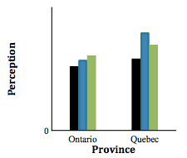
Figures: Perceptions of Corruption in Canada and Europe
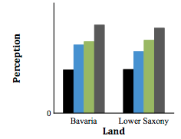
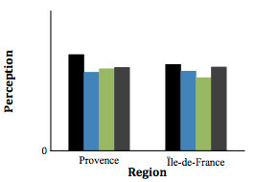

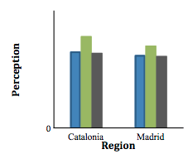
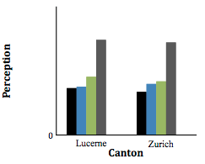

- The surveys were conducted at the time of the 2012 Quebec election, the 2011 Ontario election, the 2013 German election, the 2013 Bavaria election, the 2013 Lower Saxony election, the 2011 Spanish election, the 2012 Catalonia election, the 2011 Swiss election, the 2011 Lucerne election, the 2011 Zurich election, and the 2012 French election. In some cases (Germany, Switzerland, and Catalonia) we have measures for two different elections and the graphs present the average for these two elections. ↩

Disproportional Outcome despite PR: The 2013 German Federal Election
By DAMIEN BOL | Published: SEPTEMBER 27, 2013

by Steffen Zittlau & Thomas Gschwend, University of Mannheim

What is the story?
The federal election that took place last Sunday (September 22) in Germany has produced a clear winner, the conservative CDU/CSU. Although the party received 41.5% of the votes, it falls short of obtaining an absolute parliamentary majority by 6 seats out of the 630 of the Bundestag. The remaining seats were obtained by the three leftist parties (the SPD, the Greens, and the Left). A leftist government is however unlikely to be formed since the SPD and the Greens explicitly mentioned before the election that they would refuse to govern with the socialist Left. Possible government coalitions are thus CDU/CSU-SPD or CDU/CSU-Greens (see here)
That the CDU/CSU would do well in the election was expected: Germans were relatively satisfied with their government’s performance, and the party leader Chancellor Merkel enjoyed a historically high popularity. During the campaign, the possibility that the conservative party obtains a majority of seats was totally overlooked by political commentators. The German electoral system relying on proportional representation (PR), nobody imagined that this would be possible. As a matter of fact, it actually occurred only once in the political history of post-war Germany, in 1956. Yet estimations show that 43% of the votes would have been sufficient for the CDU/CSU to gain an absolute majority. During the election night, early projections even predicted the party to reach this threshold. In this entry, we explain how a proportional representation electoral system may lead to such an unusual result.

The importance of wasted votes
The reason why 43% of the votes would have been sufficient for the CDU/CSU to obtain a majority of parliamentary seats is the exceptionally high number of votes that were wasted on parties that gained no representation in parliament. Two parties only narrowly failed to gain representation in the parliament due to the 5% electoral threshold: The pro-business liberal FDP (4.8%), and the new anti-Euro single-issue party, Alternative for Germany (AfD, 4.7%). There will more on these parties in upcoming entries. Additionally, the vote share received by all other small parties reaches about 6.3%. In total, 15.8% of all the votes were effectively wasted as they found no representation in the parliament. This is a record for post war Germany and, certainly one of the highest scores among countries using a PR electoral system.

Vote-Seat disproportionality in Germany
The figure below shows how exceptionally disproportional the election was: The 2013 election reaches 8.6 on the Gallagher disproportionality index (Gallagher 1991, data from here). The Gallagher index is bounded between 0 and 100, where higher values represent more disproportional electoral systems. 8.6 is higher than for elections in Spain (e.g. 2011: 6.93; source), which is known to produce most disproportional outcomes due to low district magnitude (see Figure below)
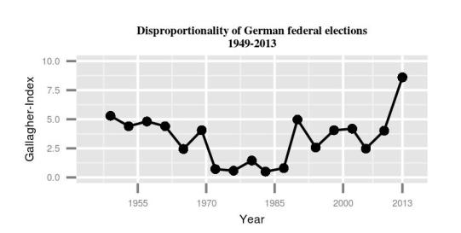
The mean value for the 17 preceding German elections since 1945 is only of around 3, which is largely in line with other countries using PR (Belgium 2010: 3.77, Switzerland 2011 3.75). Though this disproportionality remains lower than for most elections organized under plurality electoral system (such as in Canada, in 2011: 12.42; or in the UK in 2010: 15.50), it is worth noting that this index was of 3.14 for the 2010 US Congressional election.

PR does not always guarantee proportional results
This election shows that PR electoral systems are no insurance against disproportional election outcomes. The presence of a relatively high electoral threshold, a large number of parties, and the failure of voters to coordinate their votes between the parties opens the risk of a substantial vote-seat gap. More importantly, this disproportionality raises concerns about the overall representativity of the parliament (see also Powell & Vanberg 2000). In this election, the rightist parties (CDU/CSU, FDP, AfD) would have had a clear parliamentary majority if the 5% threshold would have not existed.

What lessons can be learned?
In elections, parties first and foremost try to maximize the number of votes and seats they receive. In PR electoral systems, however, they should also consider post-election bargaining. In particular, they should make sure their coalition obtains a majority of parliamentary seats. The CDU/CSU failed to do so. If 0.2% of CDU/CSU supporters would have cast a ‘rental vote’ (on the concept of rental vote, see this previous blog entry) for the junior coalition partner FDP, the CDU/CSU could now easily form a majority government without compromising too much on the agenda they campaigned on. Given the ultimate results, the CDU/CSU will have to offer many painful concessions to get either the Greens or the SPD to sign a coalition agreement. Either way, these concessions will be very costly in terms of policy orientation. Also the number of ministries held by the CDU/CSU in a coalition with the SPD for instance would be way smaller than the number it would have got in a coalition with the FDP.
Thus, let’s not forget one important characteristic of PR electoral systems: The winner of an election is not necessarily the one who gains the most votes or even the most seats!

Election Passport: New Resource on Elections Worldwide
By DAMIEN BOL | Published: SEPTEMBER 19, 2013

By David Lublin, Professor at American University
http://www.american.edu/spa/faculty/dlublin.cfm

Goal
The goal of Election Passport is to enable researchers and students to engage in high-level analysis of elections on countries for which data are not easily available. From Albania to Zimbabwe, this site provides unusually complete constituency-level election results, including votes won by very small parties, independents, and frequently, candidate names that are difficult to locate.

Why did you develop election passport?
My current work focuses on ethnic and regional parties in free democracies around the world—slightly more than 80 countries according to Freedom House. In the process of gathering election results for these countries, I collected a lot of the data now included in Election Passport. At the same time, I also realized that a lot of data for other electoral democracies was not easily available to scholars. I think it’s exciting that so many more countries are now holding elections that are meaningful in some way even if not fully free, so I began to assemble data for these countries too.
I am also concerned about preserving the world’s electoral history for future study. Many countries post election results very briefly on the web and then they disappear—perhaps forever. At any rate, they are not easily located in hard copy even at the Library of Congress or on archives like the Wayback Machine.
Most importantly, additional data will enrich political science theory and understanding. I’ve been heartened by the Ph.D. students who have already contacted me regarding the dataset and who will be the people pushing boundaries forward in the future.

Which countries are included in Election Passport?
Based on a capricious definition of regions, here is a current breakdown:

- Latin America: 17
- Caribbean: 21
- Sub-Saharan Africa: 19
- Post-Communist: 12
- Asia: 7
- Europe: 7
- Pacific: 6

Why these countries?
Ironically, many of the countries for which I gathered data for my own work are not included because their election results are available elsewhere. Why reinvent the wheel? I wanted to focus primarily on countries which constituency election data cannot be found in an organized manner from other sources, though there is overlap on occasion.

What sorts of use have you made of these types of data?
My current study focuses on the impact of electoral systems, decentralization, and other institutional rules on ethnoregional parties has been to identify their statewide and regional share of the vote. My hope is that gathering the data for partly free electoral democracies—often precisely the sort of countries where democracy is precarious or ethnic conflict threatens.
I could not have produced graphs like the following without this sort of data:
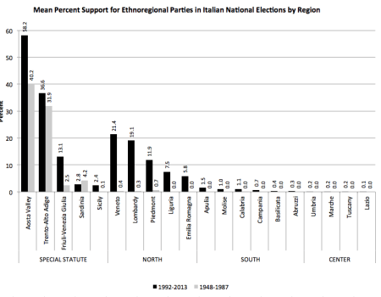
I recently published an article, “Dispersing Authority or Deepening Division? Decentralization and Ethnoregional Party Success,” in the Journal of Politics, which argues that decentralization has far less of a positive impact on ethnoregional parties than previously thought. Constituency-level data was vital to conducting this analysis across so many countries.
I also used this information to calculate the effective number of parties at both the statewide and constituency level—critical information for my current work on developing new measures of ethnic diversity and electoral system permissiveness designed to better predict the number of parties.
The descriptive aspect of the project is similarly useful to theory development. Without knowing the number of parties or the share of the vote won by ethnic parties, it is hard to develop solid grounded theories that explain when we find one or the other.

What are some of the other uses for the Election Passport data?
(1) Party-System Stability. The return of democracy to East-Central Europe has reminded scholars that party systems are not necessarily stable. Election Passport makes it possible to examine party system stability over a wider range of cases and to compare with existing data for longstanding democracies. Both should aid efforts to explain variability among both new and old democracies.
(2) Party-System Nationalization. Related to excellent work done by a variety of scholars such as Daniel Boschler and Daniele Caramani, more study is needed of the evolution of the nationalization of politics in new democracies. This study should prove especially interesting and fruitful precisely because so many are riven by ethnoregional cleavages due to the arbitrary nature of colonial boundaries that now persist as the frontiers of countries. Similarly, it will make possible to study to growth of party in countries where candidates as independents or without party labels.
(3) Incumbency Advantage. One of the first really good articles I read in political science was Andrew Gelman and Gary King’s work on the incumbency advantage, a.k.a. the personal vote, in the United States. More work needs to be done to extend this work elsewhere. Election Passport has information on candidate names for many countries, making possible to judge which candidates are incumbents.
I’m confident that many will think of alternative uses that I haven’t even conceived.

2014 European elections: A snapshot of three little known electoral systems (3rd part)
By DAMIEN BOL | Published: SEPTEMBER 15, 2013

By Fernando Feitosa Ribeiro, Intern at the Université de Montréal

What is the story?
For the past three weeks, I have been describing the particularities of the electoral system in use to elect members of the European parliament (EP) in three interesting and often forgotten countries. In particular, I focus on the possibilities given to voters to express their preference for individual candidates and intra-party competition. Last weeks, I talked about Finland and Latvia. This week, I give a snapshot of the rules of the game in Luxembourg.

The Luxembourgish electoral system for EP elections
Another variant of the party-list proportional representation (PR) will be used to elect the 6 representatives of Luxembourg for the next EP term. As in Latvia, voters have different possibilities while in the ballot booth. On the one hand, they can vote for a party list (‘en bloc‘, see Figure 1). In doing so, they actually give a vote to each candidate of the party.
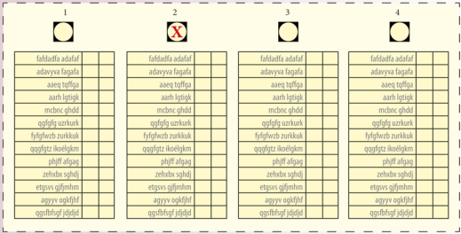
Figure 1: Example of a Luxembourgish ballot (‘en bloc)

On the other hand, voters can vote directly for individual candidates. If they opt for this last option, two subtleties appear. First, they might give their support to candidates from different parties as long as they keep their number of votes lower or equal to the number of seats to be filled (‘panachage‘, see Figure 2). Second, they might vote twice for the same candidate but still as long as they keep their number of votes lower or equal to the number of seats to be filled (see Figure 3).
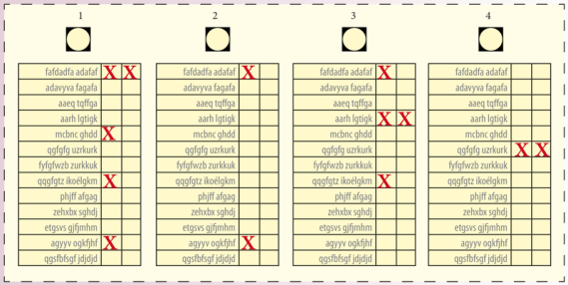
Figure 2: Example of a Luxembourgish ballot (‘panachage‘)
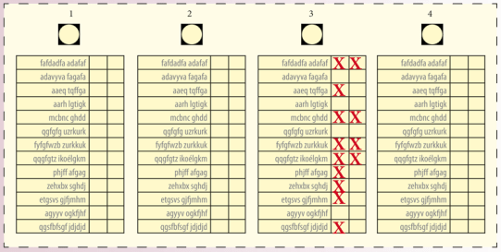
Figure 3: Example of a Luxembourgish ballot (individual candidate vote)
As in Latvia, seats are allocated on a party-basis, except that the Hagenbach-Bischoff quota is here applied. This method consists in the division of the overall number of party votes by the number of seats to be filled plus one. Once the quota is calculated, each party obtains as many seats as its overall number of party votes meets this quota. In cases of seats remaining to be filled, the d’Hondt method is used. Finally, the seats obtained by the parties are allocated to individual candidates who obtain the highest number of individual votes within their party.

Example
Imagine there are two seats to be filled in one district and two parties: The blue party that nominates two candidates (Bob, Cindy), and the yellow party that nominates two candidates as well (Carol and Sebastian).
– The individual candidates votes and the party list votes, including all of them, are first pooled. A quota is subsequently calculated in dividing this overall number by the number seats to be filled plus one.
Quota (75 pooled votes in total / (2 + 1) = 25).
– The number of each party votes is divided by the quota
Blue party: (45 party votes / 25 = 1.8)
Yellow party (30 party votes / 25 = 1.2)
– Each party is allocated a number of seats corresponding to the number obtained through this calculation (in rounding it down). In our example, the blue party obtains a seat (Quotient = 1.8), and the yellow party obtains the other seat (Quotient = 1.2).
– The votes casted for individual candidates are processed.
Blue party (45 party votes):
Bob (25 individual votes)
Cindy (20 individual votes)
Yellow party (30 party votes)
Carol (19 individual votes )
Sebastian (11 individual votes)
– Finally, the seat obtained by each party is allocated to the candidates with the highest number of individual votes. In my example, these are Bob (25 individual votes) and Carol (19 individual votes).

Conclusion
The electoral system used to elect the Luxembourgish representatives at the EP is somewhat focused on individual candidates. However, the fact that voters might cast a vote for multiple candidates across various party lists (unlike Finland) and express only positive preferences (unlike Latvia), makes this system substantially less subject to intra-party competition. Throughout these three blog entries, I tried to draw attention to the variety of electoral systems in use for European elections, and which are sometimes left aside by researchers and political observers working on the topic. Of course, these were only snapshots. Studying the functioning of these systems and their consequences for political representation would require entire chapters.

2014 European elections: A snapshot of three little known electoral systems (2nd part)
By DAMIEN BOL | Published: SEPTEMBER 6, 2013

By Fernando Feitosa Ribeiro, Intern at the Université de Montréal

What is the story?
During three weeks, I describe the particularities of the electoral systems applied to elect the members of the European parliament (EP) in three interesting and often forgotten countries. In particular, I focus on the possibilities given to voters to express their preference for individual candidates and incentives for intra-party competition. Last week, I talked about Finland. This week, I give a snapshot of the rules of the game in Latvia.

The Latvian electoral system for EP elections
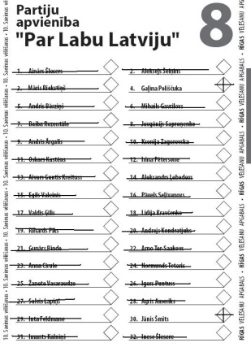
As in Finland, a variant of party-list proportional representation (PR) will be used to elect the 8 Latvian representatives for the next EP term. The system consists in a rather original voting pattern, which allows voters to either add a ‘plus mark’ next to a candidate’s name to signify they support her, or cross her name out to signify they oppose her (see Figure 1). In addition, they might leave a candidate’s name blank if they are neutral about her. It is important to note that this action takes place within a single party list.
Figure 1: Example of a Latvian filled ballot
Unlike Finland, seats are allocated among competing parties according to the Saint-Laguë method, which supposes dividing the overall number of votes each party obtains by successive uneven divisors (1, 3, 5, 7…). The seats are then allocated to parties with the highest quotients, before being distributed among individual candidates within these parties. In particular, individual candidates who obtain the highest index of support within their party receive a seat. This index is the result of subtracting from the overall number of party votes, the number of ‘cross-out votes’, added to the ‘plus votes’ they receive.

Example
Imagine there are two seats to be filled in one district and two parties: The blue party that nominates three candidates (Bob, Cindy and Paul), and the yellow party that nominates two candidates (Carol and Sebastian).
– The overall number of votes for each party is divided by successive uneven divisors.
The blue party obtains 45 votes:
45 / 1 = 45
45 / 3 = 15
45 / 5 = 9
The yellow party obtains 30 votes:
30 / 1 = 30
30 / 3 = 10
– The two seats are then allocated to the parties with the highest quotients. In my example, the blue party obtains one seat and the yellow party obtains the other (highest quotients are in bold).
– A support index is then calculated for each candidate in subtracting from the overall number of party votes, the number of ‘cross-out votes’, added to the ‘plus votes’ they receive.
Blue party:
Bob (45 party votes – 5 cross out votes + 17 plus votes = 57)
Cindy (45 party votes – 9 cross-out votes + 12 plus votes = 48)
Paul (45 party votes – 18 cross-out votes + 2 plus votes = 29)
Yellow party:
Carol (30 party votes – 1 cross-out votes + 12 plus votes = 41)
Sebastian (30 – 5 cross-votes + 9 plus votes = 34).
– The seat obtained by each party is then allocated to the candidates with the highest support index within the party. In my example, these are Bob (Index = 57) and Carol (Index = 41).

Conclusion
The electoral system used to elect the Latvian representatives for the next EP term is somewhat focused on individual candidates. In particular, the possibility given to voters to express both a negative and positive preference gives incentives to the candidates to campaign against some of their party fellows in order to maximize their chances of being elected. However, unlike in Finland, the possibility given to voters to express a preference for as many candidates as they are in the list tempers a bit intra-party competition. Next Friday, I will focus on the electoral system in use for the European election in Luxembourg.

2014 European elections: A snapshot of three little known electoral systems (1st part)
By DAMIEN BOL | Published: AUGUST 30, 2013

By Fernando Feitosa Ribeiro, Intern at the Canada Research Chair in Electoral Studies, Université de Montréal

What is the story?
On late May 2014, the European parliament (EP) will be renewed. During 4 days, separate elections will be held in each of the 28 European Union member-states. As most of people already know, the entire parliament is elected following the principle of proportional representation (PR). However, what is often ignored is that there exist huge variations concerning the precise variant in use. In particular, very unique rules are applied in some member-states as regards to the possibilities given to voters to express their preference for individual candidates, as well as incentives for intra-party competition. On each Friday, for the three coming weeks, I will describe the electoral system of an interesting and little known case. Let it start today with Finland.

The Finnish electoral system for EP elections
In Finland, a variant of party-list PR will be used to elect the 13 representatives of the country for the next EP term. Despite the existence of parties, alliances, and joint lists, these organizations play rather a secondary role. The translation of votes into seats is actually focused on candidates. First, voters cast a single vote for their preferred candidate directly, and not for their preferred party, by putting the corresponding number on the ballot paper (see Figure 1).
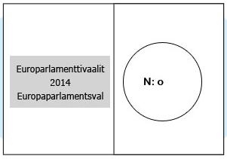
Figure 1: Sample of a Finnish ballot for 2014 EP election
Second, a comparative index is calculated and attributed for each candidate through the division of the overall number of votes obtained by all candidates of her party (including herself) by her rank relative to the numbers of votes she obtains compared to those of her fellow party candidates. As can be deduced from this calculus, the rank a candidate obtains plays a rather central role for determining whether she is elected. While the candidate who obtains the greatest number of votes within her party sees its overall score divided by one, the one who obtains the second best result sees it divided by two, even if the difference between the two is of one vote only.
Finally, after each candidate’s comparative index is calculated and attributed, seats are allocated to the candidates with the highest index.

Example
Imagine there are two seats to be filled and two parties: The blue party that nominates three candidates (Bob, Cindy and Paul), and the yellow party that nominates two candidates (Carol and Sebastian):
– The number of votes each candidate receives is used to rank the candidates by party.
Blue party:
Bob (20 votes, #1st rank)
Cindy (15 votes, #2nd rank)
Paul (10 votes, #3rd rank).
Yellow party:
Carol (25 votes, #1st rank)
Sebastian (5 votes, #2nd rank)
– The comparative index is then calculated for each candidate by dividing the overall number of votes her party obtains by her rank within this party.
Blue party:
Bob (45 votes / 1 = 45)
Cindy (45 votes / 2 = 22.5)
Paul (45 votes / 3 = 15)
Yellow party:
Carol (30 votes / 1 = 30)
Sebastian (30 votes / 2 = 15).
– The two district seats are then allocated to the candidates with the highest comparative index. In my example, these are Bob (Index = 45) and Carol (Index = 30).

Conclusion
The electoral system used to elect the Finnish representatives at the EP is very much focused on individual candidates, as indicated above. To maximize their chances to be elected, candidates should, on top of campaigning for the sake of their party, directly campaign for themselves. At the end of the day, their chances to win depends to a great extent on how good they are at catching votes compared to their party fellows. It can thus be argued that the system gives strong incentives to intra-party competition. Next Friday, I will focus on the electoral system in use for the European election in Latvia.

Evaluating US electoral institutions
By DAMIEN BOL | Published: AUGUST 8, 2013

By André Blais, Full Professor at the Université de Montréal
http://www.crcee.umontreal.ca/director_a.html

What is the story?
The United States have untypical electoral institutions. Many features are at odds compared to other world democracies: the usage of the first past the post (FPTP) system and primaries, the decentralization of electoral administration, the very short terms of office, and partisan redistricting. In this piece, I contend that while experts (i.e., specialists in comparative study of political institutions) evaluate these institutions negatively, US citizens are rather satisfied with the way it works in their country. I suggest some reasons for this divergence of opinion. I consider that experts are right and people are wrong.

Expert evaluation
Most of the experts believe that FPTP is not a very good system. In a recent study, Bowler, Farrell, and Pettitt (2005) asked international scholars in the field to rank order various types of electoral systems. FPTP came out six out of nine in mean rank, way behind other systems. As a matter of fact, very few democracies keep using FPTP. Only the UK, Canada and a handful of former British colonies have not managed to get rid of it.
The system used to elect the American President is even worse. No other contemporary democracy elects its president through electoral colleges. The few electoral colleges that existed, such as in Argentina and Taiwan, have been abolished. Among experts, this system is unanimously viewed as “dépassé” and unacceptable in a democracy.
The frequency of elections is also questionable. An overwhelming majority of first chambers in the world have four or five year terms. The two year term for the House of Representatives is extremely short, Most international experts would agree that two year terms are “crazy”.
Let’s talk about the decentralization of electoral administration. Canadians and Europeans were stunned to learn, during the 2000 presidential election mess, that fundamental decisions as the right to vote vary from one state to another. There is indeed no federal electoral law in the US. As far as I can tell, only Switzerland is in such a situation. The fact that a state legislature can decide who is allowed to vote in a federal election, in a country which is relatively centralized on most accounts, is absolutely weird.
There is another aspect where US practice appears exceptional: the drawing of constituencies. In most contemporary democracies, the drawing of constituency boundaries has been delegated to independent commissions, while this is under politicians’ control in the great majority of American states. Clearly politicians are in a conflict of interest here.
However, it has to be acknowledged the U.S. may be construed as “avant-garde” in terms of party primaries. It is the only country in which almost all party nominations are made directly or indirectly by voters. In many countries there has been a clear movement for opening the nomination process to a wider electorate.
On almost all fronts (the primaries being the only exception), U.S. electoral institutions are weird.

Citizen evaluation
American citizens have a very different opinion about the country’s electoral institutions. They appear to be very satisfied with the way democracy works. Figure 1 presents the mean score obtained to the question “on the whole, are you very satisfied (1), fairly satisfied, not very satisfied, or not at all satisfied (0) with the way democracy works in (country)? » in 16 established democracies (CSES data, round 2). The US scores quite high on this dimension. It comes clearly ahead of the UK, France, and Germany.
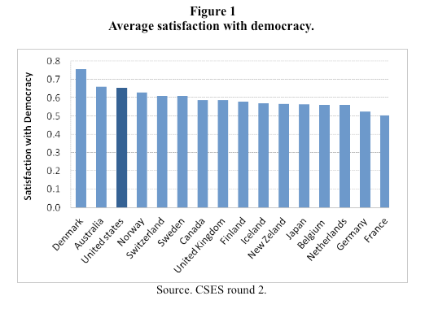
A second indicator is losers’ consent. A democratic election is bound to produce winners and losers. The hope is that losers will accept an outcome that they dislike, that is, they will recognize that the outcome is legitimate because the process through which the winner was designated was a fair one. The 2000 US presidential election certainly fits the bill of a “difficult” election. Gore has more votes yet he loses. There are serious doubts about how the votes are counted in Florida. The whole issue goes before the courts and takes weeks to be resolved. The final decision is made by the courts and the judges are divided along partisan lines. All this is awful. Yet in the end the Democrats graciously accept defeat.
A third indicator is turnout. Much is made of the fact that turnout (measured in terms of voting age population) is low in the U.S. (see Figure 2). But it is similar to that observed in other large democracies like Japan and the UK and only slightly lower than in France and Germany. If we take into account that registration is more difficult than in most other countries, that people are more mobile, and that there are far too many elections, the conclusion that turnout is low in the U.S. must be revisited. In short, turnout is not exceptionally low in the U.S. In fact it is relatively high given the extra hurdles imposed by the registration process and the exceptional mobility of its citizens.
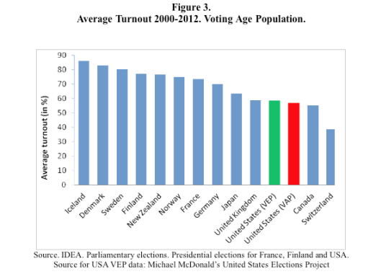

Conclusion
American electoral institutions are in many ways exceptional. Except for primaries, these institutions are construed to be “bad” by experts. So why are Americans so satisfied? My hypothesis is that their tolerance for malfunctioning institutions is high because patriotism is so strong. When you feel that you live in a great country, you are more willing to accept “deficiencies”. The culprit, I suggest, is blind patriotism. Americans are very proud of being Americans, more so than Canadians and Europeans, and this makes them unable to see that their electoral institutions are in a very bad shape.
For more information, see Blais, André. 2013. “Evaluating US Electoral Institutions in Comparative Perspective.” In Jack H. Nagel and Rogers M. Smith (eds), Representation: Elections and Beyond. Philadelphia: University of Pennsylvania Press.

MEDW conferences: Calls for papers
By DAMIEN BOL | Published: JUNE 12, 2013

Two conferences will be co-organized within the framework of the Making Electoral Democracy work Project in Montreal in 2014. Interested scholars are invited to submit an abstract (see instructions below).

Voting Experiments
The first conference will be organized by André Blais (Université de Montréal – MEDW Project), Jean-François Laslier (Paris School of Economics – MEDW Project), and Karine Van Der Straeten (Toulouse School of Economics – MEDW Project). It will be held on March 28-29.
The organizers invite papers that use experiments to address the question of how the electoral context (e.g. the electoral system, or the degree of competitiveness of elections) influence the way citizens and parties act during elections. Papers addressing methodological issues of this type of experiments are also welcome. Abstracts should be submitted via this page before October 1 (see the call for papers for further details).

Citizens, Parties, and Electoral Contexts
The second conference will be organized by Prof. Elisabeth Gidengil (McGill University – MEDW Project) and Dr. Ferran Martinez i Coma (University of Sydney – Electoral Integrity Project). It will be held on July 18 (just before the ISPA general conference).
The organizers invite papers that address the question of how the electoral context (e.g. the electoral system, or the degree of competitiveness of elections) influence the way citizens and parties act during elections in a comparative perspective. Abstracts should be submitted via the Electoral Integrity Project website before September 1 (see the call for papers for further details).

2013 MEDW team meeting
By DAMIEN BOL | Published: MAY 16, 2013

The 2013 annual meeting of the MEDW project will be held at McGill University on May 31 and June 1. During these two days, the team of researchers will get together in Montreal to discuss the state of advancement of the project and its future. The civil society partners, the advisory board members, and other invited scholars will also take part in this meeting.
Various research papers will be presented, see the program. Feel free to ask the authors for more information.

New material available
By DAMIEN BOL | Published: MAY 1, 2013

The MEDW project is the most ambitious study ever undertaken of the impact of electoral rules on the functioning of democracy. It involves studying 26 elections in 5 countries (Canada, France, Germany, Spain, and Switzerland).
In order to understand how the rules of the game and the electoral context affect party behaviour, we are systematically collecting and coding a wide range of material available during the electoral campaign. The coding scheme and the state of advancement of data collection is now available at the page party strategies.

With respect to voter behaviour, we are conducted a two-wave (pre- and post-election) internel panel survey. An example of questionnaire and the state of advancement of data collection is available at the page voter behavior.

Making voting experiments more realistic: The ‘hybrid’ experimental design
By DAMIEN BOL | Published: APRIL 9, 2013

By Delia Dumitrescu, Post-doctoral fellow, University of Montreal
http://www.crcee.umontreal.ca/dumitrescu.html

What is the story?
In general, laboratory experiments that study voting behaviour use a research design based on monetary incentives. Participants decide to vote, strategically or sincerely, or to abstain in a way that maximizes their final monetary payoff. Also, most laboratory experiments usually rely on groups of a few tens of people (for an example of such design, see this previous blog entry).
Yet, these designs are disconnected from real elections. In real life, people rarely vote for immediate financial gain reasons; rather, they vote for a party because they care about what it stands for. And the vote occurs in communities of thousands of voters, making the likelihood that an individual will cast the pivotal vote nil.
To get closer to the reality of elections, we propose an original ‘hybrid’ experimental design. Two specific features make this closer to real elections compared to classical laboratory experiments. First, voters are asked to decide on the allocation of resources for a policy cause about which they care. Second, each voter is located in a wider community of thousands of voters, whose collectively tallied ballots create the election’s outcome.

Experimental protocol
To test the validity of the hybrid experimental design, we conducted an online voting experiment in which 200 individuals took part. Participants were recruited online and received a base compensation of 5$. They had to vote (anonymously) for one of the three following options that correspond to a given allocation of an amount of 600$ (see Figure 1).
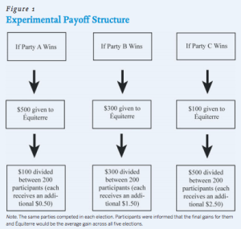

If Party A won, 500$ would be donated to the pro-environment NGO ‘Equiterre’. If Party B won, this NGO would receive 300$, and if it was Party C, 100$. The support for the environmental cause thus decreased significantly from A to C. Also, participants were told that the rest of the money would be divided equally among them as a bonus (0.5$ each in case Party A is elected, 1.50$ if this is Party B, and 2.5$ for Party C).

The treatment
The winner of the election was decided on the base of 9,200 votes. Participants were made aware that 9,000 early votes had already been cast, and that their votes would be added to the count. These early votes allowed us to manipulate parties’ winning chances. Since we expected most of our sample to support Party A, we designed the distribution of early votes in such a way as to place Party A last in the race.
In order to see how individuals vote when their preferred party has various winning chances, participants were asked to vote in five independent elections with different early vote distributions (see Table 1).
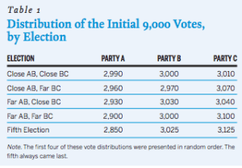
With the exception of the first election, the so-called ‘open-race’ election, Party A was significantly behind the other two parties in all elections. We refer to these elections as the ‘strategic’ elections. In all of them, Party C was in front. In two of them, Party A was separated from Party C by 110 votes, while in the other two, Party A was behind Party C by at least 200 votes. In the fourth election, it was impossible for Party A to win even if all participants voted for it.

Results
Table 2 presents participants’ voting behaviour in the strategic elections as a function of their vote in the open race election. As expected, most of them (N=119) supported Party A in the open race, while only 50 participants voted for Party B, and 31 participants for Party C. Due to the very nature of vote distribution for this election, these votes were considered as sincere.
The most striking result is the low level of defection from Party A in the strategic elections. Despite its low winning chances, 60% to 86% of Party A supporters (i.e. those who voted for it in the open race election) also voted for this party in other contexts. In particular, 60% did so even when the party had no chance whatsoever of winning (see Table 2).
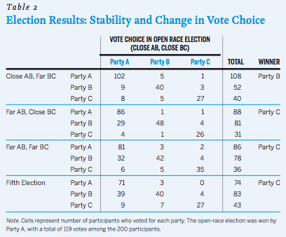
These low levels of strategic defection are very close to those observed in real life elections and at the same time much smaller than those observed in other laboratory studies. This is a strong case in favour of this type of hybrid experimental design for the study of voting behaviour. It is an interesting alternative to laboratory experiments that are sometimes considered as disconnected from the reality. Also, the hybrid experimental design shares some convenient platform and procedural characteristics with other studies. In particular, it takes place online, thereby maximizing the easiness with which individuals can take part in the study. It also asks people to vote in repeated elections, like laboratory studies. Finally, hybrid experiments do not require as much resources as field experiments. They allow us to increase the external validity of the manipulation at relatively low cost.
For more information, see Dumitrescu, Delia, and André Blais. 2011. “Increased Realism at Lower Cost: The Case of the Hybrid Experiment.” PS: Political Science & Politics 44: 521-523.

The 33rd coalition in Israel: Not minimal winning, nor super-sized
By DAMIEN BOL | Published: MARCH 15, 2013

By Renan Levine, Lecturer, University of Toronto-Scarborough
http://individual.utoronto.ca/renan/

What is the story?
After protracted negotiations, incumbent Israeli Prime Minister Benjamin Netanyahu announced that he will be leading Israel’s 33rd coalition government. In the immediate aftermath of the Israeli election on January 22, 2013, I outlined Netanyahu’s possible coalition possibilities (see previous blog entry).
The coalition Netanyahu formed is composed of his own party, Likud Beitenu, right wing Bayit HaYehudi, and two centrist parties, Yesh Atid and Hatnuah. The coalition controls 68 out of 120 seats. The government is not a minimal winning coalition because the three largest parties in the new coalition, Bayit HaYehudi, Likud Beitenu and Yesh Atid would have been able to control a 62-member majority without Hatnuah.
In contrast to predictions that governments leaders should prefer a minimal winning coalition (or at least a minimal winning connected coalition), oversized coalitions tend to be the norm in Israel because the Prime Ministers dislike being beholden to the demands of small coalition partners with the power to make or break the government. Over the past month-and-a-half, Netanyahu made it clear that he would prefer such a large coalition including parties on the right, parties in the center and ultra-Orthodox religious parties. So, what happened?
Element 1: Coordination of junior coalition partners
Netanyahu failed to realize his desired coalition because he was thwarted by a surprisingly strong alliance between Bayit HaYehudi and Yesh Atid to jointly maximize their leverage over Netanyahu. Both Bayit HaYehudi and Yesh Atid refused to join a coalition with the ultra-Orthodox religious parties, unified in their desire to implement policies in office that would result in radical reforms to the current system of state subsidies for ultra-Orthodox schools and religious institutions and ending draft deferments for ultra-Orthodox men.
Element 2: Saliency of the religious-secular cleavage
For several decades the dominant issue in Israeli politics is peace and security, including such questions like whether to attack Iran’s nuclear facilities or make concessions to the Palestinians. A secondary cleavage is over religious-secular issues, which because of the high level of state subsidies to ultra-Orthodox families and their religious schools is often wrapped up in concerns about domestic social policies.
During the campaign, the polls assured voters that Netanyahu’s Likud Beitenu would be the largest party and Netanyahu would continue his role as Prime Minister. This appears to have satisfied voters’ concerns about peace and security, since they could assume that Netanyahu would continue to take the lead on these issues. Consequently, many voters felt comfortable casting their vote to express their views on secondary cleavage instead of on peace and security. Religion and state and domestic social issues thus became very salient during the 2013 campaign, fueling support for Yesh Atid (a brand new party) and a substantially reorganized Bayit HaYehudi. Their party leaders recognized that their success was largely dependent on these issues and stood firm on these issues during negotiations.
Outcome: Expect hawkish approach to peace negotiations with Palestinians
While Netanyahu was forced to compromise on social and religious issues, he successfully held the line on peace and security. As a result, Likud will not only control the government’s median policy position on peace and security, they will also control the ministries primarily responsible for defense and foreign affairs. So, read the media headlines with some skepticism. Netanyahu and his party allies must be pleased with their ability to dominate policy-making on the issues that matter most to them and their supporters.
While many on the left are excited about the prospect of change in domestic policies and religious affairs, their excitement must be tempered by the knowledge that key positions on defense and foreign affairs will be held by politicians whose support for any compromise with the Palestinians is tepid at best. Contrary to some predictions that this government will last no more than a few months, popular reforms on social and religious issues combined with more of tough talk on peace and security could boost Netanyahu and the Likud at the next election.

Vote for Pope: African Cardinal leading online vote
By DAMIEN BOL | Published: MARCH 11, 2013

The results for the second week (March 4 – 10) of the Vote for Pope online experiment are out.
According to the votes cast by the participants, Peter Turkson (Cardinal from Ghana) should be the next Pope. He is winning under each four electoral systems (alternative vote, one-round plurality vote, majority runoff vote, and approval vote).
Please note that most of the participants come from North America and Europe and that Latin America in particular is underrepresented. A new election is going on this week. People are invited to visit the site and vote under four each electoral system. Every Monday, we will announce the results for the previous week (to see preceding week’s results, see this blog entry).

Vote for Pope: Different electoral systems, different results
By DAMIEN BOL | Published: MARCH 4, 2013

The results for the first week (February 27- March 3) of our online vote of Vote for Popeare inspiring.
According to the votes cast by the participants,
Marc Ouellet is the winner under one the round plurality and the runoff majority votes
Peter Turkson is the winner under the alternative and approval vote.

Keep voting! There is a new election every week. Every Monday, the results for the previous week is announced.

Vote for Pope: A tool to better understand electoral systems
By DAMIEN BOL | Published: FEBRUARY 27, 2013

The Making Electoral Democracy Work research team has launched the website voteforpope.net.
voteforpope.net has two objectives: (1) inform the public about the various electoral systems that exist in the world to elect state leaders, and (2) collect data on voters’ behaviour under these systems. The study focuses on the election of the next Pope.

The website is available in six languages (French, English, Italian, Spanish, Portuguese, and German) and provides information about four electoral systems that can be utilized for the election of a head of state: one round plurality, two round runoff, alternative vote, and approval vote. The electoral system that is used for the election of the Pope is also described (see Snapshot 1).
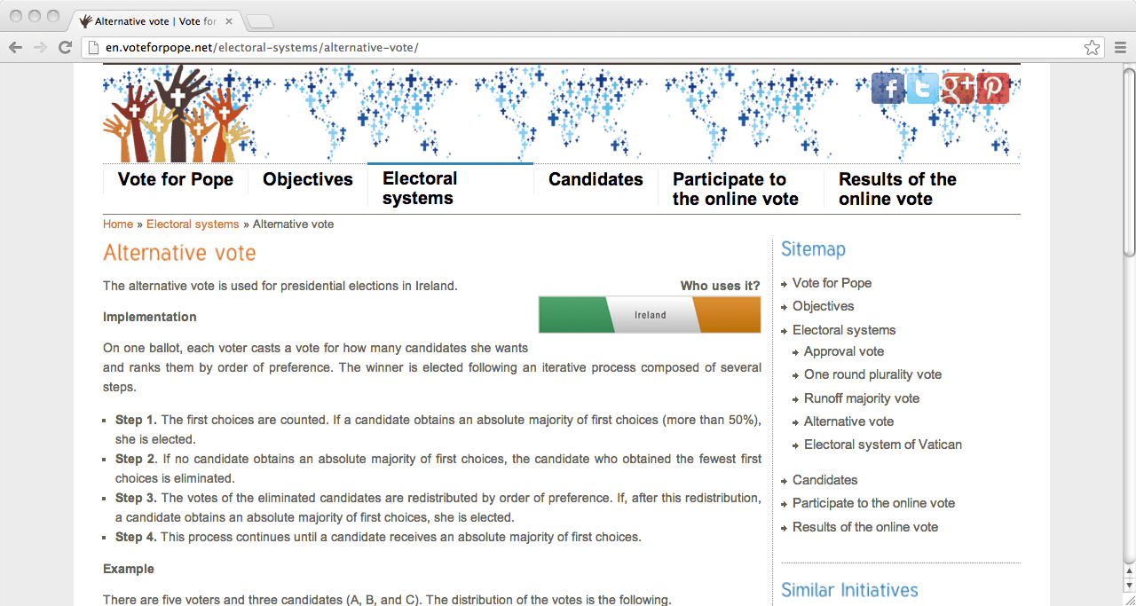
Snapshot 1: Description of the alternative vote.
The visitor is then invited to imagine how he/she would vote if the Pope was elected under each of these four electoral systems. The interactive section of the website allows people to cast a vote under each system (see Snapshot 2). Information is also provided about some of the main candidates for the succession of Benedict XVI.
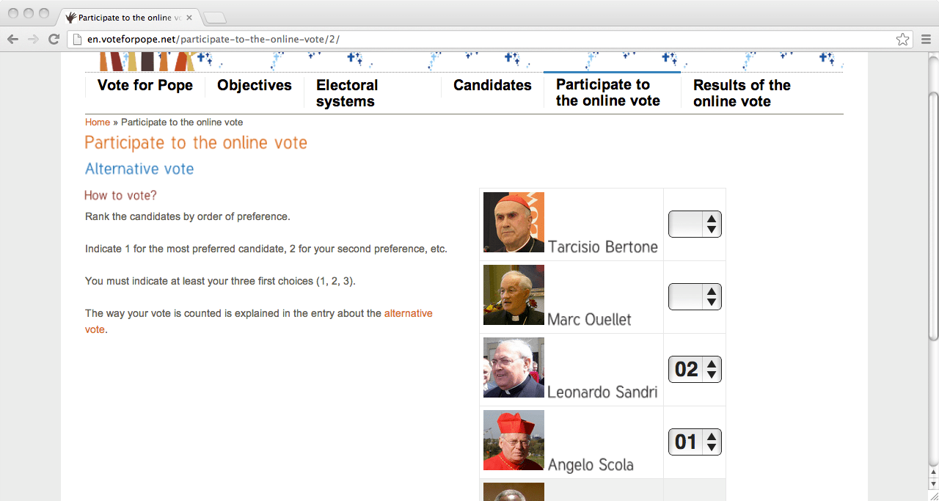
Snapshot 2: Voting under the alternative vote.
Similar websites have been developed for recent elections in France and Iceland, as well as the Canadian provinces of Ontario and Quebec.
For more information, please contact the research team in charge of voteforpope.net:

- André Blais (University of Montreal, Canada)
- Jean-François Laslier (CNRS and Polytechnique, France)
- Damien Bol (Canada Research Chair in Electoral Studies)

Contrasting Strategic Voting under FPTP and TRR: A Lab Experiment
By DAMIEN BOL | Published: FEBRUARY 13, 2013

What is the story?
In a previous blog entry, we reported the results of an online experiment conducted within the context of the 2011 Ontario elections and pointed out that the overall amount of strategic voting varies depending on the electoral system in use. In particular, we showed that strategic desertion is higher under first past the post (FPTP) than under alternative vote (AV).
Along these lines, another research has been conducted to contrast the importance of strategic voting under FPTP and two-round runoff system (TRR). This time, the laboratory experiment design has been chosen. The strategic paradigm assumes that voters attempt to maximize their expected utility, which is based on a combination of preferences and expectations about likely outcomes, and it is very difficult to isolate these parameters. As a consequence, such models are usually not testable directly using observational data.
The experimental protocol
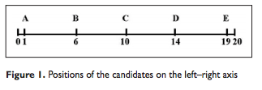
8 experiments have been conducted between December 2006 and February 2007 in Paris, Lille and Montreal. For each experiment, 21 participants were submitted to 8 successive elections, 4 under FPTP and 4 under TRR (order varies). In each election, there were 5 candidates, located at 5 distinct points on a left–right axis that goes from 0 to 20: an extreme left candidate, a moderate left, a centrist, a moderate right, and an extreme right candidate (see Figure 1 below).
According to theoretical models, two factors are crucial to characterize strategic voting. First, there is the benefit associated with electoral outcome. To measure it, the participants were informed from the beginning that one of the 8 elections will be randomly drawn as the “decisive” election. They were also told that they would be paid €20 (or $20) minus the distance between the elected candidate’s position and their own randomly assigned position. For instance, a voter whose assigned position is 11 would receive €10 if candidate A wins in the decisive election, €12 if E wins, and so forth. In the experiment (as in real life), it was in the voter’s interest that the elected candidate be as close as possible to his or her own position. Second, the perceived viability of each candidate is also crucial. When casting his or her vote, the participant was asked to rate, on a 0-to-10 scale, each of the candidates’ chances of winning the election.
Finding: Similar strategic considerations under the two electoral systems
As expected, the experimental data shows that the propensity to vote for a candidate increases with the benefit associated with this candidate and with his or her perceived viability. As reported in Table 4, the related regression coefficients are both positive and highly significant. What is more surprising is that this pattern holds for both FPTP and TRR (although the effect of viability is stronger in the former). In other words, and contrary to what Duverger (1954) argued in his seminal book “Political Parties”, strategic considerations are no different under one-round and two-round elections.
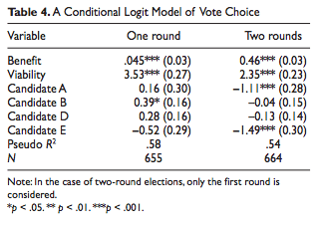
As a consequence, an alternative explanation needs to be found to account for the existence of a multitude of parties in some democracies using TRR such as in France. Further research will be conducted within the framework of the Making Electoral Democracy Work project to elucidate this paradox.
Further details may be found in Blais, André, Labbé St-Vincent, Simon, Laslier, Jean-François, Sauger, Nicolas, and Karine van der Straeten. 2011. “Strategic Vote Choice in One Round and Two Round Elections: An Experimental Study.” Political Research Quarterly, 21: 637-646.

Rental Votes in Action in Lower Saxony
By DAMIEN BOL | Published: JANUARY 27, 2013

By Steffen Zittlau and Thomas Gschwend, University of Mannheim

What is the story?
Last election in Lower Saxony was a very close race. In the evening of Jan. 20, the first projections that came in saw the incumbent right-wing CDU-FDP coalition in a very narrow lead, later in the evening the projections shifted in favor of a left-wing SPD-Greens coalition. At the end of a long election night, the CDU-FDP coalition fell short of only around 1,000 votes, giving to their opponent a one-seat majority in parliament.
A close race was predicted by the polls,
What took everybody by surprise was the performance of the FDP.
While it was lingering around the 5% electoral threshold according to most polls (see our previous blog entry), it ultimately reached 10% of the votes. How to explain these differences? This time is not so much the polls that went wrong (see another previous blog entry on polls at the last Catalan election), an explanation needs to be found in the Lower Saxony’s electoral system and the incentive it gives voters, and in some specific campaign anecdotes.
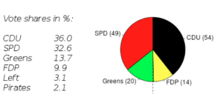
Figure 1: Results of Lower Saxony 2013 election
General explanation: Ticket-splitting
The Lower Saxony parliament, as most German states’ parliaments, is elected through a compensatory mixed-member PR system, where voters cast one vote for a district candidate, and one vote for a party list. This two-tiered system offers the opportunity to strategically split the ticket in a way that favors the preferred coalition. For example,
CDU supporters ensure a coalition with the FDP by ‘renting out’ their party list vote to the FDP, while still casting a candidate vote for the local CDU candidate.
This strategy, known in the literature as ‘rental vote’ (Leihstimme), becomes especially important if voters have reasons to expect that their preferred coalition partner will fall below the electoral threshold, as it was in the case of the FDP in Lower Saxony.
To assess the importance of this practice, Figure 1 reports the difference between the vote share obtained by the parties in the two tiers at the district-level. The respective junior coalition partners, i.e. FDP and Greens, obtained more list than candidate votes in essentially all districts, while their senior coalition partners, i.e. CDU and SPD, got more candidate votes than list votes. This strongly suggests that both camps were able to coordinate their votes. However, the CDU-FDP camp seemed to have better coordinated: On average FDP list vote shares are more than 3 times higher than their candidate vote shares. As a matter of comparison, this factor is only of 1.3 for the Greens. This is very much in line with an analysis conducted by the polling firm Infratest dimap, which estimates that the FDP received up to 104.000 list votes from CDU supporters, which represents about a third of its total list votes.
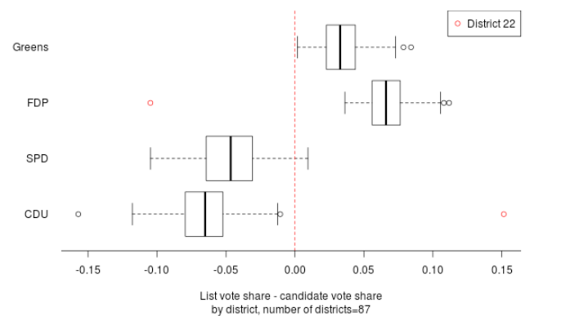
Figure 2: Difference of party list and candidate vote share (in %). Positive numbers indicate that the party has received more party list than candidate votes
Specific anecdote: The district 22
As reported in Figure 2, one district does not follow this general pattern. In the 22nd electoral district, the FDP received 17.5% of the candidate votes, and only about 7% of the party list votes. This seems to undermine our story about coalition voting, but a specific anecdote explains this result. In district 22, the CDU candidate dropped out of the race just before the election because of a scandal. The CDU therefore heavily encouraged their supporters in the district to support the FDP candidate. Nevertheless, the CDU candidate had to remain on the ballot pro forma, and still managed to gain about 22.5% of the candidate votes. In other words,
The CDU-FDP camp split their votes but failed to coordinate. As a result, the SPD candidate was able to win this district.
Ironically, if this coordination in district 22 had been successful, the FDP candidate would have won the district.
For more on ‘rental voting’ and other strategic incentives in mixed-electoral systems, see:
- Meffert, Michael F., and Thomas Gschwend. 2011. “Polls, coalition signals and strategic voting: An experimental investigation of perceptions and effects.” European Journal of Political Research 50(5): 636–667
- Meffert, Michael F., and Thomas Gschwend. 2010. “Strategic Coalition Voting: Evidence from Austria.” Electoral Studies 29(3): 339-349.
- Gschwend, Thomas. 2007. “Ticket-Splitting and Strategic Voting under Mixed Electoral Rules: Evidence from Germany.” European Journal of Political Research 46(1): 1–23.

The impact of a low electoral threshold on Israeli coalition politics
By DAMIEN BOL | Published: JANUARY 26, 2013
By Renan Levine, Lecturer, University of Toronto-Scarborough

What is the story?
In a previous blog entry, Steffen Zittlau and Thomas Gschwend discussed the intricacies of how electoral thresholds must concern instrumental voters who seek to influence post-election coalition negotiations in Lower Saxony.
In Israel, the electoral system provides centrifugal incentives for voters to cast votes for small parties who can make outsized demands on the large parties during coalition negotiations or provide a voice for minority population sectors in parliament.
Israel has a very low electoral threshold (2%, about 75,000 votes in 2013), combined with a ‘pure’ proportional representation (PR) system that treats the entirely country as one district with 120 parliamentary seats. With no party being able to win an outright majority, multiparty coalition governments are the norm.
Effect 1: Low threshold, many parties and a large surplus of seats
Responding to these incentives, political entrepreneurs formed 32 parties to contest the 2013 election, making it difficult for many to cross the threshold.
Twenty parties ultimately fell short of the threshold. Cumulatively, these parties attracted almost 270,000 votes (or 7% of the total votes cast).
If all these votes had been cast for the same party, that party would have been the sixth largest party in parliament (see Figure 1).
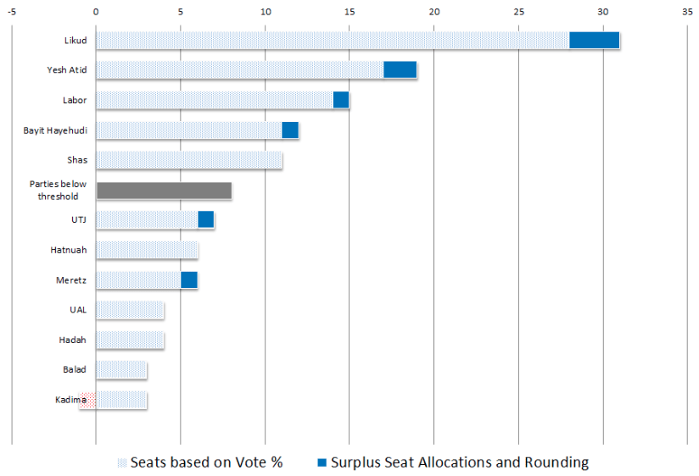
Figure 1: Israel Election Results 2013
Effect 2: Large surplus benefits largest parties, especially PM Netanyahu’s Likud
Votes “wasted” on parties too small to cross the threshold created surplus seats which are allocated using the Hagenbach-Bischoff method, favoring large parties. In 2013, this method benefits incumbent Prime Minister Benjamin Netanyahu’s Likud Party.
The Likud received three out of the eight seats allocated through the Hagenbach-Bischoff method.
The second-largest party on the right also received an extra seat. These extra seats give Netanyahu quite a bit of flexibility in choosing coalition partners and some leverage over those potential coalition partners despite his party’s disappointing electoral performance and the failure of a small nationalist party to cross the threshold. See also the following graphic in English, depicting the election results by party-bloc.

Effect 3: Threshold paradoxically takes seats away from nationalist bloc, but gives the largest nationalist party more leverage when assembling a coalition
The electoral threshold draws an arbitrary line between small parties that are represented in parliament and those that are not. The largest party in the outgoing parliament, centrist Kadima, imploded, but a remnant defied exit poll projections and barely crossed the threshold with 2.1% of the vote to secure two seats. A far-right party, Otzma Leyisrael, lost too many voters to similar parties in the nationalist bloc led by incumbent Prime Minister Benjamin Netanyahu and the nationalist’s religious party allies, and missed crossing the threshold by under 10,000 votes. Although Otzma Leyisrael’s failure to cross the threshold cost the Netanyahu’s bloc valuable seats, when the surplus seats were allocated, the nationalist bloc still was fortunate to obtain a razor-thin majority of 61 seats in the 120 seat parliament.
Despite being a natural ally of Prime Minister Netanyahu,
Otzma Leyisrael’s exclusion is to Netanyahu’s advantage. Otzma Leyisrael would have been the most extreme party in any coalition, and might have pulled coalition policy too far to the right for any potential coalition partner from the center.
Setting aside Netanyahu’s own policy convictions or the international community, the inability to attract any support from the center would put Netanyahu’s government at the mercy of every one of its nationalist and religious allies.
Effect 4: The flexibility to form coalitions without the religious parties, opening a window for dramatic domestic policy change.
Netanyahu could still assemble a coalition with his nationalist and ultra-Orthodox religious parties allies with 61 seats. Without Otzma Leyisrael, Netanyahu has several coalition options, which at a minimum, give Netanyahu more leverage over these religious parties in coalition negotiations than in the past and may open a window for dramatic domestic policy changes. These options include:
- A minimal connected winning coalition with nationalist-Orthodox Bayit Yehudi and centrist Yesh Atid with Likud occupying the coalition policy median.
- A coalition of the secular center, combining Likud with Kadima, Yesh Atid and former Kadima leader (and Likud MP) Tzipi Livni’s Hatnuah Party, yielding 62 seats.
Election result source: Official Israeli Government Election Website (in Hebrew).

State Election in Lower Saxony: The Intricacies of Electoral Thresholds
By DAMIEN BOL | Published: JANUARY 11, 2013
By Steffen Zittlau and Thomas Gschwend, University of Mannheim

What is the story?
On January 20, the citizens of the German state of Lower Saxony will elect a new state parliament. These elections are seen as a dress rehearsal for the next federal election in September this year. Angela Merkel for instance plans to speak at a dozen of campaign rallies over the next two weeks.
The latest polling results predict a very close race over who is going to lead the next state government. The charismatic incumbent state prime minister David McAllister’s right-wing conservative CDU is polling at around 40% and will certainly gain the largest vote share (slightly less than at the latest elections in 2008 where they scored at about 43%). Despite the strength of the CDU, McAllister may however not be able to remain state prime minister. At least three realistic coalition scenarios exist.

Scenario 1: The CDU and the FDP
One possibility is the continuation of the incumbent coalition formed by the CDU and its current junior coalition partner in the state government, the centre-right liberal FDP. However, according to latest polls, the incumbent coalition will just fall short of gaining a majority of the seats. Moreover, the FDP may loose a lot of support and only gain around 5% of the votes compared to their 8% in 2008. This brings them dangerously close to the electoral threshold of 5%. If the FDP falls below 5%, they will loose representation in the parliament. This will take this scenario off the table (see Figure 1).
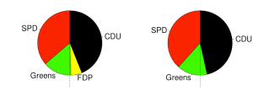
Figure 1: Seat projections if the FPD passes the 5% threshold (right) or not (left). Note: Seat shares are hard to predict in Germany since the total number of seats in parliament is not fixed.
Scenario 2: The SPD and the Greens
A coalition consisting of the social democratic SPD and the Green party would be a viable government coalition, as these parties signaled that they would like to form a new coalition government and are presently polling at 33% and 13%, respectively (30% and 8% in 2008). According to these polls, even if the FDP passes the 5% threshold though, this coalition will gain a short majority of the seats (see Figure 1).
Scenario 3: A “Grand Coalition”
The options outlined above are subject to the assumption that neither the radical socialist Left nor the free-internet Pirate Party, which are both polling at 3-4%, overcomes the 5% threshold. If one or both of these parties should enter the legislature, all bets are off. In a five- or six-party parliament, an absolute majority of seats for either a CDU-FDP or a SPD-Greens coalition is unlikely. Even though a CDU or SPD minority government would be possible, the most likely option in that case is a CDU-led “Grand Coalition” with the SPD (see Figure 2).
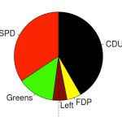
Figure 2: Seat projection in a five-party parliament

Consequence: Mixed incentives for voters
A close multi-party race in combination with such an electoral system leads to unclear expectations about who is going to form the new coalition government in Lower Saxony. Voters could have weird counter-intuitive strategic incentives, e.g. a conservative CDU supporter who most prefers a CDU-SPD coalition should cast her party list vote for the Left or the Pirate Party in order to prevent both a CDU-FDP and SPD-Green coalition to gain a majority of seats in the new parliament. To the contrary, a more economically right-wing CDU supporter could cast a strategic vote for the FDP in order to help this party overcome the threshold and to keep at least the possibility of a reelection of the CDU-FDP government on the table. It remains to be seen how voters and parties deal with this situation during the last days of the campaign and, later, in the government formation process.

Support for independence and referendum in the Catalan parliament
By DAMIEN BOL | Published: JANUARY 7, 2013
by Marc Guinjoan, Associate Professor, Pompeu Fabra University
http://elpatidescobert.cat/

What is the story?
The Catalan elections held in last November were perceived by many observers as decisive for the region. The ruling nationalist and centre-right party Convergència i Unió (CiU) called early elections with the promise to hold a referendum on Catalan independence during the following legislature. With only 50 seats, the party however lost 12 deputies in the regional parliament (out of a total of 135) and about 8 percentage points to reach a share of 31% of the votes.
Does that mean that Catalans rejected the idea of independence? Two pieces of evidence point in another direction.
First piece of evidence: Secessionist parties in the Catalan parliament
The results were not bad for parties supporting Catalan independence. Many of the former electors of the CiU opted for the secessionist party of the Republican Left of Catalonia (ERC), which became the second largest party after the CiU. In addition, the new pro-independence and far-left party CUP managed to enter the parliament with 3 deputies. The first row in Figure 1 shows that
The parties supporting Catalan independence represent a majority of the newly elected Catalan deputies (74 out of 135).
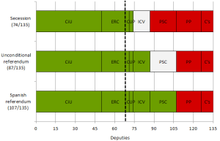
The left-wing ecologist party ICV is in white since their position on the issue in unclear. According to the polls though, more than half of their voters support Catalan independence.
Figure 1. Catalan parties supporting secession and referendum
Second piece evidence: Pro-referendum parties in the Catalan parliament
Unlike Scotland or Quebec, the Spanish Constitution does not allow territories to organise a referendum about their independence. However,
Despite the threat that such a referendum would probably be declared illegal by the Spanish Constitutional court, the vast majority of Catalan deputies support this idea.
All the secessionist parties and the ICV are indeed in favour of holding a referendum on Catalan independence. As the second row of Figure 1 shows, they represent 87 of the 135 deputies. This number is even bigger when one considers the deputies of the Catalan branch of the Spanish Socialist Party PSC who would support such a referendum after having reformed the Constitution to make it legal (see the third row of Figure 1). This reform is however unlikely since it is not on the agenda of any of the Spanish national parties.
The ERC decided to support a CiU minority government from the opposition bench. The two parties signed a joint commitment to hold a referendum during the 2012-2016 legislature. As the Spanish government will probably do its best to discredit and prohibit this referendum, Catalan politics will surely reserve some very intense moments in the coming years.

What went wrong with the polls in the last Catalan elections?
By DAMIEN BOL | Published: DECEMBER 10, 2012
by Marc Guinjoan, Associate Professor, Pompeu Fabra University
http://elpatidescobert.cat/

What is the story?
The 25th of November, Catalans elected their new regional parliament. In my previous blog post on the subject, I pointed out that there was little uncertainty about the results. All opinion polls indeed showed a strong convergence towards a clear repartition of vote share. In The main uncertainty laid in the decision of the new government to hold or not a referendum on self-determination.

I must acknowledge that I was wrong. The actual results differed drastically from poll estimates. Figure 1 shows these discrepancies. The 2007 electoral results are also presented. The right-wing nationalist party CiU maintains as expected its leadership position. But it did not gain a majority of parliamentary seats nor massive popular support. The CiU was expected to gain between 62 and 66 deputies and eventually obtained only 50 out of the 135 seats of the Catalan parliament. The discrepancy is partly explained by the important gains obtained by the left-wing secessionist party ERC, which became the first opposition party, over-passing the left-wing federalist party PSC (which was still ruling the Catalan government only 3 years ago). The right-wing unionist party PP experienced a small gain, as well as the eco-socialist pro-referendum party ICV. The unionist C’s also increased their electoral support, while the far left-wing secessionist party CUP entered the Parliament with 3 deputies.
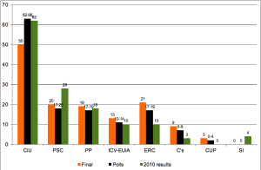
Why did the opinion polls fail to anticipate the electoral results?
Figure 1. Electoral results and polls in the 2012 Catalan elections
First explanation: Quality of the polls
Since the election, the quality of opinion polls in Spain has been largely discussed (see for example this post, in Spanish). Newspapers typically conduct opinion polls on small non-representative samples For instance,
The proportion of citizens choosing to answer surveys in Catalan is systematically higher than the actual proportion of citizens talking this language at home.
Although national and regional opinion polls institutes usually correct for these problems, there remains some doubt about the overall validity of the polls.
Second explanation: An increase in turnout
As shown in Figure 2, the turnout in Catalonia tends to be lower in regional than in national elections. This phenomenon of differential abstention has been pointed out by some scholars. They argue that some voters only identify themselves with the national Spanish institutions and therefore tend to abstain in regional elections.

Due to the large focus put on the possibility of holding a referendum about the independence of Catalonia during the campaign, those usual abstainers may have decided to show up at the polling booths the 25th of November.
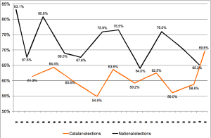
There was indeed an increase in the participation rate of almost 11 percentage points, compared to the 2007 elections.
Figure 2. Participation in the Catalan and general elections, 1977-2012
In a following blog post, I will perform an ecological inference analysis to test whether this hypothesis is supported by empirical evidence. Additionally, I will analyze the consequences of these electoral results with regard to the debate on independence and the likelihood of a referendum.

Winning, Vote Choice, and Satisfaction with Democracy
By DAMIEN BOL | Published: DECEMBER 3, 2012
by Shane Singh, Assistant Professor, University of Georgia
http://shanepsingh.com

What is the story?
People are happier when they win. Those who voted for a winning party, for instance, may experience both tangible and intrinsic benefits associated with victory. The tangible benefit is the election of a party that will advocate for, and potentially pass, policies that the voter supports. The psychological benefit is the election of a party that the voter likes and to which he might feel attached. Electoral losers, on the other hand, must endure the victory of a disliked party, and, potentially, the implementation of non-preferred policies.
In multiparty systems, coalition governments often form after an election. This means that a “winning” vote can come about through support of more than one party and begs the question: are all winners equal? In response to this question, André Blais, Ekrem Karakoç, and I conducted a study of the May 2010 election in the German state of North Rhine-Westphalia, after which a minority government between the Social Democratic Party (35% of seats) and the Greens (12% of seats) replaced an outgoing majority government of the Christian Democrats and the Free Democrats.
Finding 1: The impact of holding a parliamentary seat vs. a position in government
Those who voted for the Social Democrats or the Greens—the parties that went on the form the government—expressed the biggest rise in satisfaction after the election. Further, the size of the boost for Social Democrat and Green voters was very similar, which suggests that the number of seats has less of an impact than a spot in government on voter satisfaction with democracy. This is illustrated in Figure 1, below.
Finding 2: The impact at various levels of government
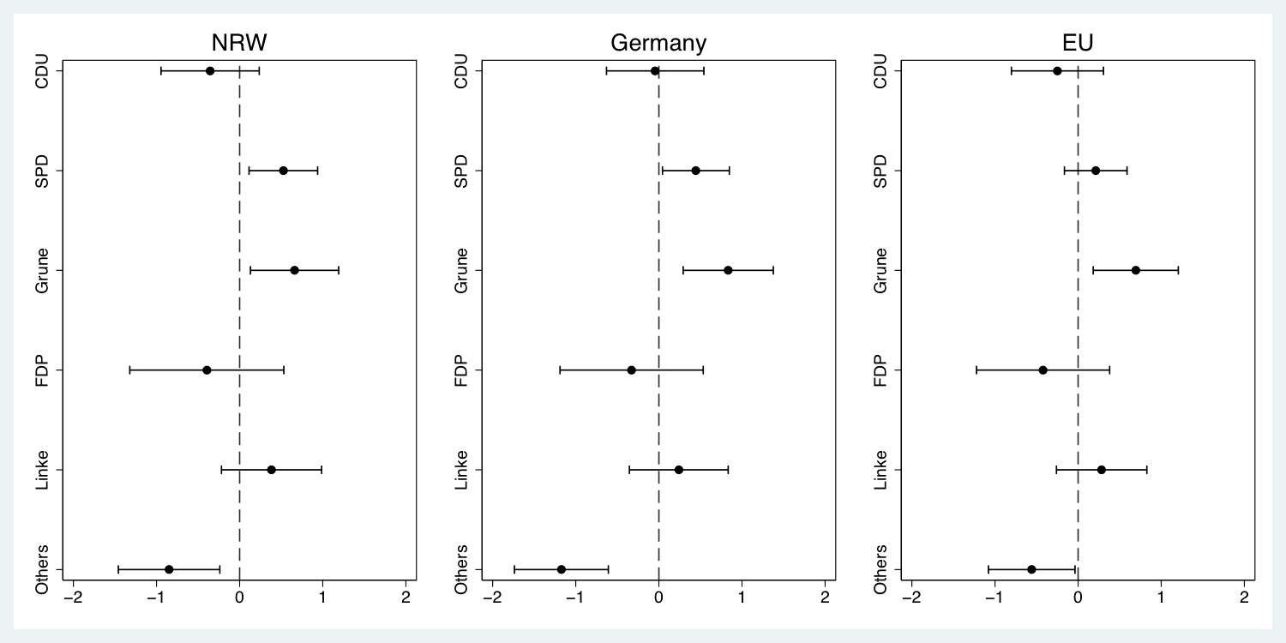
As also reported in Figure 1, these satisfaction boosts were not confined to the regional level. In fact, those who voted for the SPD and the Greens in the NRW election also expressed more satisfaction with democracy in Germany, and to a lesser extent, in the European Union.
Figure 1: The Effects of Vote Choice on Satisfaction
The MEDW data continues to come in, providing more and more pre- and post-election surveys conducted in conjunction with several other regional and national elections in Europe and Canada. With this data, we will have the opportunity to see whether these patterns hold in a broader context.
For more details, see: Singh, Shane, Ekrem Karakoç, and André Blais. 2012. Differentiating Winners: How Elections Affect Satisfaction with Democracy. Electoral Studies 31 (1):201-211.

The Catalan elections at crossroads
By DAMIEN BOL | Published: NOVEMBER 21, 2012
by Marc Guinjoan, Associate Professor, Pompeu Fabra University
http://elpatidescobert.cat/

There is a lot to decide. Catalans are going to the polls next Sunday 25th November in a contest that has attracted much international attention. Last month, the Catalan Prime Minister, Mr. Artur Mas –from the Catalan nationalist and centre-right Convergència i Unió (CiU)– called early elections, only two years after the beginning of his mandate. On the 11th September 2012 one and a half million people marched in Barcelona for Catalan independence, in the biggest demonstration ever held in the region. Catalan nationalism has historically based its claim for more self-government (or secession) on identity grounds and has been asking for the right to self-determination. However, the vertiginous growth in support for secession experienced in recent times has to do with other considerations as well, mainly economic. According to data from the Spanish government, Catalonia’s fiscal imbalance represents between 6.5% and 8% of the Catalan GDP.
According to a series of surveys carried out by the Catalan Centre for Opinion Studies (CEO) since 2006 support for a Catalan independent state has increased from 13% to 44% (see Figure 1 below). Additionally,
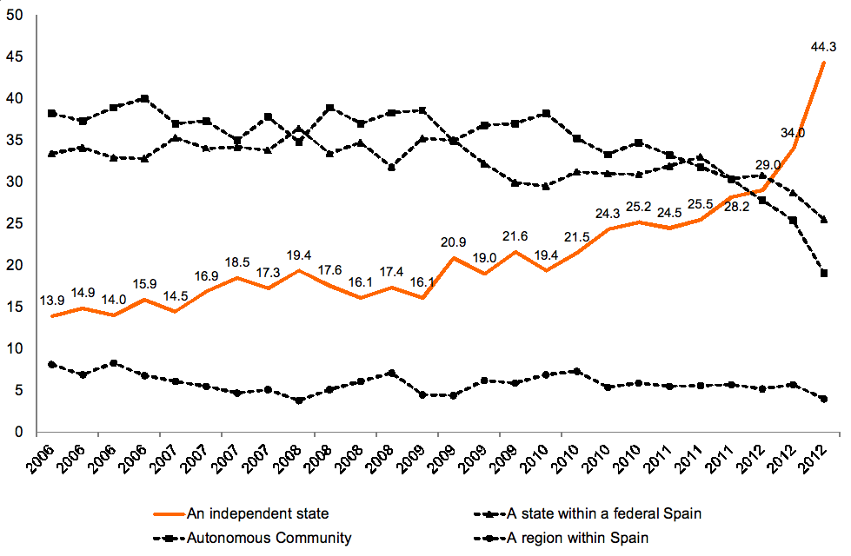
Around 57% of Catalans answer Yes when asked “If tomorrow a referendum to decide the independence of Catalonia was held, what would you vote”.
Figure 1: Support for different territorial preferences in Catalonia, 2006 to 2012
However, the Spanish constitution does not allow the secession of any Spanish territory or the right to self-determination. Nonetheless, in response to the massive demonstration held in Barcelona, and after the Spanish Prime Minister –Mariano Rajoy, from the conservative Popular Party– refused to negotiate a better fiscal treatment for Catalonia,
The Catalan Prime Minister called elections and announced his intention to hold a referendum on Catalan secession during the upcoming 4-years mandate.
Although these elections are seen as crucial, there is almost no uncertainty about the final electoral results. In a 135 seat parliament, the incumbent party, CiU, will obtain between 62 and 66 seats (according to most surveys), still far from the majority. On the other side, the main opposition party is the PSC, the Catalan branch of the Spanish socialist party PSOE; the party is expected to have between 17 and 20 deputies (in 2006 the PSC had 46 seats). The conservatives and pro-unity party PP, as well as the leftist and pro-secession ERC, may surpass the PSC: each of these parties should gain between 17 and 19 seats. The leftist and pro-referendum ICV may obtain between 10 and 14 deputies, and the pro-centralisation unionist C’s should do much better, going from the current 3 seats to 7 or 8 deputies. Finally, the far-left and secessionist CUP may enter into the Parliament with 0 to 4 deputies (see Figure 2 below).
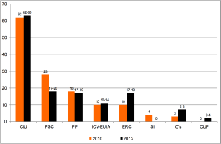
Figure 2: Electoral results in 2010 Catalan elections and expected electoral performance in 2012
It is clear that the parties in favour of secession will obtain a majority of the seats (around 80 seats),
and those in favour of the right of Catalonia to decide its own future could even hold two-thirds of the seats in Parliament. These are exciting times. The MEDW survey will allow us to make sense of this crucial election period and to better understand what is going on in Catalan society.

A new approach to study the impact of electoral rules
By DAMIEN BOL | Published: NOVEMBER 15, 2012
What is the story?
Ascertaining the impact of electoral systems is a tricky business. On the one hand, the long-rooted observational approach consisting in comparing electoral outcomes across countries with different electoral systems has been unable to produce unbiased results because of almost infinite numbers of factors intervening in the explanation of this outcome. On the other hand, although promising, recent experimentations on voting behavior of subjects in simulated election in a lab have been unable to capture real-life complexity.
To address these problems, a ground-breaking quasi-experimental study has been developed by the Making Electoral Democracy Work project. Shortly before the 2011 Ontario election, a Website called ThreeOntarioVotes was launched. The goal was to collect data on the impact of three electoral systems: first past the post (FPTP), the alternative vote (AV), and proportional representation (PR). This was done by inviting Web users to indicate their constituency and to vote under each of the three electoral systems. In doing so, we were able to control for a whole range of intervening factors while keeping the study in a real-life framing. This study leads to 2 major findings.

Finding 1: The impact of electoral rules on votes’ fragmentation
As reported in Table 3, people tend to adapt their voting behavior by considering the potentiality of their vote being wasted under FPTP and AV. As expected, the vote distribution is more fragmented under PR than under FPTP. The fragmentation of the votes under AV is located somewhere in between these two.
Although conventional theories assumes that the incentives in terms of vote-wasting to be similar under FPTP and AV, the fragmentation of the vote distribution appears to be much greater under the latter.
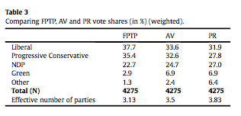

Finding 2: The impact of electoral rules on party success
The distribution of seats obtained by each party considering the distribution of votes presented above has been computed for each electoral system. The FPTP/AV comparison is particularly interesting. As reported in Table 6, AV produces less strategic desertion of weak parties than FPTP. Also,
Compared to FPTP, AV advantages parties that are acceptable to many voters, which are likely to be centrist in most instances.
In the particular case of the 2011 Ontario election that party happened to be the Liberal party, which succeeded in getting more seats under AV than under FPTP in spite of the fact that it got fewer first votes.
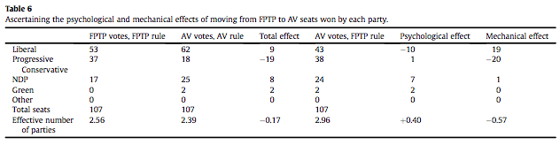
For more details, see Blais, André, Héroux-Legault, Maxime, Stephenson, Laura, Cross, William, and Elisabeth Gidengil. 2012. “Assessing the Psychological and Mechanical Impact of Electoral Rules: A Quasi-Experiment.” Electoral Studies 31: 829-837.

Visit of the Chinese People’s Political Consultative Conference
By DAMIEN BOL | Published: SEPTEMBER 28, 2012
On September 17, 2012, the Centre for the Study of Democratic Citizenship hosted a visit by a delegation from the Chinese People’s Political Consultative Conference (CPPCC). The 18-member delegation was led by Mr. Xiao Liu, Deputy Director-General of the Guizhou Provincial Committee. The purpose of the visit was to promote international cooperation and the exchange of knowledge and best practices regarding the democratic supervision over the work of government. The delegation heard a presentation on electoral systems by Professor André Blais, director of the Canada Research Chair in Electoral Studies at the Université de Montréal. Professor Blais also presented some findings from the Making Electoral Democracy Work project. The Centre’s Director, Elisabeth Gidengil, presented the Centre’s research program and demonstrated two electoral literacy tools that have been developed by Centre’s members, the Québec Vote Compass and Vote au Pluriel, Québec / Three Ontario Votes.
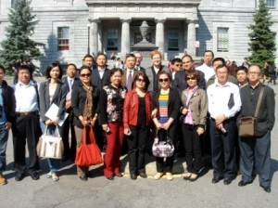
The delegation poses with Professor Blais and Professor Gidengil on the McGill campus
Professor Blais and Professor Gidengil are shown exchanging gifts with Mr. Xiao Liu, Deputy Director-General of the Guizhou Provincial Committee
The delegation listens to the presentation by Professor Blais

Making Electoral Democracy Work at the 2012 EPOP conference
By DAMIEN BOL | Published: JULY 24, 2012
The Making Electoral Democracy Work project will be represented at the conference Elections, Public Opinion and Parties (EPOP), which will be held at the University of Oxford, from the 7th to the 9th September. Three papers related to the project will be presented. The first one is entitled “Party Mobilization and Electoral Systems” and has been written by Ignacio Lago, Sandra Bermúdez, Marc Guinjoan, Kelly Rowe and Pablo Simón. It investigates how the type of party strategies vary across Spanish electoral systems. The second paper is entitled “The impact of Voting Rules in the 2012 French Presidential Elections” and has been written by Jean-François Laslier, Karine van der Straeten and André Blais. It assesses the influence of electoral rules on vote choice and election outcomes using a quasi-experiment conducted during the 2012 French presidential election. Finally, a paper entitled “Choice, Information and Complexity: Voting Behaviour in Swiss Elections”, written by Laura Stephenson, Marian Bohl, Ekrem Karakoc, André Blais and Hanspeter Kriesi, will be presented. It examines who among voters takes advantage of the opportunity to cast a customized ballot in the Swiss open ballot PR system.

2012 MEDW meeting
By DAMIEN BOL | Published: JULY 24, 2012
On June 1 and 2, the Universitat Pompeu Fabra (Barcelona, Spain) hosted the annual meeting of the MEDW project. The meeting was efficiently organized by Professor Ignacio Lago and his research team. During the two days of the meeting, the members and their students presented early results of various ongoing researches.

2012 CPSA annual conference
By DAMIEN BOL | Published: JULY 24, 2012

Several members of the MEDW project presented papers at the Canadian Political Science Association (CPSA) conference held from June 12 to June 15 in Edmonton, Alberta. Laura Stephenson, William Cross, Jonathan Malloy and Tamara Small organized a Panel about the 2011 Ontario election. Find out more about the panel and the conference here.

Farewell and welcome
By DAMIEN BOL | Published: JULY 24, 2012

Last June, Ekrem Karakoc left us after two years of involvement in the MEDW project. He has been offered a tenure stream position in the Political Science Department of the University of Binghamton, SUNY. We would like to thank him for his contributions to the project and wish him the very best for his future researches. This spring, we advertised an opening for a postdoctoral fellow. We received many applications from excellent candidates. We selected Damien Bol (U.Louvain) and Laurie Beaudonnet (European University Institute). We hereby warmly welcome them!

Three Ontario Votes Project Report
By DAMIEN BOL | Published: OCTOBER 12, 2011

Since its launch on September 17, more than 9000 people have visited the Three Ontario Votes website. These visitors had the opportunity to learn about three different electoral systems: the first-past-the-post system (FPTP) currently used in Ontario, the alternative vote (AV) and the list proportional representation (List PR). They also had the unique opportunity to cast their vote in the provincial election using three different voting system ballots.
Please click here to read the full report.

MEDW launched a new project: Three Ontario Votes
By DAMIEN BOL | Published: SEPTEMBER 21, 2011

In collaboration with a number of universities (University of Montreal, McGill, Carleton and Western Ontario), media and other organizations (CSDC, Toronto Star, Vote Compass, Bell Chair in Parliamentary Democracy), the MEDW group has engaged in a new project that aims to analyze how respondents would vote under three electoral systems in Ontario. The so-called Three Ontario Votes project has launched a new webpage where Ontario voters can vote under three electoral systems, namely the currently used first past the post (FPTP), the alternative vote (AV), and the list proportional representation (List PR): www.threeontariovotes.ca. The website also included information about the different electoral systems with concrete examples so that the respondents were informed about these electoral systems before answering the questions. After voting under the three electoral systems, the respondents are invited to answer a short questionnaire.

MEDW Announcement in PS
By DAMIEN BOL | Published: JUNE 19, 2010

Please click here to see a write-up on the MEDW project in PS: Political Science & Politics.

June 6-7 2011 MEDW Montreal Meeting
By DAMIEN BOL | Published: APRIL 6, 2010
From June 6 to 7, around 25 members of the MEDW research team come together to Montreal to discuss early findings of the various projects. Those who requested hotel accommodations will be staying at:
Hotel Le Cantlie Suites
Address: 1110, Sherbrooke Ouest, Montréal, Québec H3A 1G9
Website: http://www.hotelcantlie.com/
Detailed information about the content of the meeting will be sent to all participants.

MEDW Call for Bids
By DAMIEN BOL | Published: FEBRUARY 12, 2010

The MEDW project is calling for bids on one, some or all of the election studies included in the project. Please see the link for more details.

CALL FOR BIDS – Internet Survey Project

Electoral Studies MEDW Article
By DAMIEN BOL | Published: FEBRUARY 4, 2010

André Blais has published an article outlining the MEDW project. Click here to see Making Electoral Democracy Work in Electoral Studies.

Zurich and Lucerne Elections
By DAMIEN BOL | Published: JANUARY 22, 2010

ELECTIONS IN ZURICH AND LUCERNE

The first two elections covered by the “Making Electoral Democracy Work” project have been held. The voters of the Cantons Zürich and Luzern have elected their legislative as well as the cantonal executive councils elections on April 3 (Zürich) and April 10 (Luzern). Since Zürich is the most populated canton of Switzerland and Luzern the leading and most populated canton of historically catholic and rebellious Inner Switzerland, both of these elections have been widely regarded as test-ballots for the national elections in the fall and therefore received considerable media attention. In both cantons, the parties of the moderate center, the FDP and the CVP lost a considerable share of votes as well as representations, the Green-Liberals were the clear winners in both cantons in terms of winning new voters and seats. This might be due to the increased competition in the center of the new BDP and Green-Liberals, a “Fukushima-effect” which is widely recognized as helpful for the Greens and Green-Liberals, though not uncontested, and the generally moderate and noncontroversial campaigns, which did not mobilize many voters, even in the face of the test-election media environment. 35% of the eligible population of Zürich and 43.5% of the entitled voters of Luzern (an all-time low turnout for the latter canton) made use of their democratic right. In Zürich, the SVP, although losing 2 of 56 seats (180 in total), still is the largest party, the CVP lost 1/7 of her seats, but still stays the largest party in her stronghold Luzern with 39 of 120 seats.
The elections for the 7 seats in the executive council of Zürich were very close. Apart from Maja Ingold, the candidate of the minor EVP, all 8 candidates of the major parties reached the quorum of 50% of 1/7 of the votes cast, the first and last only 18,548 votes apart. So CVP-candidate Hans Hollenstein, incumbent and seen as a relatively safe winner in the polls, but defeated by the Green candidate Martin Graf with a margin of only 2328 votes, had to accept the fact, that there was no seat for him in the new executive council. So the new executive council of Zürich consists of 2 candidates of the SP, 1 of the Greens, 2 of the FDP and 2 of the SVP. In Luzern, only the incumbent CVP-candidate Guido Graf reached the quorum to secure one of the 5 seats in the executive council. There will be a runoff between 5 remaining candidates (1 CVP, 1 Independent, 1 FDP, 1 SP, 1 SVP) for the other 4 seats on May 15th, silent election of the 4 best candidates was not possible, because only CVP and Greens withdrew their candidate on 6th and 8th place, respectively. We will therefore expand our data collection efforts to cover the second round.
In the course of the two nearly simultaneous campaigns, data from many sources such as newspaper ads, letters to the editor, TV-debates, party manifestos, interviews with campaign managers etc. have been or are collected at the moment. Also a pre- and post-election panel survey has been fielded in both cantons with over 1000 pre- and ~750 post-respondents each. Bringing these data together will give us the opportunity to assess and make sense of the different parties’ strategies, actions and non-actions and their impact on the strategic behavior of cantonal voters in Switzerland and, when compared to the data from Spain, Germany, Canada and France later on, subnational voters in general.

Pre-Election Questionnaire Topics
1. Satisfaction with democracy
2. Vote
3. Satisfaction with government /at regional/federal level over last 12 months
4. Economic evaluations over last 12 months
5. Government responsibility for economic situation
6. Party ratings
7. Evaluation of potential government formations (coalitions/minority governments)
8. Perceived likelihood of coalitions/minority governments
9. Awareness of electoral agreements between parties
10. Which minor parties will get enough votes to get into parliament?
11. How much do you care about who is elected in your local district?
12. Party identification (e.g., Do you feel close to a party? Which party? How close?)
13. Left-right ideology battery of questions
14. Feelings of efficacy
15. Impact of each level of government on well-being of self
16. Corruption in government at each level

Post-Election Questionnaire Topics
1. Satisfaction with democracy
2. Vote choice
3. Were you contacted by parties?
4. Political participation questions (battery)
5. Representativeness of the election
6. Evaluations of electoral system
7. Electoral system information questions
8. Feelings of efficacy
9. Occupation
10. Internal migration
11. Use of voting advice applications
12. Awareness of pre-existing electoral coalition agreements
13. Union membership

Launch of Making Electoral Democracy Work research project
By DAMIEN BOL | Published: MAY 18, 2009

The Social Sciences and Humanities Research Council of Canada has awarded a major grant for a seven-year research project entitled Making Electoral Democracy Work.

Our project brings together an exceptional team of economists, political scientists, and psychologists from Canada, Europe, and the United States to undertake the most ambitious study ever undertaken of the impact of electoral rules on the functioning of democracy.

The study will examine 27 elections in five countries.

There are three inter-related components:

* an analysis of party strategies in these same 27 elections;
* an internet panel survey of the same voters over different elections;
* and a series of innovative experiments designed to complement the analyses of party and voter behavior

For more information, please contact us at: info@electoraldemocracy.com

